 

Sentosa Development Corporation (SDC): Guest Experience Feedback Insights (GIE)

Date of Submission: 30-JUN-2022

Submitted By:

|  |
| --- |
| Kelvin Thor 21066261 |
| Luqman Hakim Bin Abdullah 21066645 |
| Ng Shu Wee Gina 21066631 |
| Tan Hui Zi, Odelia 21066364 |
| Alfred Tan Hsien Boon 21066499 (Team I/C) |

# Abstract

Making sense of feedback is always valuable for any marketing campaign. Social media has become one of the main methods visitors of places of interest talk about their experiences on the internet.

With this in mind, we move to extract the data from social media and analyse the data extracted to derive insights from available data sources online.

Data was extracted mainly from Twitter and Travel Review websites. Extracting data was more difficult than expected as most social media platforms do not give functionality to filter and sort data. Travel review websites also block attempts to extract data as well.

Much of the difficulty was from data extraction while the other part is lack of pre-trained AI NLP models Asian Languages.

Despite the difficulties encountered we could derive insights of visitors from the data retrieved for Bahasa Indonesia.

The effort of this project can be applied to other Asian languages and better insights derived from marketing campaigns with social media considerations in mind.

# Acknowledgement

Thanks to Fu Zhixiang from Sentosa Development Corporation for giving input on overcoming Klook’s anti-botting measures and ideas to evaluate multiple sentiment models for best results.

**Table of Contents**

Abstract 2

Acknowledgement 3

i. Introduction 6

**1. Sentiment Analysis for Social Media – By Kelvin Thor / Luqman Hakim Bin Abdullah** 8

1.1 Scope and Background for each social media platform 8

1.2 Extracting Text from Social Media 9

1.3 Data extraction from Twitter 14

1.4 Issues encountered – Generic Keywords, Misspellings, and Internet Slang 17

1.5 Conclusion 18

1.6 Recommendations 18

**2. Review Sentiment Analysis – By Luqman Hakim Bin Abdullah / Kelvin Thor** 19

2.1 Background 19

2.2 Methodology and Design 19

2.3 Findings 25

2.4 Evaluation and Analysis 30

2.5 Conclusion 35

2.6 Recommendations 35

**3. Hotels and Dining Travel Reviews – By Gina Ng** 36

3.1. Basic Market Background Research 36

3.2. Data Collection 39

3.3. Hotel Analysis and Findings 48

3.4. Dining Trends and Insights 64

Hindsight 78

**4. Part of Speech Extraction and Analysis – By Odelia Tan** 79

4.1 Background 80

4.2 Methodology and Design 82

4.3 Findings 85

4.4 Evaluation and Analysis 89

4.5 Conclusion 91

4.6 Recommendations 91

**5. Topic Modelling and Labelling – By Alfred Tan** 92

5.1 Background 93

5.2 Methodology and Design 94

5.3 Findings 96

5.4 Evaluation and Analysis 98

5.5 Results 101

5.6 Conclusion 104

5.7 Recommendations 104

GIE Conclusion 105

Appendices 106

References 117

# i. Introduction

This is a joint project between Republic Polytechnic (RP) and SDC (Sentosa Development Corporation). The main goal of the project is to seek Asian Guest Feedback of Sentosa Island and derive insights using NLP (Natural Language Processing) AI models for Asian Languages.

One of the first main scope was determined to use information openly available on the internet. Travel Review websites and social media were identified as places on the Internet that Guests either talk about their experiences at Sentosa or write reviews about various attractions, restaurants, or hotels.

Bahasa Indonesia was chosen as the main language to tackle first in this project in order reduce the scope of the project and focus on could be derived from the data.

Our team split itself to 2. One part of the team to tackle Travel Review websites, the other to tackle social media. This report is split into 5 main parts and are as follow:

1. Sentiment Analysis for Social Media – Kelvin Thor / Luqman Hakim Bin Abdullah

2. Travel Reviews Sentiment Analysis – Luqman Hakim Bin Abdullah / Kelvin Thor

3. Market Research / Data Collection / Travel Reviews / Hotels & Dining – By Gina Ng

4. Part of Speech Extraction and Analysis – Odelia Tan

5. Topic Modelling and Labelling – By Alfred Tan

# 1. Sentiment Analysis for Social Media – By Kelvin Thor / Luqman Hakim Bin Abdullah

## **1.1 Scope and Background for each social media platform**

The social media websites we decided to look into are Meta(Facebook), Instagram, Tiktok and Twitter. We decided to leave out chat based social media websites like WeChat, SnapChat etc as they are used more as a communication tool. QZone and Sina Weibo are social media platforms are meant for Mandarin speaking users hence are also left out as well.

From there, we started to investigate what kind of data is available on the 4 social media platforms.

One of the key aspect and similarity between all platforms is the low number of words used. Each platform posts ranges from 28 characters to 150 characters. Considering the average length of a English word is 4.7 characters (taking a round number as 5). A post on social media is usually not longer than a single paragraph and more often it is just a single sentence.

Though in terms of similarities, this is where it ends between the 4 social media platforms. Each platform is driven or used differently.

Starting with Instagram, it is a photography centric social media platform. As much as 80-90% of Instagram posts have a photo. Though you can post videos on Instagram, it is not as common as videos. One of the reasons videos are not as common on Instagram is due to not being able to posts videos when it first launched.

If a user is looking for short video format on social media, that would be TikTok. TikTok is a video centric platform and videos are the basis each post on the platform. TikTok was first launched in China (known as Douyin in Mandarin pinyin) before it was launched for the rest of the world as TikTok in 2017.

As video drives TikTok, it is common to have posts to just have less than 30 characters which serves as the title of the video.

Twitter is a text centric social media platform. When Twitter first launched, it was able to accept SMS messages from your mobile and process those SMS messages into a twitter. Which resulted in a 140-character limit per post. The character limit has doubled in the recent years, services that enable adding photographs and videos to each Twitter post are added later as well.

Lastly we have Meta(Facebook). Facebook’s posts are driven by posts that the users of the platform want to share with their known friends. Often it is usually information, links to other websites or family photographs. One of the key aspects of Meta is the being able to restrict your posts to be viewable to only specific users.

**References**   
<https://sproutsocial.com/insights/social-media-character-counter/>

<http://norvig.com/mayzner.html>

<https://en.wikipedia.org/wiki/Timeline_of_Instagram>

<https://en.wikipedia.org/wiki/TikTok>

## **1.2 Extracting Text from Social Media**

In order to determine how much useful data, we can extract from the social media websites, we will need to consider a few factors from each social media platform. Let’s start with Instagram and TikTok.

Looking at both platforms search functionality, only very basic search is available. There are no options to sort the posts for Instagram and only 3 options to sort the posts on TikTok.

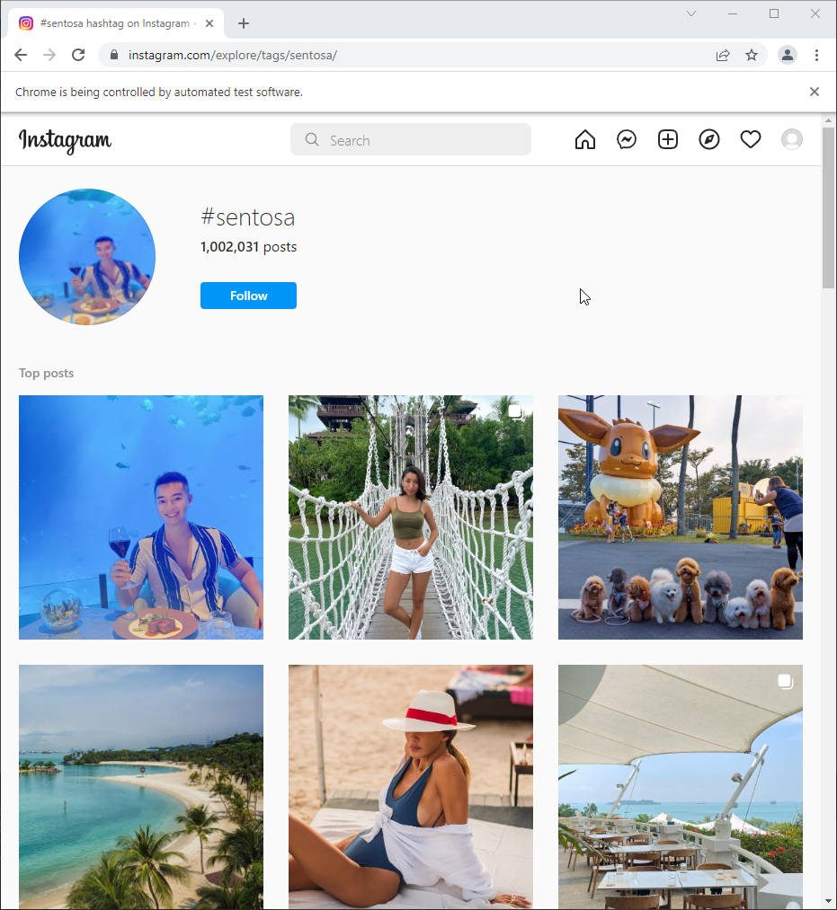

Figure 1 Instagram search

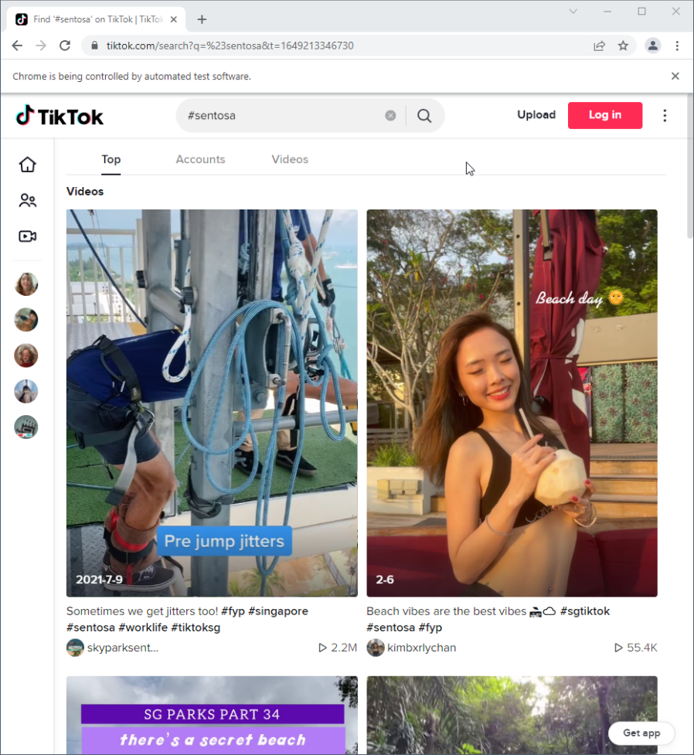

Figure 2 TikTok Search

With Instagram being photo centric and TikTok being video centric we are unable to use NLP AI models to derive insights for sentiment analysis from the platforms.

Searches on Meta can be filtered by dates and location. Though one of the problems is face is the low number of posts available from users. This is due to Meta having the feature to restrict posts to people they want to have access to view it.

People using Meta often want their posts to be only viewable either between their friends or families.

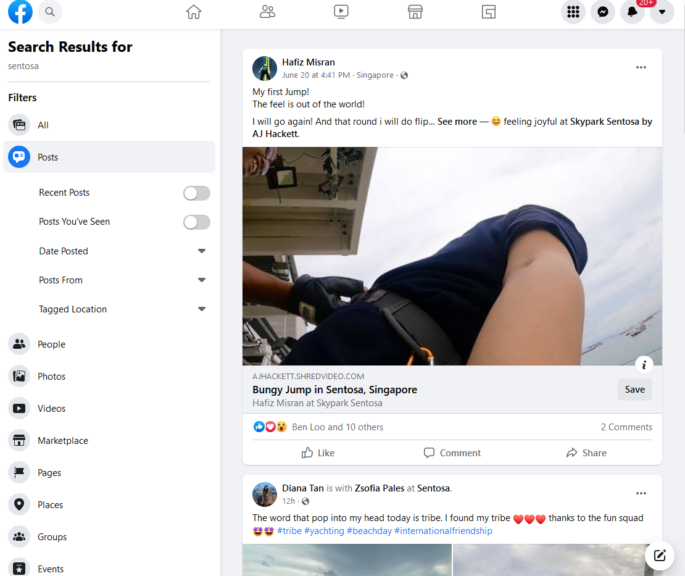

Figure 3 Facebook Search

For twitter, advance searches are available. You are able to filter the posts by date, location, language etc. Twitter provides and API to search their posts as well.

<https://developer.twitter.com/en/docs/twitter-api/v1/tweets/search/api-reference/get-search-tweets>

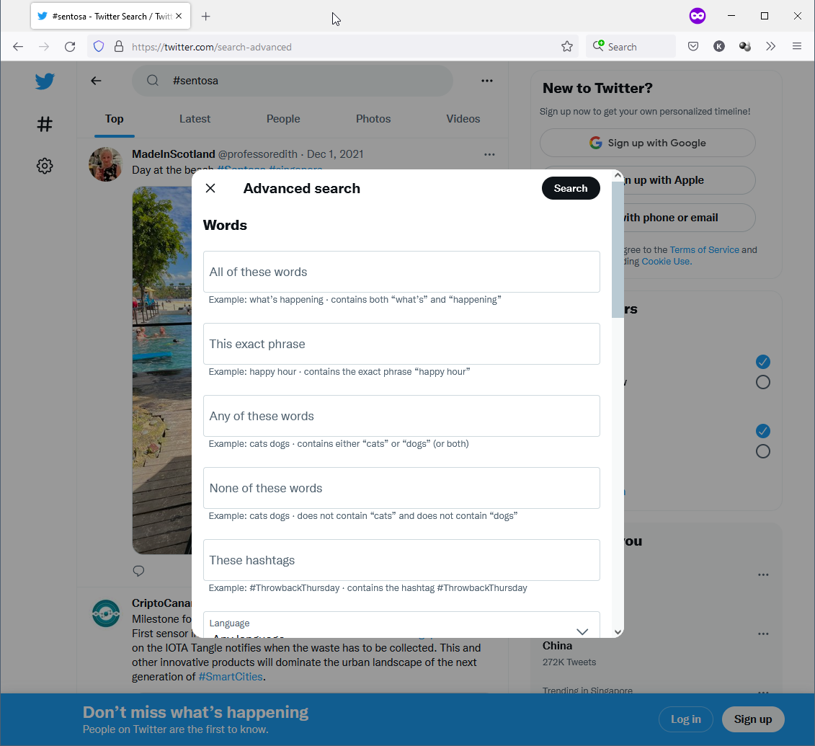

Figure 4 Twitter Search

With all consideration stated previously, this leaves twitter to be the most viable for extracting data from among all the social media platforms.

## **1.3 Data extraction from Twitter**

We start the process by first determining what are the search filters we will be using.

The terms we are using are as follow:

1. Specific year (E.g. 2019)
2. Language will be Bahasa Indonesia
3. Hashtag / Keywords (E.g. Sentosa, Siloso Beach)

I used the library SNScrape in python to scrap the data from twitter. Snscrape allows you to call the twitter API with Python.

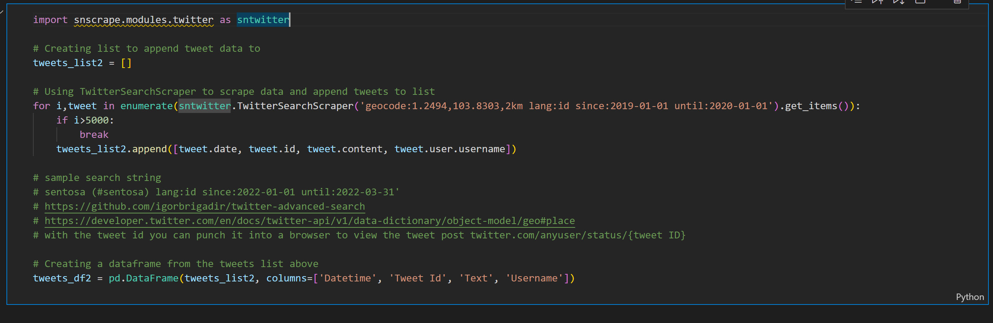

Which gives me the following dataframe.

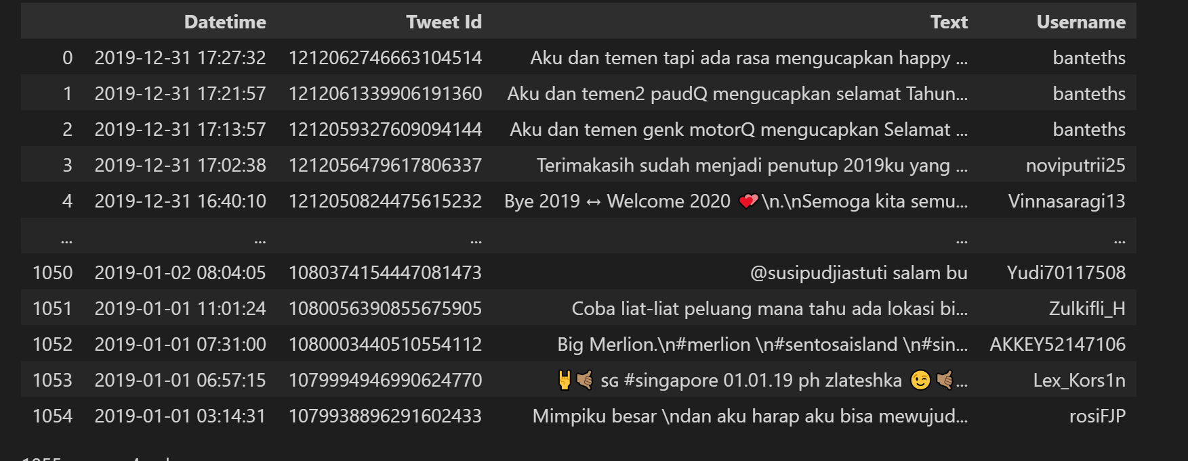

From here I process the data extracted from twitter by translating the emojis and emoticons to English words and back to Bahasa Indonesia.

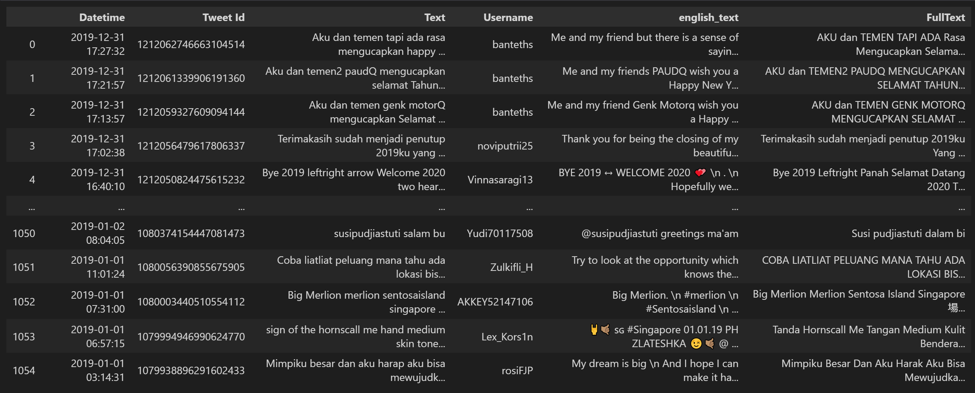

Word cloud is used to identify the words that are irrelevant to our filter and using those words we removed the tweets that contain those words.

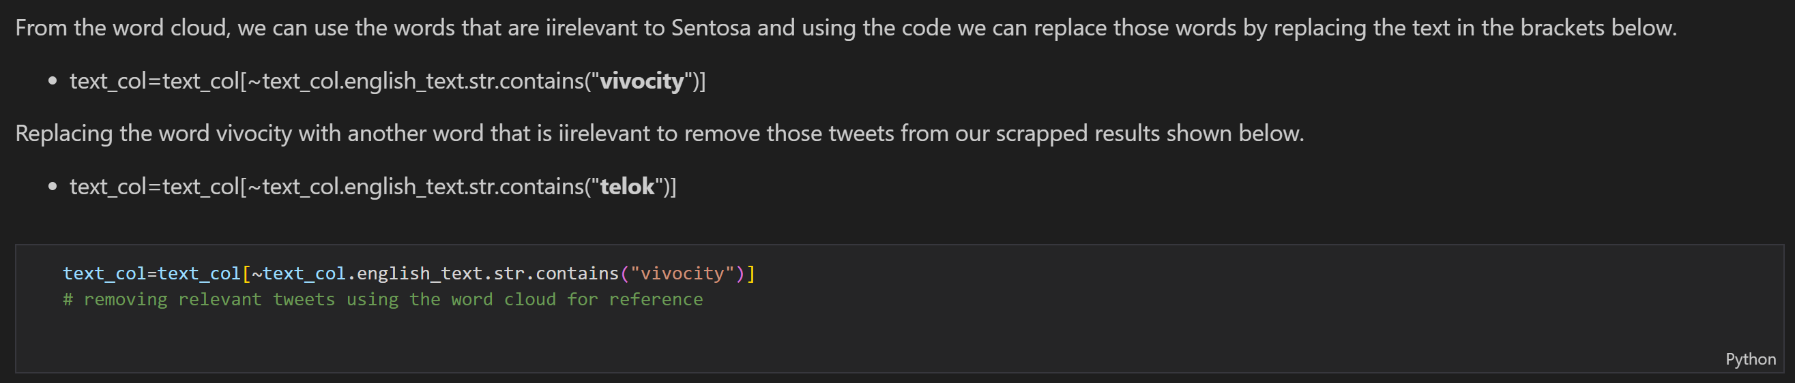

From here we start processing the text for Sentiment Analysis.

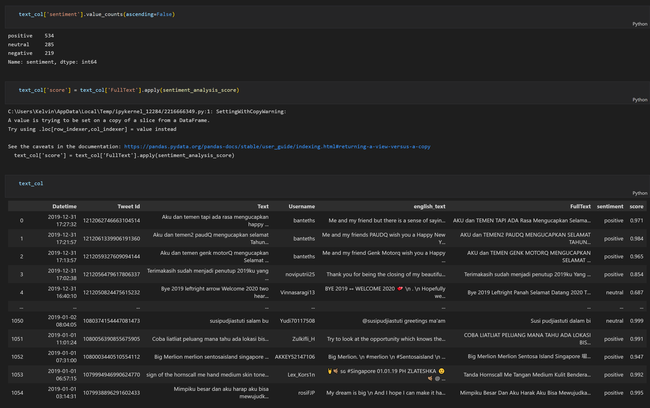

Regarding the pre-processing of the text and model used. Please refer to part 2 of this report which goes further into details of what model was used and the findings around it.

## **1.4 Issues encountered – Generic Keywords, Misspellings, and Internet Slang**

There were 3 main issues with capturing data from social media

First, using generic keywords lead to irrelevant posts. Using a word that is too difficult has opposite effect of nobody remembering the word. This leads to low amount of data available.

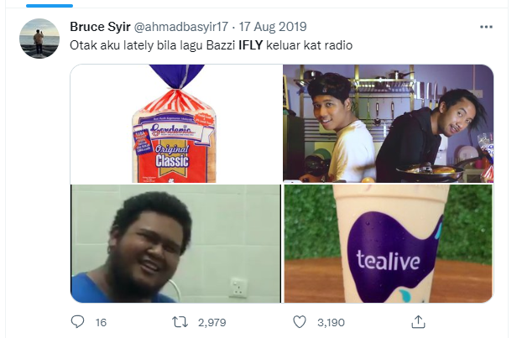

Figure 5 Irrelevant posts with generic search term

Second, misspellings are common on social media which leads to relevant posts being removed from the filtering.

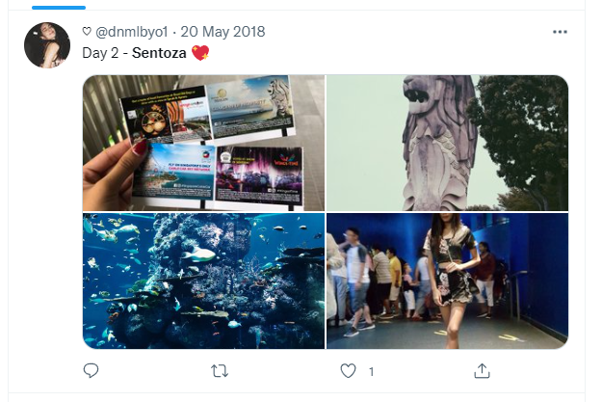

Figure 6 Misspellings

Lastly, Internet Slang might influence sentiment analysis in directions not expected. As example of this is “Netflix and Chill”. Thought the term contains Netflix and the word “chill” which tends to a positive context but the overall phrase online means something else entirely and skews the sentiment towards a positive sentiment even if the actual meaning is something else.

## **1.5 Conclusion**

One of the main strengths of social media comes from being near instantaneous feedback and the ability to determine the amount of engagement for a specific subject. This makes up on the shortcoming of not being able to derive deeper insights and analysis over just being positive or negative.

## **1.6 Recommendations**

A good marketing campaign with good hashtags / keyword will be able to derive better insights over searching for a general trend with generic keywords.

# 2. Review Sentiment Analysis – By Luqman Hakim Bin Abdullah / Kelvin Thor

**Abstract**

Social media and review websites can be a very salient source of useful information for an organization's target market. User-generated content provides a window into consumers' minds, giving us insights about their opinions and feelings. Due to the vast amounts of such messages, an analysis of population-wide developments becomes possible.

In this report, we analyze reviews collected reviews from TripAdvisor, Klook, Traveloka, and Google Reviews, collected between 2014 and 2022. The content extracted is specifically from the Indonesian population. This is implemented with a sentiment analysis model from the Google Cloud Platform Language API. We separate the review results by attraction and evaluate the positive, neutral, and negative keywords of each attraction. This allows us to gain insight into how further improvements can be made.

## **2.1 Background**

Travel websites have evolved to become a source of varied kinds of information. This is the nature of travel websites on which people post reviews about their experiences. Companies have started to poll these travel websites to get a sense of the general sentiment of their experiences or restaurants. Many times, these companies study user reviews and reply to users on these travel websites. Our challenge is to build a pipeline to detect and summarize sentiments about Sentosa’s attractions based on the Indonesian population.

In this report, we look into four popular travel websites, namely TripAdvisor, Klook, Traveloka, and Google Reviews, and build models for classifying these reviews into positive, neutral, and negative sentiment. We experiment with four different classification models, one RoBERTa based model, two BERT based models, and a sentiment model from the Google Cloud Platform Language API.

## **2.2 Methodology and Design**

**Proposed pipeline for sentiment analysis**

Sentiments are the words or sentences that represent a view or opinion that is held or expressed and can be positive, negative, or neutral. We will also consider features like emojis and emoticons, fixing of slang words, text summarization, stemming, removal of stop words, and capitalization as they have become a large part of the internet language.

The proposed Sentiment Analysis on review data is based on two important parts namely Data Extraction, pre-processing of extracted data and classification.

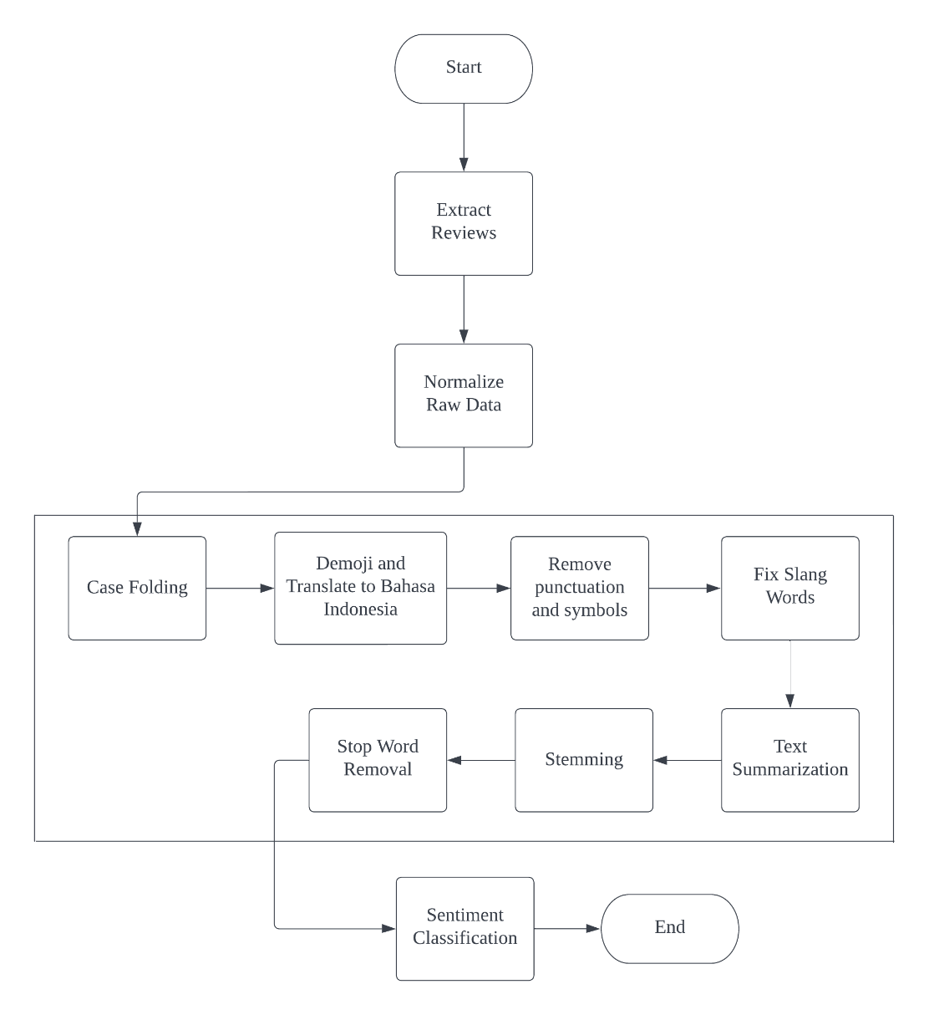

Figure 1: Sentiment Analysis Pipeline

To uncover the sentiments, we will first extract the reviews from four main travel websites and find out their orientation: positive, neutral, or negative.

**Extract reviews**

There are 4 main websites that we are extracting from namely TripAdvisor, Klook, Traveloka and Google Reviews. We will only be extracting reviews written by the Indonesian population. We collected over 4000 native reviews across these 4 websites. Different websites have their own challenges, and we will be discussing how we overcome them with various tools.

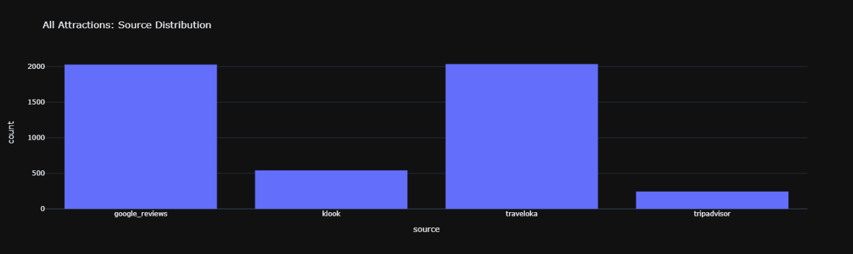

Figure 2: Review count across websites

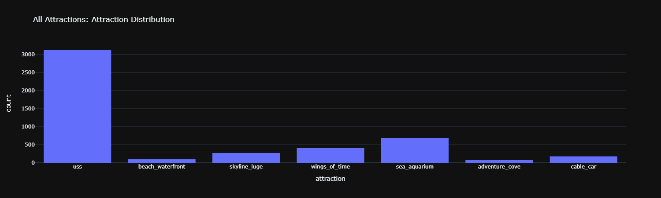

Figure 3: Review count across attractions

**TripAdvisor**

TripAdvisor was the easiest to web scrape because it had no anti-botting or anti-scraping procedures. Selenium was the primary library used. The elements retrieved were reviewer usernames, review dates, and reviews. Filtering just native reviews was one of the obstacles. The Indonesian reviews were identified by the term 'Google Terjemahan' beneath each review container, indicating that the review was written in Bahasa Indonesia. By selecting 'Google Terjemahan,' the native review is translated into English. Each element was located using relative XPATH for simpler modification when the website's HTML structure changed. The script can paginate until it can no longer detect the native review.

To utilize the script, a separate CSV file includes two columns, each of which contains the name of the attraction and the TripAdvisor link to it. The script iterates through the CSV file of attractions and links and stores the data into its respective attraction excel file.

One of the main challenges was that TripAdvisor had two variations of the website. It had a completely different HTML structure and would require a second script. The second script was developed but had its issues.

**Klook**

Klook was a challenging website to extract reviews from as they used JavaScript pagination and they also had anti-botting measures. This resulted in Selenium not being compatible and we used requests and BeautifulSoup4 as the Python libraries.

We extracted the link from the network tab of the browser's Developer Tools.

An example of a link:

klook.com/v1/usrcsrv/activities/**132**/reviews?**page=1**&limit=8&star_num=&**lang=id_ID**&sort_type=1&only_image=false

Going to the link on the browser will result in details of the reviews in JSON format. Each attraction has its own ID, which is **132** in the example link, and it displays the page number. The ID is used to iterate a list of attraction ids. The pagination is also looped by changing the number in "page=1". The JSON formatted data is extracted using the requests library. The contents taken are the author of the reviews, the date of review, and the review itself. Each attraction's reviews are exported to its own excel file.

They have placed safeguards to prevent bots from scraping their site. With the help of SDC's Fu Zixiang's recommendations, we attempted many strategies to prevent it. We experimented with each strategy separately and in combination.

*Rotating random user agent*

We first attempted to set random user agents on each pagination loop from a list of over 7000 different user agents based on Chrome version 100. This produces comparable outcomes.

*IP Rotation/ Proxy*

We scraped a list of free proxies from "https://free-proxy-list.net" and filtered it down to only elite proxies and 'https' because they provide the most anonymity. It did not work because the proxies were free and hence unstable, and we were eventually blocked.

*Setting A Referrer*

Next, we set the request referrer to "https://www.google.com" to make it appear as if we came via a Google search. It did not improve the outcome.

*Scrape Data from the Google Cache*

This method simply did not produce any results, as Klook uses JavaScript to store and display their data. Using this method only shows the very first review of each attraction.

*Scrapping at random intervals*

In each repetition of pagination and attraction links, random intervals were used. Pagination was set between 60 and 120 seconds, and attraction iteration was set between 300 and 420 seconds. The whole playtime was 138 minutes and 17.6 seconds, including 14 separate attractions. When the console ceased printing results and the CSV file was blank on the third iteration, we can assume we were blocked once again.

In conclusion, an external software called DataMiner was used for web scrapping Klook as it had built in measures to bypass anti-botting attempts by the websites.

**Traveloka & Google Reviews**

Traveloka was another website that we attempted to scrape data from. It uses an API to store data, including reviews. Google Reviews was the last website and one of the challenges was its infinite scrolling reviews for pagination. A program called webscraper.io was used to scrape from Traveloka and DataMiner software was used to scrape from Google Reviews/

**Normalizing raw data**

For consistency, date and rating normalization on raw data is essential prior to preprocessing for sentiment analysis. There are also duplicated rows that must be removed. Firstly, we removed the duplicated rows using Pandas DataFrame. Dates and ratings are presented in a variety of formats. Normalization is necessary for sentiment analysis. They're used to compare sentiment and ratings from a sentiment model. In addition, we can sort them by year.

Except for Google reviews, all websites use the correct datetime format. The date in Google reviews is formatted as a string, such as '10 bulan lalu,"seminggu lalu,' and so on. It means "ten months ago" and "a week ago." To fix this, we utilized the dateutil module to subtract the relevant week, month, or year from the current date.

To eliminate decimals, we had to standardize the scores to 10 because it was the greatest whole number utilized (Traveloka). To begin, we constructed a basic dictionary to replace the words 'Baik' with 8 and 'Sangat Direkomendasikan' with 10. The rows for TripAdvisor and Google Reviews were then selected using a mask in Pandas DataFrame. The index 0 was chosen from the ratings (5,0 out of 5) and multiplied by two. The index number 14 was then chosen from the Google Reviews ratings (Diberi rating 5,0 dari 5) and multiplied by 2.

**Preprocessing**

There were various factors to consider when deciding on the preprocessing steps. To begin, users usually employ slang, short words, or a combination of languages. Data cleaning procedures included case folding, demoji and translate, removing characters and punctuation, fixing slang, text summarizing, stemming and removal of stop words.

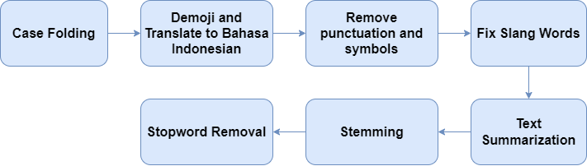

Figure 4: Preprocessing steps

***Case folding***

Lowercasing the reviews is important to maintain consistency for other preprocessing steps, such as fixing the slang words.

***Demoji and translate it to Bahasa Indonesian***

Emojis and emoticons can contain valuable information in reviews. As sentiment models are not able to read emojis and emoticons, we decided to convert them to text and translate them into the Indonesian language. The ‘emot’ Python library is used to pull all the emojis and emoticons with their respective English aliases and put them in a dictionary of emojis and emoticons as keys and its alias as value. The aliases contain symbols such as ":" and "_" that will be removed. To ensure we capture all the emojis, the SpaCy library is used to tokenize the review, as using Python’s default ".split()" does not split properly when 2 emojis are beside each other. The emojis are then replaced by their respective aliases and translated using Google’s translator library.

***Remove punctuation and symbols***

The remaining punctuation and symbols are then removed to remove noise when doing sentiment classification. They are removed using regular expression by only keeping characters which are alphabetical.

***Fix slang words***

Users typically type in many different styles on the Internet. They often use slang words, and sentiment models are unable to discern them in text. We replaced the slang words by using a dictionary found on a GitHub repository called "louisowen6/NLP_bahasa_resources". It has a key value pair of slang words and its proper word form.

***Text summarization***

Sentiment models usually have a max tensor size of 512. Tensors are the total amount when the text is tokenized. Some of the reviews extracted exceed the requirement by a large margin and are unable to be classified by the sentiment model. As the lowest number of characters in the Indonesian/Malay language is 3, we used 3 x 512 = 1536 characters maximum in a review to be summarized.

We looked into SDC’s preferred platforms such as Microsoft Azure and Google Cloud Platform, but they do not support the Indonesian language for text summarization. Support for Indonesian is limited to HuggingFace. We used a pre-trained model "cahya/t5-base-indonesian-summarization-cased" for our text summarization. A DataFrame mask is used to only select reviews with a length greater than 1536 and using pandas ".apply()" to run the summarization model.

***Stop word removal***

Stop words are pronouns (he/she, it), articles (a, an, the), and prepositions (above, in, near, under, besides). These words are nothing but offer little to no information about the emotions in the reviews. The default English stop words from SpaCy’s "en_core_web_lg" object. Additional stop words are also added from "countwordsfree.com/stopwords" and from a GitHub repository "louisowen6/NLP_bahasa_resources".

## **2.3 Findings**

**Comparing sentiment models**

Before sentiment classification, a validation of different models must be done to ensure the best results. We will be validating 4 different sentiment models, 3 from HuggingFace and 1 from the Google Cloud Platform Language API. 50 reviews were randomly selected using Pandas's sample function, then manually labelled using Excel and imported back into Python to preprocess and run with the 4 models. The models are evaluated using scikit-learn’s confusion matrix and classification report.

The metrics to look for are high accuracy overall and high recall for negative sentiment. It is OK if a positive review is classified as negative or neutral, but a negative review should not be labelled as positive. We can always gain insights for improvement in negative and neutral reviews.

***sahri/indonesiasentiment (HuggingFace)***

This model is a pre-trained RoBERTa based model that was fine-tuned on the Indonlu dataset. It has an above average accuracy of 67% and high precision and recall for negatives, but its neutral precision and recall scores are very low.

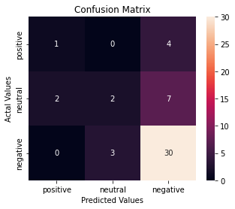

Figure 5: ‘sahri/indonesiasentiment’ confusion matrix

|  |  |  |  |
| --- | --- | --- | --- |
| Sentiment | Precision | Recall | F1-score |
| Positive | 33% | 20% | 25% |
| Neutral | 40% | 18% | 25% |
| Negative | 73% | 91% | 81% |
|  |  |  |  |
| Accuracy |  |  | 67% |

Figure 6: ‘sahri/indonesiasentiment’ classification report

***ayameRushia/bert-base-indonesian-1.5G-sentiment-analysis-smsa (HuggingFace)***

This model is a pre-trained BERT based model that was fine-tuned on indonlu dataset. It has a very low accuracy of 55% and low negative and neutral recall.

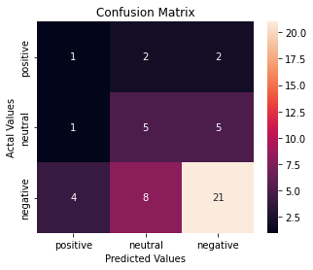

Figure 7: ‘ayameRushia/bert-base-indonesian-1.5G-sentiment-analysis-smsa’ confusion matrix

|  |  |  |  |
| --- | --- | --- | --- |
| Sentiment | Precision | Recall | F1-score |
| Positive | 17% | 20% | 18% |
| Neutral | 33% | 45% | 38% |
| Negative | 75% | 64% | 69% |
|  |  |  |  |
| Accuracy |  |  | 55% |

Figure 8: ‘ayameRushia/bert-base-indonesian-1.5G-sentiment-analysis-smsa’ classification report

***Tyqiangz/indobert-lite-large-p2-smsa (HuggingFace)***

This model is an Indonesian version of the pre-trained BERT based model that was fine-tuned on the Indonlu dataset. It has an accuracy of 63% and an above average negative precision of 73% and a negative recall of 82%.

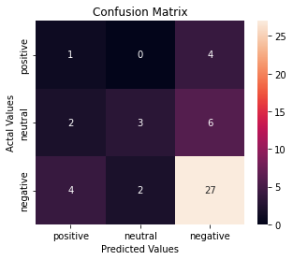

Figure 9: ‘tyqiangz/indobert-lite-large-p2-smsa’ confusion matrix

|  |  |  |  |
| --- | --- | --- | --- |
| Sentiment | Precision | Recall | F1-score |
| Positive | 14% | 20% | 17% |
| Neutral | 60% | 27% | 37% |
| Negative | 73% | 82% | 77% |
|  |  |  |  |
| Accuracy |  |  | 63% |

Figure 9 & 10: ‘tyqiangz/indobert-lite-large-p2-smsa’ classification report

***The Google Cloud Platform Language API***

Google’s sentiment model returns a score from 1 to -1 instead of labels. To classify the sentiment, we used 3 ranges for positive, neutral, and negative.

|  |  |
| --- | --- |
| Sentiment | Score (x) |
| Positive | x >= 0.5 |
| Neutral | 0 >= x <=0.49 |
| Negative | x < 0.0 |

Figure 11: ‘GCP’ sentiment range

Google’s sentiment model performed the best for our use case. It scored the highest accuracy of 76% when comparing the models. It also scored a perfect 100% precision on neutral. The negative precision is 74% and negative recall of 97%. It manages to classify most of the true negative reviews.

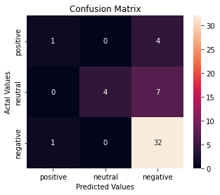

Figure 12: ‘GCP Language API’ confusion matrix

|  |  |  |  |
| --- | --- | --- | --- |
| Sentiment | Precision | Recall | F1-score |
| Positive | 50% | 20% | 29% |
| Neutral | 100% | 36% | 53% |
| Negative | 74% | 97% | 84% |
|  |  |  |  |
| Accuracy |  |  | 76% |

Figure 13: ‘GCP Language API’ classification report

We will be using the Google Cloud Platform Language API as it has the best overall accuracy of 76%, a high neutral precision score of 100% and a high negative recall of 97%.

## **2.4 Evaluation and Analysis**

To explore the data further, the review length and word count is added. Plotly is mainly used as the visualization Python library as it is interactive on the Jupyter notebook.

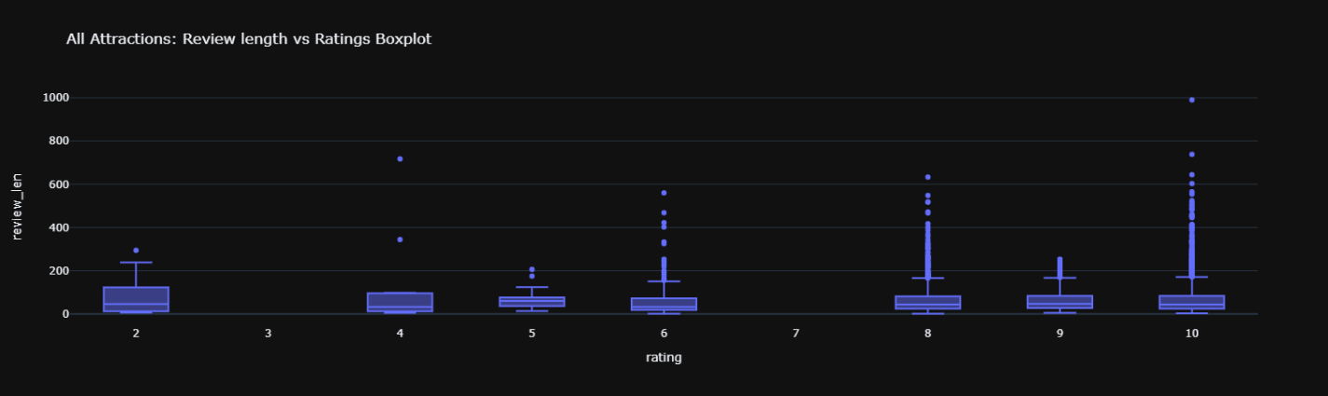

Figure 14: Review length for ratings

The boxplot shows that the median review length across the ratings is consistent throughout.

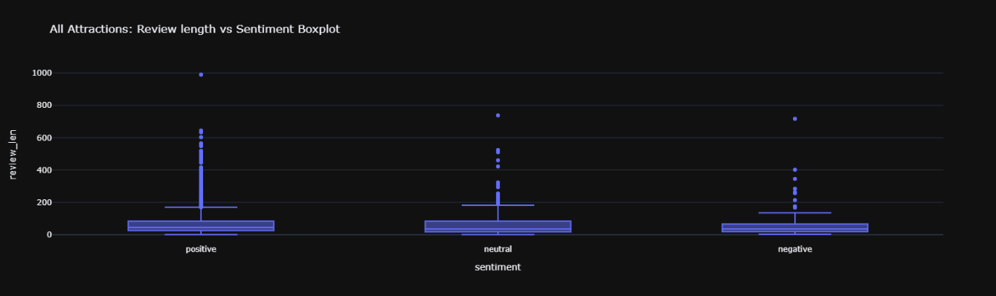

Figure 15: Review length for sentiment

The boxplot shows that the median review length across the sentiment is also consistent.

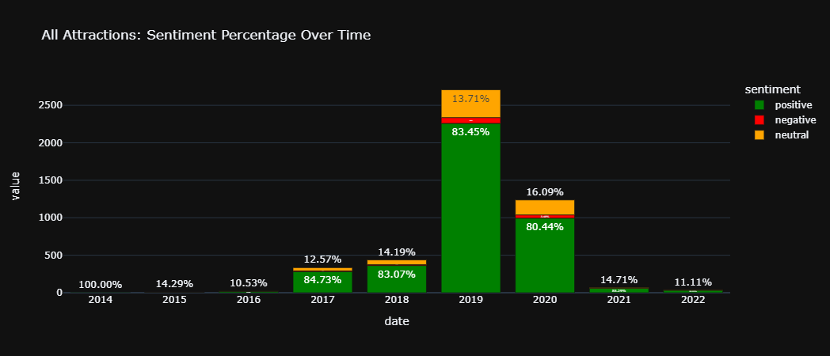

Figure 16: Sentiment share of all attractions over time

The figure shows the overall sentiment share of all attractions over the years. The graph may not be the actual outcome as the review count distributions are uneven.

This report will be focusing on the attractions with the top 3 most review count. The attractions are Universal Studios Singapore, S.E.A Aquarium, and Wings of Time. A dashboard will be shown as an overview of each attraction based on its sentiment. The dashboard shows the top 15 words in positive, neutral, and negative, a word cloud, the ratings vs sentiment, and sentiment share of the attraction. These figures give an overview of the overall attraction sentiment. The sentiment share over time is also shown by looking at how the attractions performed over the years.

***Universal Studios Singapore***

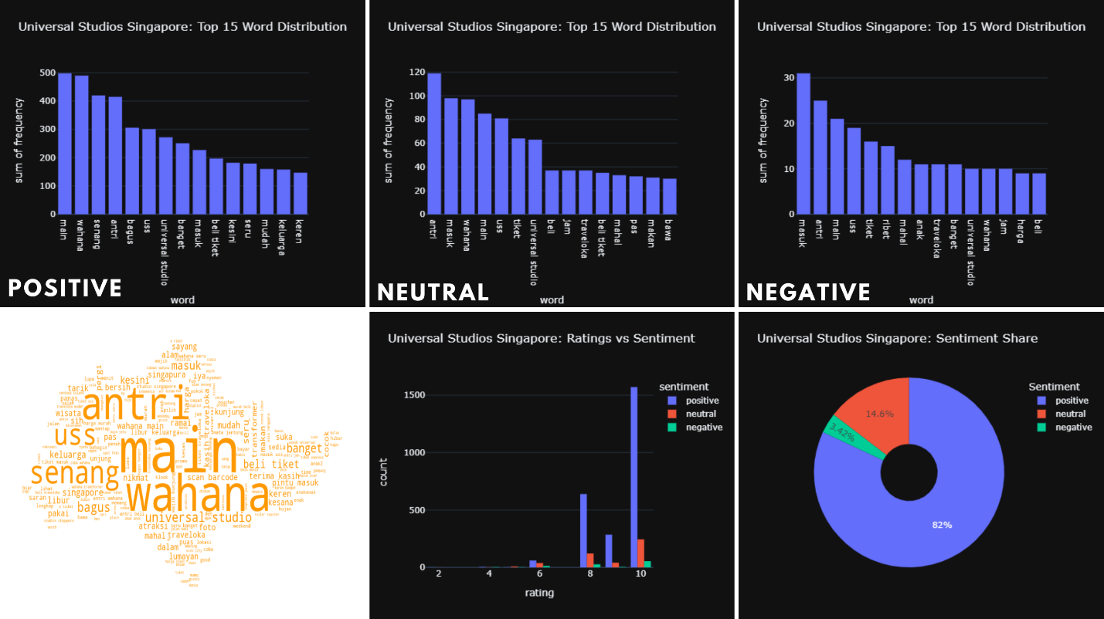

Figure 16: Universal Studios Singapore dashboard

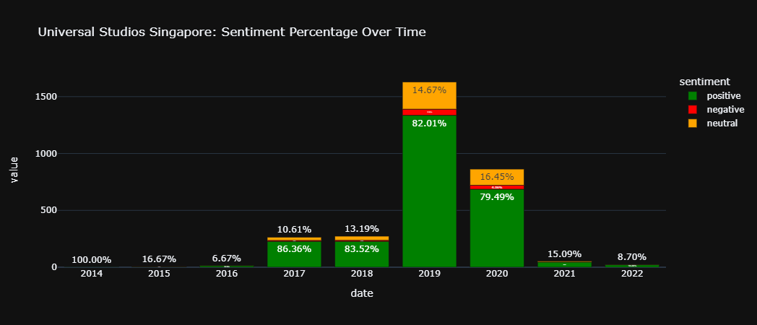

Figure 17: Universal Studios Singapore sentiment over time

***S.E.A Aquarium***

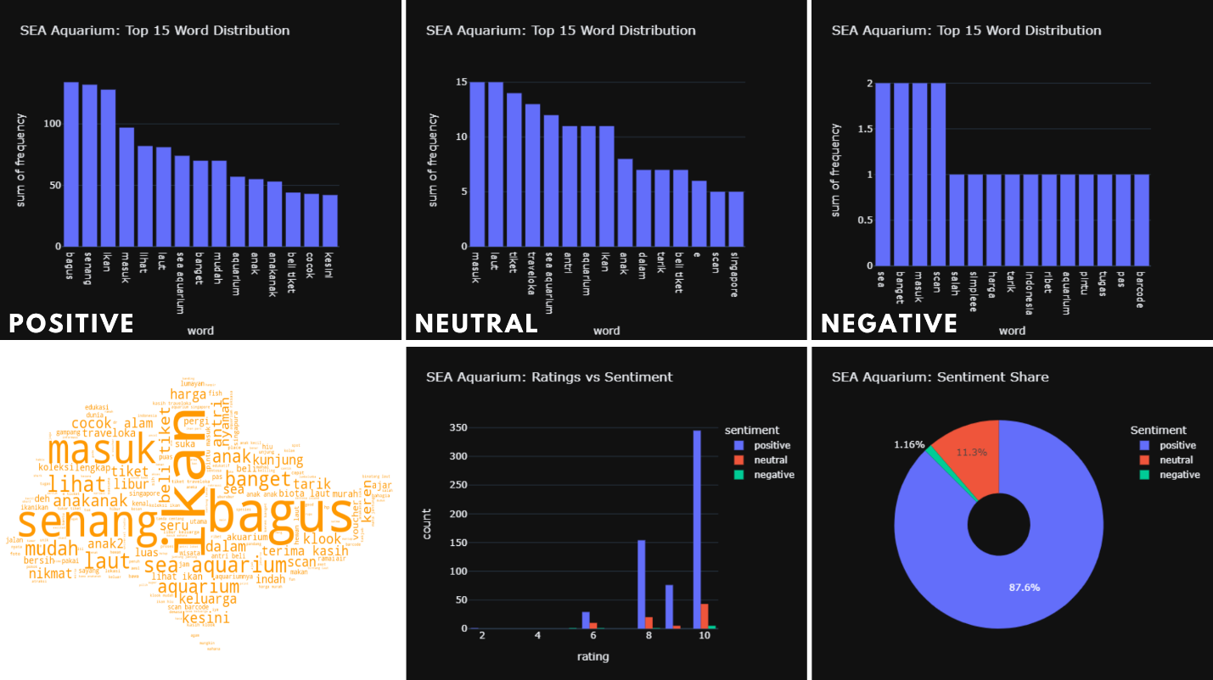

Figure 18: S.E.A Aquarium dashboard

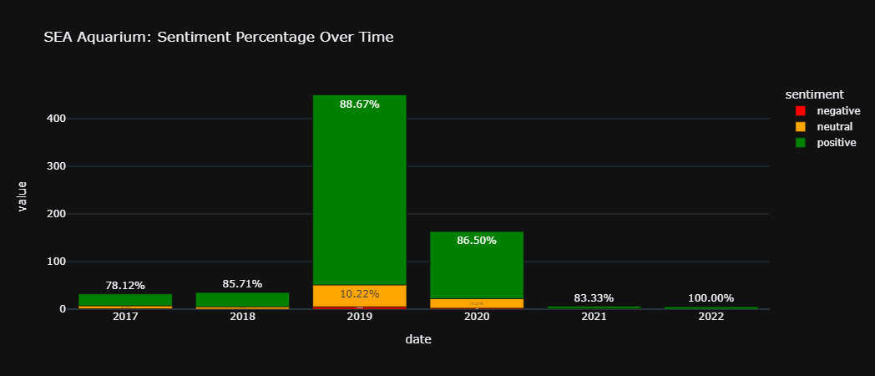

Figure 19: S.E.A Aquarium sentiment over time

***Wings of Time***

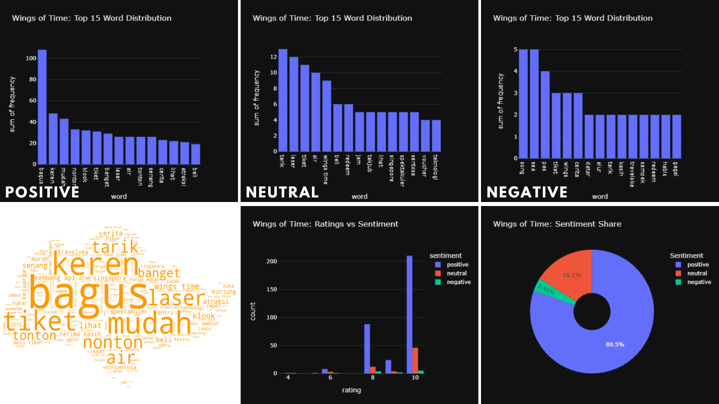

Figure 20: Wings of Time dashboard

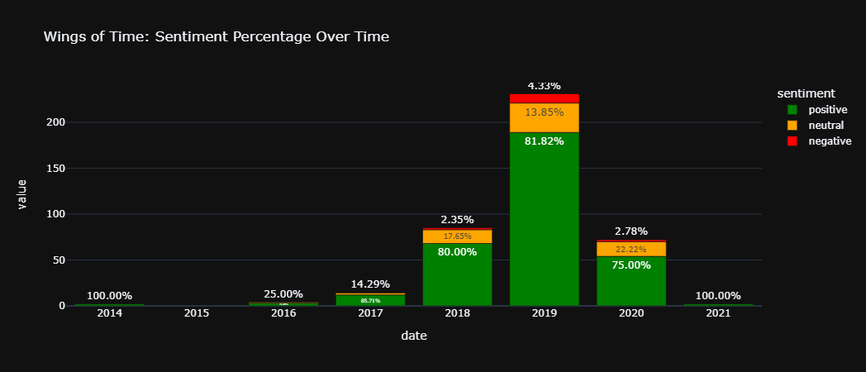

Figure 21: Wings of Time sentiment over time

## **2.5 Conclusion**

As travel websites become increasingly popular for people to check reviews before visiting a place or restaurant, those reviews can also be important for companies to understand their customers' opinions. The evidence is clear: a pre-trained sentiment model has its limitations, and a custom machine learning model can be trained with self-labeled data. Although this approach would take a longer time, it would represent a significant step towards more reliable and accurate sentiment analysis.

The use of unigrams in the above analysis has drawbacks because we would only be guessing the insights from single words. In Chapter 4, we improved the analysis by employing bi-grams and trigrams to gain more accurate insights from positive and negative evaluations.

## **2.6 Recommendations**

*Sentiment Analysis*

Pre-trained sentiment models can be useful depending on the use case. Moving forward, a better validation method can be applied by comparing 50 self-labeled rows of positive, neutral, and negative sentiment each.

As pre-trained sentiment models do not support hyperparameter tuning, the best approach would be to utilize Azure AutoML to train our own data by self-labelling the sentiment.

Here are the next actionable steps:

1. Extract 1000 random reviews from the extracted data
2. Label sentiment for reviews
3. Run Azure AutoML on labelled data
4. Select the best Azure AutoML model based on desired metrics
5. Deploy model

*Visualisations*

A dashboard for the sentiment analysis could be deployed to the web using Plotly and Dash. This enables us to have an interactive dashboard which allows us to toggle between attractions and date. A deployment solution would be to deploy the dash through GitHub and Heroku. (Ref: https://dash.plotly.com/deployment)

# 3. Hotels and Dining Travel Reviews – By Gina Ng

## **3.1. Basic Market Background Research**

SDC’s current textual analysis capabilities is for local market share in Singapore limited to English. India, Malaysia, China[1], and Indonesia[2] are among the top countries where recent visitors originate from.

This joint project collaboration focused on Bahasa Indonesia for fifteen (15) weeks of industrial engagement due to four (4) key considerations:

1. Singapore Tourism Board (STB) [3] 2019 registered 3.11m Indonesian visitors[4] compared to China 3.63m and India 1.42m (Figure 1)

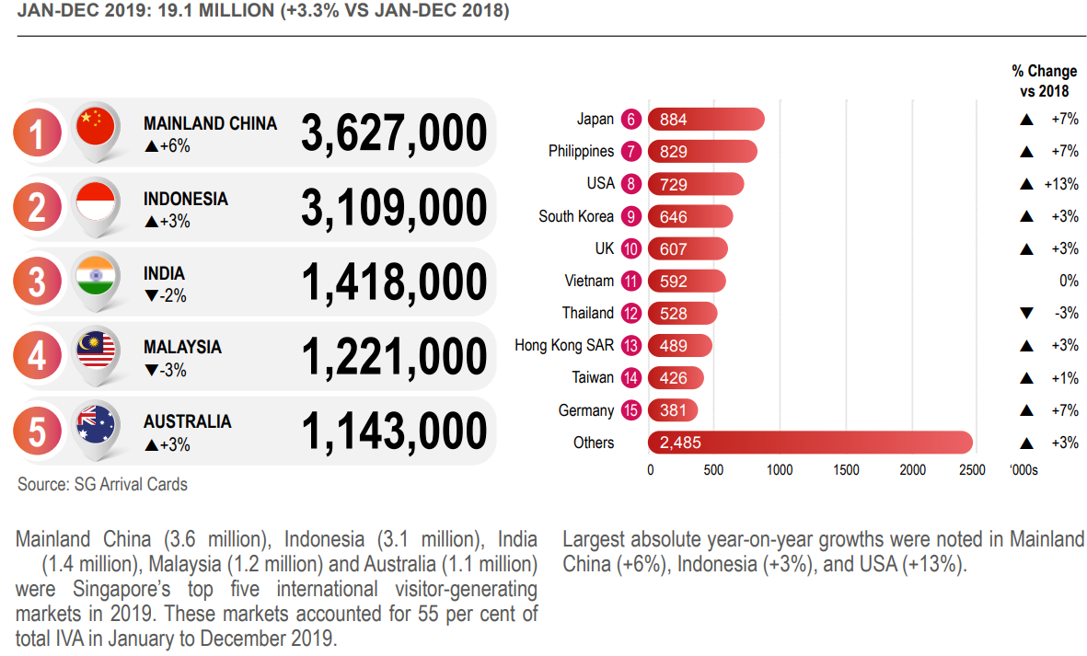

Figure

1. Accessibility to China’s tourists dataset is largely restricted[5] by its ‘Great Firewall’
2. Indonesia has the lowest[6] proficiency (Figure 2) and the least users in English language as of 2021[7] & significantly much higher usage in their native language

|  |  |  |  |
| --- | --- | --- | --- |
| **2021 Rank** | **Country** | **2021 Score** | **2021 Proficiency Band** |
| 4 | Singapore | 635 | Very High Proficiency |
| 28 | Malaysia[8] | 562 | High Proficiency |
| 48 | India[9] | 515 | Moderate Proficiency |
| 49 | Mainland China[10] | 513 | Moderate Proficiency |
| **80** | Indonesia[11] | 466 | **Low Proficiency** |

Figure

* (Figure 3) Only 29.4% of Indonesia population knows English (‘*inggris’*)[12]
* 97% uses Bahasa Indonesian daily[13]

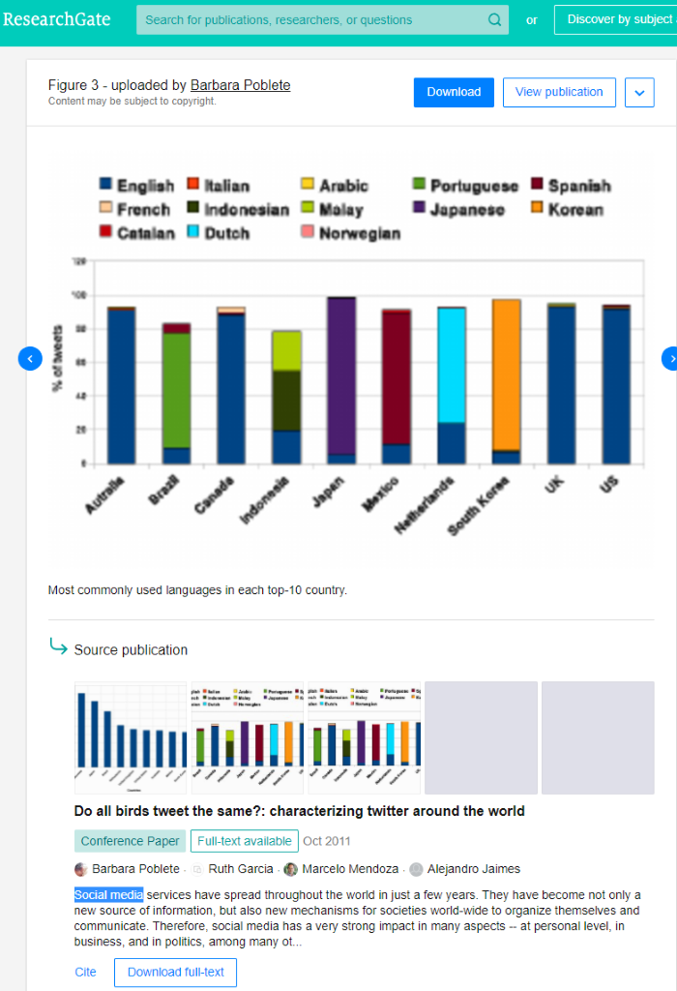

**\***

Figure

1. Indonesia consistently ranks within the top 5 countries for the common 5 most popular social media[14] platforms globally (Figure 4)

|  |  |
| --- | --- |
| Tiktok (22.2 mil) | #4 In Indonesia (#2 globally) |
| YouTube (139 mil) | #2 in Indonesia (#3 globally)[15] |
| [Facebook](https://www.facebook.com/sentosaofficial) (176.5 mil)[16] | #1 in Indonesia (#3 globally)[17] |
| Instagram (99.15 mil) | #3 in Indonesia (#4 globally) |
| Twitter (18.45 mil) | #5 In Indonesia (#5 globally) |

Figure

* 191.4 million social media users in Indonesia in January 2022[18]
* equivalent to 68.9% of the total population (277.7 million / 4th largest country)[19]
* increased by 21 million (+12.6%) between 2021 and 2022

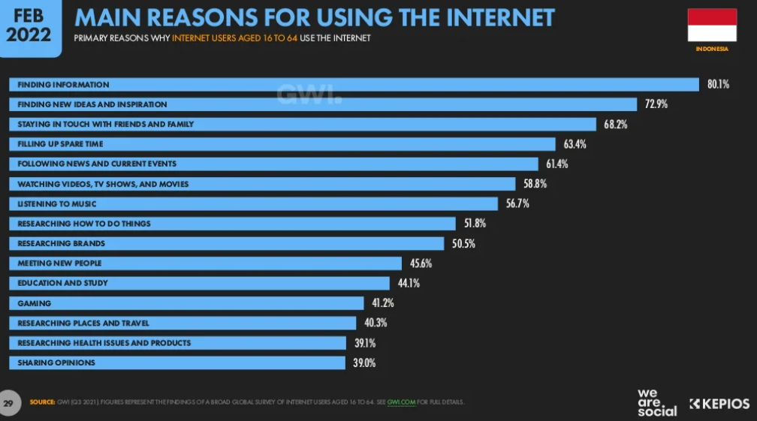

Figure

## **3.2. Data Collection**

Majority of the social media content were audio-visuals which could be explored for next possible data analysis in future development that utilises ‘Computer Vision’ in Artificial Intelligence (A.I.). Facebook and Instagram are also excluded due to restrictive users’ privacy enforced; thus, only Twitter remains as one of the data source.[20]

Top Indonesian influencers[21] only generate minimally limited Singapore content and not about Sentosa.

Travel reviews form the other appropriate channel for relevant data collection, which **Traveloka** was the top local website[22] for Indonesia:

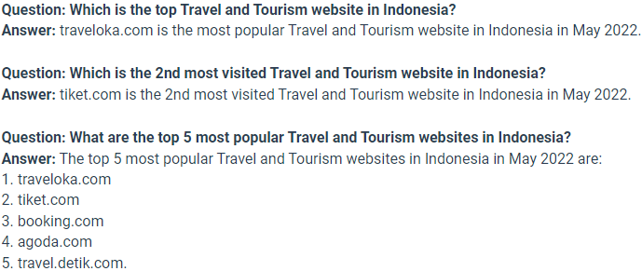

Figure

Proposed duration in **two** (**2**) distinct segments:

1. 2018 – 2019 for twenty-four (24) months of normal tourism data prior to Covid restriction (12-months X 2 years)
2. 2020 – current (2022 May) for twenty-nine (29) months of inactive travel globally

(Figure 7) DataMiner (<https://dataminer.io/>) is used for the data collection of Google reviews to promptly overcome the challenge[23] of being blocked upon bot-detection.

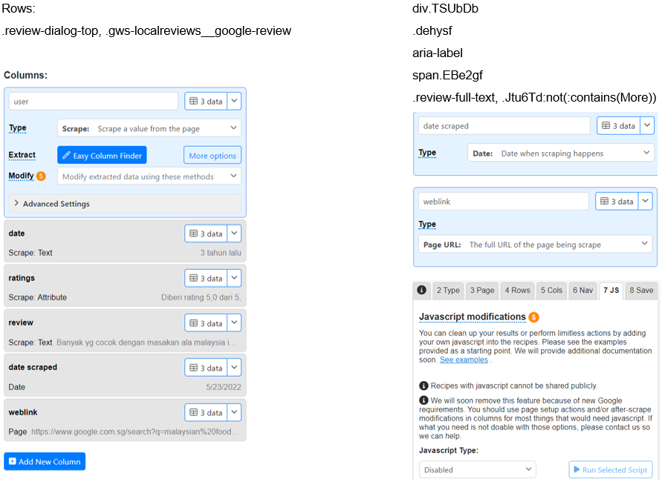

Figure

(Figure 8) WebScraper (<https://webscraper.io/>) was used for Indonesia travel reviews data collection from Traveloka[24], Tiket (Figure 6), TripAdvisor[25] and Klook[26].

[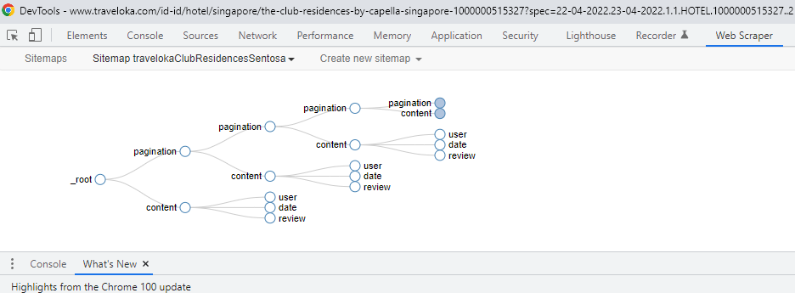](https://webscraper.io/)

Figure

(Figure 9) Accommodations reviews (**27%**) are more than double in quantity than dining, despite almost half of the listings (approximately 48%) online travel websites are for F&B[27]

**58%** of the travel reviews are for ‘Attractions’ but barely **13%** for ‘Dining’.

[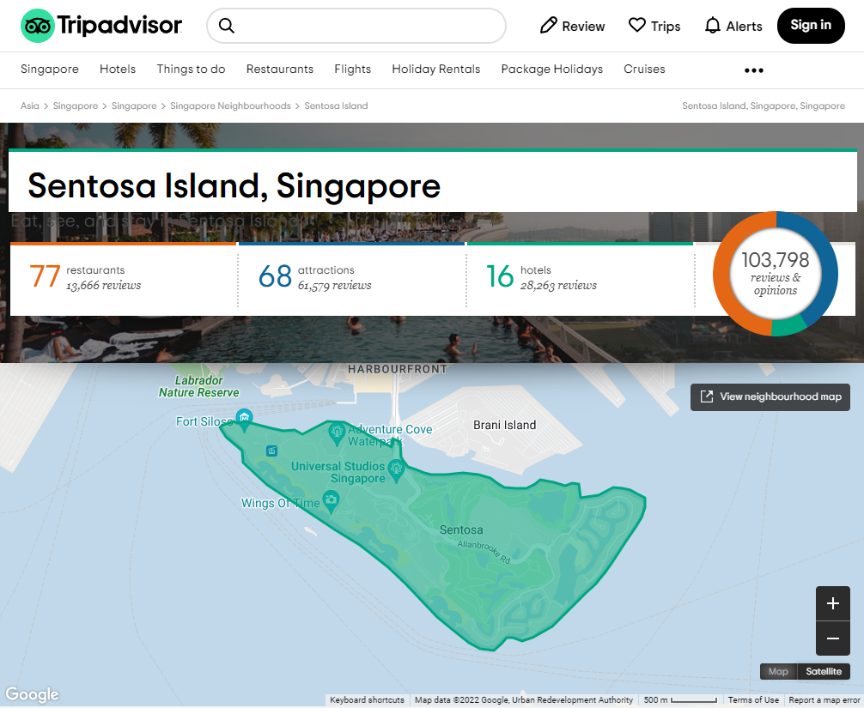](https://www.tripadvisor.com/Neighborhood-g294265-n15622665-Sentosa_Island-Singapore.html)

Visitors are more likely to write reviews for **accommodations** than dining (more than double)

**59%**

Almost 48% (nearly half) of the listings are **F&B** but 13% reviews

Figure

(Figure 10) Only 25% of the Indonesia reviews falls into the twenty-nine (29) months from 2020 till May 2022 due to inactive tourism affected by Covid-19 restriction[28] where Singapore imposed strict mandates around mid-April 2020.

(Figure 11) Over **41%** of this Indonesia reviews is dated from the year **2019** while 2018 is about 34%.

Traveloka has the best data yield, but Sentosa Dining is not listed on this platform.

|  |  |  |  |  |  |  |  |  |  |  |
| --- | --- | --- | --- | --- | --- | --- | --- | --- | --- | --- |
| Travel Review | Hotel (**222**) | | | | | Dining (**98**) | | | | |
| **Traveloka**[29] | **117** | | | | | N.A. | | | | |
| 68 (2018) | 43 (2019) | 6 (2020) |  |  |
| Google | **92** | | | | | **86** | | | | |
| 14 (2018) | 36 (2019) | 29 (2020) | 7 (2021) | 6 (2022) | 20 (2018) | 37 (2019) | 25 (2020) | 3 (2021) | 1 (2022) |
| TripAdvisor | **4** | | | | | **12** | | | | |
| 1 (2018) | 3 (2019) |  |  |  | 5 (2018) | 6 (2019) | 1 (2020) |  |  |
| Klook | **0** | | | | | 0 | | | | |
| Tiket[30] | **9** (out of 16 / *7 Inggris reviews*) | | | | | N.A. | | | | |
| 1 (2018) | 7 (2019) | 1 (2020) |  |  |

Figure

*Jan-May*

*only 5 months*

**26.8%**

**28.8%**

**36.5%**

Figure

**(**Figure 11) **Google** reviews continue to provide data during the lull tourism years.

|  |  |  |  |  |  |  |
| --- | --- | --- | --- | --- | --- | --- |
|  | Attractions | Indo 2018-2022 | Dining | Indo 2018-2022 | Hotel | Indo 2018-2022 |
| Traveloka | 13.7% | 2,042 | - | - | 3,302 | 3.5% |
| Google |  | 2,049 | 29,645 | 0.3% | 23,721 | 0.4% |
| TripAdvisor | 0.4% | 244 | 13,666 | 0.0878% | 28,263 | 0.0142% |
| Klook | 0.3% | 543 | 14,366 | 0.0% | 8,927 | 0.0% |
| Tiket | 94 | - | - | - | 22 | 40.9% |

Figure

**(**Figure 13**)** <https://www.tiket.com/> users are not actively writing reviews though majority of this platform data fulfil our group project’s requirements for native local language in Bahasa Indonesia. Attractions data were not collected from this source due to smaller quantity compared to what has already been collected from the larger platforms online Traveloka and Google as dictated by Team I/C.

(Figure 13) Only 0.2% **TripAdvisor** reviews were originally in Bahasa Indonesia (Figure 14)

[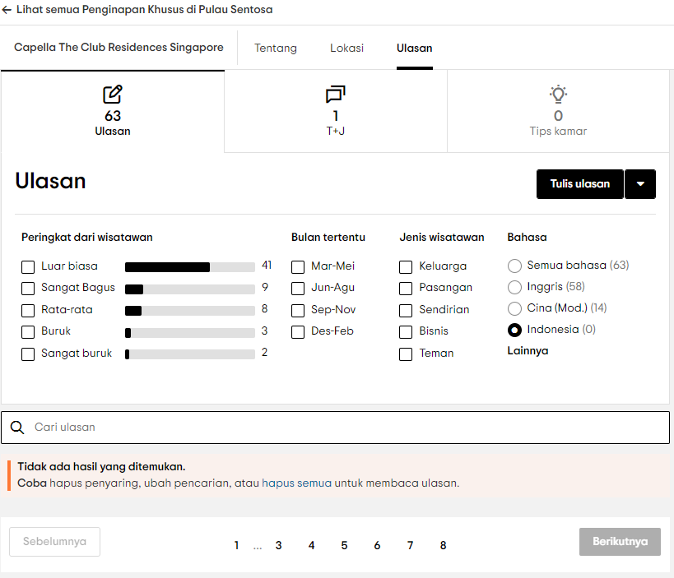](https://www.tripadvisor.co.id/Hotel_Review-g294264-d8427678-Reviews-or50-Capella_The_Club_Residences_Singapore-Sentosa_Island.html)[31]

Figure

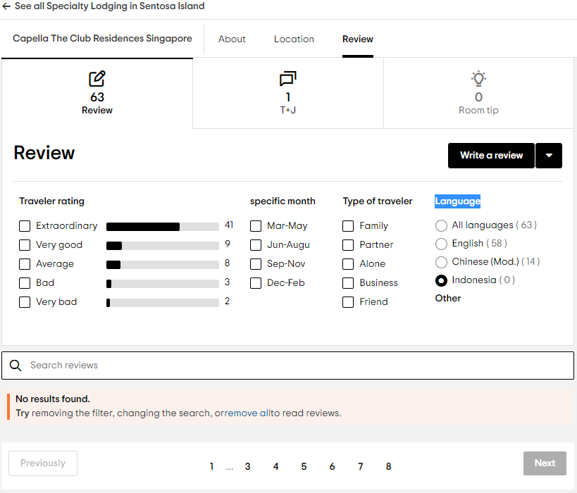

Figure

Translation from the native language in Bahasa Indonesia to English is only done at the end strictly just to understand the output. All textual analysis is processed in its original form with minimal pre-processing necessitated[32] to reduce lose in accuracy.

One of the best options for social media text that can process emoji[33] is only available in English; non-English is automatically translated by default.

Lack of support in Natural Language Processing (NLP) for Bahasa Indonesia[34] include emoji/emoticon processing replace the symbols to English text instead of matching its original language. SDC suggested translating this English output from the basic pre-processing into Bahasa Indonesia so as to not exclude this aspect from analysis[35] simply with removal.

Named Entity Recognition (NER[36]) in SpaCy[37] pipeline[38] (with Wikipedia QID[39]) requires time-consuming additional pre-training thus was not effective to extract keywords for filtering relevant social media data[40] as one of the useful tools right out-of-the-box.

(Figure 15) No Indonesia reviews in native language from klook (**0%**) for hotel and dining[41]

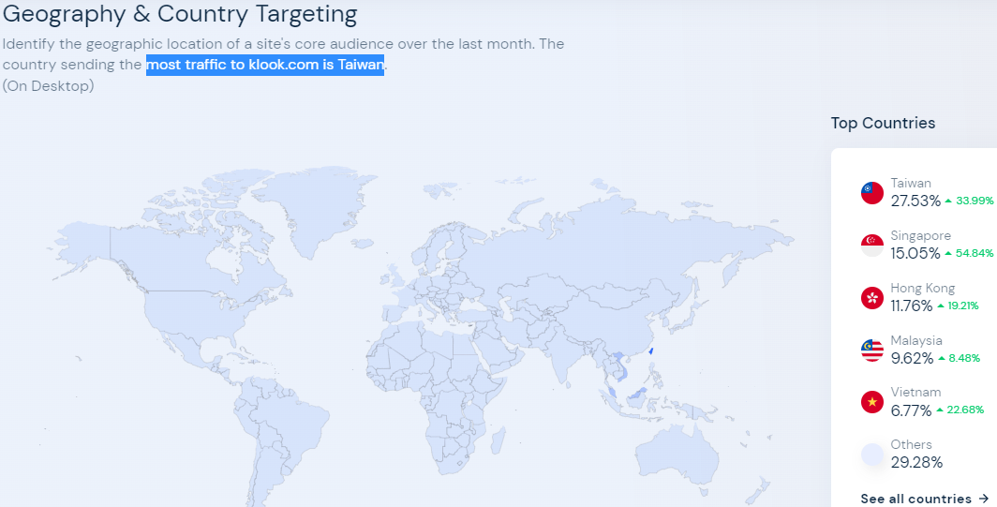

Figure

(Figure 16) ‘Tampilkan Bahasa Asli’ translates as ‘Show Native Language’[42]

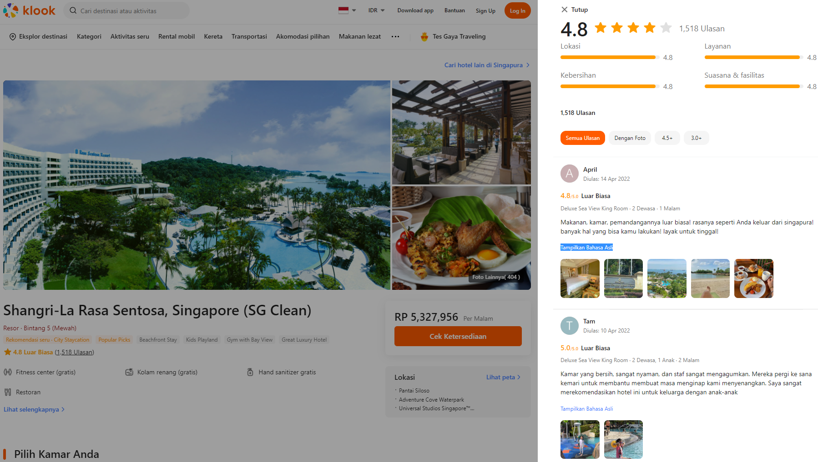

Figure

## **3.3. Hotel Analysis and Findings**

(Figure 17) Top accommodation is Siloso Beach Resort with 29 Indonesia reviews online Traveloka and 11 from Google.

Festive Hotel in Resort World Sentosa ranks second garnering 19 Traveloka reviews and 14 online Google from Indonesians.

Michael Hotel in Resort World Sentosa has a total of 28 Indonesian reviews, while Hard Rock Hotel follows closely behind with 26.

|  |  |  |  |  |  |  |  |  |  |  |
| --- | --- | --- | --- | --- | --- | --- | --- | --- | --- | --- |
| **Hotel Reviews** | **2022** | **2021** | **2020** | **2019** | **2018** | **Hotel Total** | **Indo Ratings** | **Traveloka Score** | **Google Score** | **TripAdvisor Score** |
| Amara |  |  |  | 1 | 3 | 4 | 8.6 | 7.8 (270) | 3.9 (1,851) | 3.5 (853) |
| Barracks Hotel Sentosa |  |  |  |  |  | 0 | - | 9.2 (5) | 4.8 (166) | 5 (551) |
| Beach Villa |  |  |  |  | 1 | 1 | 10 | 8.9 (11) | 4.2 (121) | 4.5 (161) |
| Capella Singapore |  |  | 2 |  | 1 | 3 | 9.9 | 9.1 (8) | 4.6 (1,822) | 4.5 (2,912) |
| Club Residences @ The Knolls |  |  |  |  |  | 0 | - | - (1) | N.A. | 4.5 (63) |
| Crockfords Tower |  |  | 1 | 5 |  | 6 | 9.6 | 7.8 (3) | 4.6 (175) | 4.5 (227) |
| Equarius RWS |  |  | 2 | 5 | 3 | 10 | 9.3 | 8.3 (505) | 4.3 (1,357) | 4.5 (2,063) |
| Festive RWS |  |  | 7 | 17 | 14 | 38 | 8.8 | 8.6 (289) | 4.1 (1,152) | 3.5 (2,262) |
| Glamping |  |  |  |  |  | 0 | - | N.A. | 3.1 (17) | N.A. |
| Hard Rock® Hotel | 1 | 2 |  | 14 | 9 | 26 | 8.8 | 8.5 (255) | 4.3 (1,145) | 3.5 (2,588) |
| Michael RWS | 2 |  | 7 | 11 | 8 | 28 | 9 | 8.2 (**682**) | 4 (1,139) | 4 (1,201) |
| Oasia Resort | 1 |  |  | 4 | 9 | 14 | 8.9 | 9 (173) | 4.6 (78) | 4.5 (340) |
| ONE°15 Marina | 1 | 2 | 1 | 1 | 3 | 8 | 9.7 | 8.5 (231) | 4.5 (1,491) | 4 (493) |
| Shangri-La |  |  | 1 | 2 | 5 | 8 | 9.2 | 8.7 (328) | 4.5 (**5,071**) | 4.5 (**4,849**) |
| Siloso Beach Resort | 1 |  | 7 | 15 | 20 | 43 | 8.6 | 8.3 (432) | 4.2 (2,039) | 3 (1,656) |
| Sofitel Sentosa |  |  | 4 | 6 | 7 | 17 | 8.9 | 8.1 (80) | 4.2 (2,827) | 4.5 (4,597) |
| TreeTop Lofts |  |  |  |  |  | 0 | - | N.A. | 5 (3) | 0 |
| Ocean Suites RWS |  |  |  |  |  | 0 | - | N.A. | N.A. | 4 (68) |
| Outpost Hotel |  |  |  | 2 |  | 2 | 10 | 9.1 (11) | 4.5 (222) | 4.5 (228) |
| Village Hotel |  | 3 | 1 | 5 |  | 9 | 7.5 | 8.7 (28) | 4.3 (672) | 4.5 (438) |
| W Hotel Sentosa |  |  | 3 | 1 | 1 | 5 | 5 | 8.9 (41) | 4.5 (2,475) | 4.5 (3,082) |
| **Year Total** | **6** | **7** | **36** | **89** | **84** | 222 | **8.7** | **8.57** | 4.33 | 4.21 |
|  |  |  |  |  |  |  |  |  | **8.65** | **8.42** |

Figure

Traveloka Hotel Indo

1) Siloso Beach **29**

2) Festive RWS 19

3) Hard Rock Hotel 14

4) Oasia Resort 13

5) Michael RWS 11

7) ShangriLa 6

7) Village Sentosa 6

8) Equarius RWS 5

9) Sofitel Sentosa 4

10) Amara Sentosa 3

12) ONE°15 Marina Sentosa Cove 2

12) W Hotel Sentosa 2

14) Capella 1

14) Crockfords Tower 1

Tiket Hotel Indo

1) Festive RWS **4**

2) Siloso Beach Resort 3

3) ShangriLa 2

Google Hotel Indo

1) Michael RWS **17**

2) Festive RWS 14

3) Sofitel Sentosa 13

5) Hard Rock Hotel 11

5) Siloso Beach 11

6) ONE°15 Marina Sentosa Cove 6

8) Crockfords Tower 5

8) Equarius RWS 5

10) Village Sentosa 3

10) W Hotel Sentosa 3

11) Capella 2

13) Oasia Resort 1

13) Outpost Sentosa 1

TripAdvisor Hotel Indo

Outpost 1

Hard Rock Hotel 1

Festive RWS 1

Beach Villas 1

Figure

(Figure 19) Traveloka Hotel Reviews (as of 2022 May)

|  |  |  |  |  |  |
| --- | --- | --- | --- | --- | --- |
|  |  | Bahasa Indonesia | | **2018-2022** | |
| TOTAL | **3,302** | **8.96%** | **296** | **117** | **3.54%** |
| 1)    Amara Sanctuary Resort Sentosa | 267 | 4.87% | 13 | **4** | **1.50%** |
| 2)    Beach Villas | 11 | 36.36% | 4 | **0** | **0.00%** |
| 3)    Club Residences @ The Knolls | 1 | 0.00% | 0 |  |  |
| 4)    Capella Singapore | 7 | 28.57% | 2 | **1** | **14.29%** |
| 5)    Crockfords Tower | 3 | 33.33% | 1 | **1** | **33.33%** |
| 6)    Equarius Hotel™ | 507 | 5.33% | 27 | **5** | **0.99%** |
| 7)    Festive Hotel™ | 289 | 13.49% | 39 | **19** | **6.57%** |
| 8)    Hard Rock® Hotel Singapore | 252 | 10.32% | 26 | **14** | **5.56%** |
| 9)    Hotel Michael | 681 | 4.99% | 34 | **11** | **1.62%** |
| 10) Oasia Resort Sentosa | 173 | 19.65% | 34 | **13** | **7.51%** |
| 11) ONE°15 Marina Sentosa Cove Singapore | 228 | 4.82% | 11 | **2** | **0.88%** |
| 12) Shangri-La Rasa Sentosa Singapore | 323 | 4.02% | 13 | **6** | **1.86%** |
| 13) Siloso Beach Resort | 414 | 15.94% | 66 | **29** | **7.00%** |
| 14) Sofitel Sentosa | 79 | 7.59% | 6 | **4** | **5.06%** |
| 15) Barracks Hotel Sentosa | 5 | 60.00% | 3 | **0** | **0.00%** |
| 16) Outpost Hotel Sentosa | 11 | 36.36% | 4 | **0** | **0.00%** |
| 17) Village Hotel Sentosa | 11 | 72.73% | 8 | **6** | **54.55%** |
| 18) W Hotel Sentosa | 40 | 12.50% | 5 | **2** | **5.00%** |

Figure

(Figure 20) [TripAdvisor.co.id/Tourism-g294264-Sentosa_Island-Vacations.html](https://www.tripadvisor.com/Tourism-g294264-Sentosa_Island-Vacations.html)

|  |  |  |  |  |  |
| --- | --- | --- | --- | --- | --- |
|  |  | Bahasa Indonesia | | **2018-2022** | |
| TOTAL | **28,264** | **0.6%** | **165** | **4** | **0.0142%** |
| 1)    Amara Sanctuary Resort Sentosa | 852 | 0.00% | 0 |  |  |
| 2)    Beach Villas | 159 | 1.9% | 3 | **1** | **0.6%** |
| 3)    Club Residences @ The Knolls | 63 | 0.00% | **0** |  |  |
| 4)    Capella Singapore | 2,906 | 0.1% | 2 | **0** | **0.00%** |
| 5)    Crockfords Tower | 227 | 2.2% | 5 | **0** | **0.00%** |
| 6)    Equarius Hotel™ | 2,060 | 0.6% | 12 | **0** | **0.00%** |
| 7)    Festive Hotel™ | 2,262 | 1.2% | 27 | **1** | **0.04%** |
| 8)    Hard Rock® Hotel Singapore | 2,585 | 1.8% | 46 | **1** | **0.04%** |
| 9)    Hotel Michael | 1,201 | 2.2% | 26 | **0** | **0.00%** |
| 10) Oasia Resort Sentosa | 329 | 0.00% | **0** |  |  |
| 11) Ocean Suites | 68 | 1.5% | 1 | **0** | **0.00%** |
| 12) ONE°15 Marina Sentosa Cove Singapore | 491 | 0.00% | **0** |  |  |
| 13) Shangri-La Rasa Sentosa Singapore | 4,848 | 0.1% | 5 | **0** | **0.00%** |
| 14) Siloso Beach Resort | 1,654 | 0.8% | 14 | **0** | **0.00%** |
| 15) Sofitel Sentosa | 4,564 | 0.3% | 13 | **0** | **0.00%** |
| 16) Barracks Hotel Sentosa | 545 | 0.00% | **0** |  |  |
| 17) Outpost Hotel Sentosa | 228 | 0.4% | 1 | **1** | **0.4%** |
| 18) Village Hotel Sentosa | 438 | 0.00% | **0** |  |  |
| 19) W Hotel Sentosa | 3,077 | 0.3% | 10 | **0** | **0.00%** |

Figure

Bi-gram and tri-gram easily extracted the entities to provide quick insights of the Indonesian visitors’ behavior for Sentosa hotels without requiring NER nor Part-Of-Speech tagging.

Translating[43] the Indonesian top-words, bi-grams, tri-grams[44] and word-clouds (sorted from rare to common words)[45] revealed obvious insights on how the hotels trends shifted across the five years.

‘Clean’ is mentioned four (4) times in the (6) reviews dated 2022, all online Google.

Five (5) Sentosa Hotels out of total 21 listed online that doesn’t have any Indonesia reviews are: 1] Barracks Hotel Sentosa, 2] Club Residences @ The Knolls, 3] Glamping, 4] TreeTop Lofts, & 5] Ocean Suites RWS

|  |  |  |  |  |  |  |  |  |  |  |
| --- | --- | --- | --- | --- | --- | --- | --- | --- | --- | --- |
| **Translation** | [TOP WORDS](https://databasic.io/en/wordcounter/results/6294ab9468665c0909e66f28/download/words.csv) | | **Frequency** | | **2018** | **2019** | | **2020** | **2021** | **2022** |
| hotel | hotel | | 138 | | 37 | 86 | | 14 | 1 |  |
| room | kamar | | 92 | | 36 | 50 | | 4 |  | 2 |
| good | bagus | | 81 | | 34 | 34 | | 10 | **3** |  |
| close | dekat | | 53 | | 19 | 30 | | 4 |  |  |
| comfortable | nyaman | | 53 | | 15 | 26 | | 9 | 1 | 2 |
| peace | sentosa | | 50 | | 16 | 28 | | 6 |  |  |
| pool | kolam | | 44 | | 9 | 29 | | 5 | 1 |  |
| swimming | renang | | 43 | | 10 | 27 | | 5 | 1 |  |
| no | tidak | | 43 | | 15 | 23 | | 4 |  | 1 |
| clean | bersih | | 38 | | 13 | 16 | | 4 | 1 | **4** |
| child | anak | | 36 | | 6 | 25 | | 5 |  |  |
| stay overnight | menginap | | 34 | | 9 | 21 | | 2 |  | 2 |
| the place | tempatnya | | 34 | | 17 | 10 | | 4 | 1 | 2 |
| okay | oke | | 33 | | 13 | 12 | | 7 |  | 1 |
| we | kami | | 32 | | 10 | 21 | | 1 |  |  |
| service | pelayanan | | 29 | | 12 | 14 | | 2 | 1 |  |
| friendly | ramah | | 29 | | 15 | 14 | |  |  |  |
| beach | pantai | | 27 | | 8 | 12 | | 6 |  | 1 |
| breakfast | sarapannya | | 27 | | 8 | 17 | | 2 |  |  |
| the room | kamarnya | | 26 | | 11 | 12 | | 1 |  | 2 |
| facility | fasilitas | | 25 | | 7 | 16 | | 2 |  |  |
| family | keluarga | | 25 | | 6 | 12 | | 6 | 1 |  |
| singapore | singapura | | 25 | | 7 | 12 | | 5 | 1 |  |
| location | letak | | 24 | | 9 | 12 | | 3 |  |  |
| again | lagi | | 23 | | 6 | 15 | | 1 |  | 1 |
| nice | enak | | 22 | | 11 | 11 | |  |  |  |
| universal | universal | | 22 | | 6 | 14 | | 2 |  |  |
| large | luas | | 21 | | 13 | 5 | | 2 |  | 1 |
| same | sama | | 21 | | 2 | 19 | |  |  |  |
| many | banyak | | 19 | | 6 | 10 | | 3 |  |  |
| the food | makanannya | | 19 | | 4 | 13 | | 2 |  |  |
| studio | studio | | 19 | | 6 | 12 | | 1 |  |  |
| time | waktu | | 19 | | 6 | 11 | | 1 |  | 1 |
| enough | cukup | | 18 | | 8 | 9 | | 1 |  |  |
| not enough | kurang | | 18 | | 9 | 8 | | 1 |  |  |
| water | air | | 17 | | 2 | 13 | | 2 |  |  |
| holiday | liburan | | 17 | | 5 | 9 | | 2 | 1 |  |
| pleasant | menyenangkan | | 17 | | 4 | 13 | |  |  |  |
| view | pemandangan | | 17 | | 6 | 9 | | 1 | 1 |  |
| uss | uss | | 17 | | 5 | 10 | | 2 |  |  |
| free | gratis | | 16 | | 6 | 8 | | 2 |  |  |
| night | malam | | 15 | | 2 | 12 | | 1 |  |  |
| his | nya | | 15 | | 6 | 7 | | 1 |  | 1 |
| like | seperti | | 15 | | 4 | 6 | | 5 |  |  |
| every | setiap | | 15 | | 1 | 13 | |  |  | 1 |
| staff | staf | | 15 | | 10 | 5 | |  |  |  |
|  |  | |  | |  |  | |  |  |  |
| **Translation** | | [BIGRAMS](https://databasic.io/en/wordcounter/results/6294ab9468665c0909e66f28/download/bigrams.csv) | | **Frequency** | | |
| swimming pool | | kolam renang | | 24 | | |
| close to | | dekat dengan | | 23 | | |
| this hotel | | hotel ini | | 19 | | |
| universal studio | | universal studio | | 15 | | |
| comfortable and | | nyaman dan | | 13 | | |
| staying at | | menginap di | | 13 | | |
| the hotel | | hotel yang | | 13 | | |
| that room | | kamar yang | | 12 | | |
| vivo city | | vivo city | | 12 | | |
| the swimming pool | | kolam renangnya | | 11 | | |
| which is very | | yang sangat | | 11 | | |
| at the hotel | | di hotel | | 11 | | |
| at peace | | di sentosa | | 10 | | |
| to universal | | ke universal | | 9 | | |
| shuttle bus | | shuttle bus | | 9 | | |
| good and | | bagus dan | | 9 | | |
| clean and | | bersih dan | | 9 | | |
| and comfortable | | dan nyaman | | 8 | | |
| very good | | sangat bagus | | 8 | | |
| here | | di sini | | 7 | | |

|  |  |  |
| --- | --- | --- |
| **Translation** | [TRIGRAMS](https://databasic.io/en/wordcounter/results/6294ab9468665c0909e66f28/download/trigrams.csv) | **Frequency** |
| very close to | sangat dekat dengan | 6 |
| to universal studio | ke universal studio | 5 |
| resort world sentosa | resort world sentosa | 5 |
| close to universal | dekat dengan universal | 5 |
| with universal studio | dengan universal studio | 5 |
| one of the hotels | salah satu hotel | 5 |
| universal studio and | universal studio dan | 4 |
| in this hotel | di hotel ini | 4 |
| good hotel | hotel yang bagus | 4 |
| stay here | menginap di sini | 4 |
| on sentosa island | di sentosa island | 4 |
| room on the floor | kamar di lantai | 4 |
| vivo city and | vivo city dan | 4 |
| on the 2m floor | di lantai 2m | 4 |
| hard rock hotel | hard rock hotel | 4 |
| and close to | dan dekat dengan | 3 |
| shuttle bus for | shuttle bus untuk | 3 |
| and universal studio | dan universal studio | 3 |
| for family and | untuk keluarga dan | 3 |
| very close to | dekat sekali dengan | 3 |

|  |  |  |
| --- | --- | --- |
| **6 Google reviews** | **72 words** | **2022** |
| clean and | bersih dan | 4 |
| be careful | hati hati | 1 |
| dirty sheets | kotor sepreynya | 1 |
| fine later | nanti denda | 1 |
| 5 fine | denda 5 | 1 |
| 5 million | 5 jt | 1 |
| jt room | jt kamarnya | 1 |
| the room is spacious | kamarnya luas | 1 |
| spacious place | luas tempatnya | 1 |
| strategic location | lokasinya strategis | 1 |
| strategic couple | strategis beberapa | 1 |
| in michael | di michael | 1 |
| excellent hospitality | excellent hospitality | 1 |
| always tidy | selalu rapi | 1 |
| neat clean | rapi bersih | 1 |
| and smells good | dan wangi | 1 |
| guaranteed safety | keamanan terjamin | 1 |
| comfortable | nyaman deh | 1 |
| enjoy the room | aamiin kamarnya | 1 |
| take a break | buat istirahat | 1 |

|  |  |  |
| --- | --- | --- |
| **Hard Rock® Hotel / Michael RWS / Oasia Resort / Siloso Beach Resort** | | **2022** |
| sleep carefully | nginep hati hati | 1 |
| don't get dirty | jangan sampai kotor | 1 |
| the sheets will be fined | sepreynya nanti denda | 1 |
| 5 million rooms | 5 jt kamarnya | 1 |
| jt spacious room | jt kamarnya luas | 1 |
| the place is also clean | tempatnya juga bersih | 1 |
| several strategic locations | lokasinya strategis beberapa | 1 |
| stay at michael | menginap di michael | 1 |
| excellent hospitality room | excellent hospitality ruangan | 1 |
| the room is always tidy | kamar selalu rapi | 1 |
| neat and clean | rapi bersih dan | 1 |
| clean and fragrant | bersih dan wangi | 1 |
| security is guaranteed | keamanan terjamin lumayan | 1 |
| good enough to reduce noise | lumayan meredam bising | 1 |
| it's comfortable to stay | nyaman deh menginap | 1 |
| let's stay here | deh menginap disini | 1 |
| back there again | kembali lagi kesana | 1 |
| not too bright | tidak terlalu terang | 1 |
| suitable for rest | cocok buat istirahat | 1 |
| comfortable blue beach | nyaman pantai biru | 1 |

|  |  |  |
| --- | --- | --- |
| **7 Google reviews** | **63 words** | **2021** |
| comfortable vacation | nyaman liburan | 1 |
| vacation together | liburan bersama | 1 |
| with family | bersama keluarga | 1 |
| hard rock family | keluarga hardrock | 1 |
| hard rock singapore | hardrock singapore | 1 |
| singapore enjoy | singapore menikmati | 1 |
| enjoy the pool | menikmati kolam | 1 |
| swimming with | renang dengan | 1 |
| with a view | dengan pemandangan | 1 |
| beautiful scenery | pemandangan yang | 1 |
| view photos | melihat foto | 1 |
| singer photo | foto penyanyi | 1 |
| international singer | penyanyi international | 1 |
| really international | international sungguh | 1 |
| singer yuliana | singer yuliana | 1 |
| highly recommended | sangat direkomendasikan | 1 |
| heaven on earth | syurga dunia | 1 |
| very good | sangat bagus | 1 |
| clean service | bersih pelayananya | 1 |
| hotel pick up | hotel diambilkannya | 1 |

|  |  |  |
| --- | --- | --- |
| **Hard Rock® Hotel / ONE°15 Marina / Village Hotel** | | **2021** |
| comfortable vacation together | nyaman liburan bersama | 1 |
| holiday with family | liburan bersama keluarga | 1 |
| hard rock singapore family | keluarga hardrock singapore | 1 |
| singapore enjoying the pool | singapore menikmati kolam | 1 |
| swimming with a view | renang dengan pemandangan | 1 |
| with a great view | dengan pemandangan yang | 1 |
| beautiful view | pemandangan yang indah | 1 |
| beautiful and see | indah dan melihat | 1 |
| and view photos | dan melihat foto | 1 |
| see singer's photo | melihat foto penyanyi | 1 |
| international singer photo | foto penyanyi international | 1 |
| real international singer | penyanyi international sungguh | 1 |
| longing to come | rindu untuk datang | 1 |
| sing with models | bernyanyi bersama model | 1 |
| yuliana highly recommended | yuliana sangat direkomendasikan | 1 |
| heaven on earth exists | syurga dunia ada | 1 |
| nice and pretty | bagus dan cantik | 1 |
| the place is clean | tempatnya serta bersih | 1 |
| very long service | pelayananya sangat lama | 1 |
| took too long | diambilkannya juga lama | 1 |

|  |  |  |
| --- | --- | --- |
| **36 reviews** | **470 words** | **2020** |
| swimming pool | kolam renang | 3 |
| close to | dekat dengan | 3 |
| at the hotel | di hotel | 2 |
| this is a hotel | ini hotel | 2 |
| and mature | dan dewasa | 2 |
| what's good | bagus apalagi | 2 |
| too expensive | terlalu mahal | 2 |
| more hotels | hotel lebih | 2 |
| like a hostel | seperti hostel | 2 |
| very narrow | sangat sempit | 2 |
| location in | lokasi di | 2 |
| at peace | di sentosa | 2 |
| comfortable and | nyaman dan | 2 |
| and comfortable | dan nyaman | 2 |
| the place | tempat yang | 2 |
| Qibla direction | arah kiblat | 2 |
| sentosa singapore | sentosa singapore | 2 |
| to universal | ke universal | 2 |
| hotel distance | jarak hotel | 1 |
| with uss | dg uss | 1 |

|  |  |  |  |  |  |
| --- | --- | --- | --- | --- | --- |
| **Festive RWS / Michael RWS / Siloso Beach Resort / Sofitel / W Hotel** | | | | | **2020** |
| hotel distance from | | jarak hotel dg | | | 1 |
| hotel with uss | | hotel dg uss | | | 1 |
| with uss sea | | dg uss sea | | | 1 |
| uss sea et al | | uss sea dkk | | | 1 |
| sea ​​et al only | | sea dkk hanya | | | 1 |
| et al just a step | | dkk hanya selangkah | | | 1 |
| just a step | | hanya selangkah klo | | | 1 |
| if the curse is for | | klo tukuan utk | | | 1 |
| for the holidays | | tukuan utk liburan | | | 1 |
| for holidays | | utk liburan d | | | 1 |
| holiday on the island | | liburan d pulu | | | 1 |
| very peaceful island | | pulu sentosa sangat | | | 1 |
| very welcome | | sentosa sangat disrnkan | | | 1 |
| very recommended to stay | | sangat disrnkan nginap | | | 1 |
| recommended to stay at | | disrnkan nginap di | | | 1 |
| here around the hotel | | sini sekitar hotel | | | 1 |
| around the hotel a lot | | sekitar hotel banyak | | | 1 |
| hotel with many restaurants | | hotel banyak resto | | | 1 |
| open for breakfast | | buka utk sarapan | | | 1 |
|  | |  | | |  |
| **89 reviews** | **3,000 words** | | **2019** |
| swimming pool | kolam renang | | 16 |
| this hotel | hotel ini | | 15 |
| universal studio | universal studio | | 10 |
| close to | dekat dengan | | 9 |
| comfortable and | nyaman dan | | 7 |
| that room | kamar yang | | 7 |
| vivo city | vivo city | | 6 |
| hard rock | hard rock | | 6 |
| to uss | ke uss | | 5 |
| for family | untuk keluarga | | 5 |
| and clean | dan bersih | | 5 |
| festive hotel | festive hotel | | 5 |
| shuttle bus | shuttle bus | | 4 |
| very good | sangat bagus | | 4 |
| for breakfast | untuk sarapan | | 4 |
| and children | dan anak-anak | | 4 |
| check in | check in | | 4 |
| hotel facility | fasilitas hotel | | 4 |
| village hotel | village hotel | | 4 |
| extraordinary | luar biasa | | 3 |

|  |  |  |
| --- | --- | --- |
| **Festive RWS / Siloso Beach Resort / Hard Rock® Hotel / Michael RWS** | | **2019** |
| one of the hotels | salah satu hotel | 5 |
| to universal studio | ke universal studio | 4 |
| hard rock hotel | hard rock hotel | 4 |
| for family and | untuk keluarga dan | 3 |
| to the pool | ke kolam renang | 3 |
| very close to | sangat dekat dengan | 3 |
| to this hotel | ke hotel ini | 3 |
| every 30 minutes | setiap 30 menit | 3 |
| direct access to | akses langsung ke | 3 |
| in every room | di setiap kamar | 3 |
| food served | makanan yang disajikan | 3 |
| in hard rock | di hard rock | 3 |
| there is water spray | ada semprotan air | 2 |
| universal studio and | universal studio dan | 2 |
| shuttle bus for | shuttle bus untuk | 2 |
| suitable for family | cocok untuk keluarga | 2 |
| and vivo city | dan vivo city | 2 |
| one of the best hotel | satu hotel terbaik | 2 |
| provide halal food | menyediakan makanan halal | 2 |
| this hotel is new | hotel ini baru | 2 |

|  |  |  |
| --- | --- | --- |
| **84 reviews** | **1,466 words** | **2018** |
| close to | dekat dengan | 11 |
| at peace | di sentosa | 6 |
| vivo city | vivo city | 5 |
| the hotel | hotel yang | 5 |
| comfortable and | nyaman dan | 4 |
| shuttle bus | shuttle bus | 4 |
| to singapore | ke singapore | 4 |
| universal studio | universal studio | 4 |
| at the hotel | di hotel | 4 |
| the good one | yang bagus | 4 |
| swimming pool | kolam renang | 4 |
| enough room | kamar cukup | 4 |
| good service | pelayanan baik | 3 |
| the room is spacious | kamarnya luas | 3 |
| friendly and | ramah dan | 3 |
| very helpful | sangat membantu | 3 |
| resort world | resort world | 3 |
| extraordinary | luar biasa | 3 |
| with nature | dengan alam | 3 |
| Near the beach | dekat pantai | 3 |

|  |  |  |
| --- | --- | --- |
| **Siloso Beach Resort / Festive RWS / Hard Rock® Hotel / Oasia Resort** | | **2018** |
| very close to | sangat dekat dengan | 3 |
| resort world sentosa | resort world sentosa | 3 |
| good hotel | hotel yang bagus | 3 |
| with universal studio | dengan universal studio | 3 |
| right in front | persis di depan | 2 |
| spacious room | kamar yang luas | 2 |
| on sentosa island | di sentosa island | 2 |
| to vivo city | ke vivo city | 2 |
| good for | yang bagus untuk | 2 |
| there is a shuttle bus | ada shuttle bus | 2 |
| one with nature | menyatu dengan alam | 2 |
| can speak Indonesian | bisa berbahasa indonesia | 2 |
| family room enough | keluarga kamar cukup | 2 |
| wide enough service | cukup luas pelayanan | 2 |
| enjoy all the facilities | menikmati semua fasilitas | 2 |
| very go green | sangat go green | 1 |
| green and environment | green dan lingkungan | 1 |
| kids like it very much | anak2 sangat suka | 1 |
| love swimming service | suka berenang pelayanan | 1 |
| night watchman | yg jaga malam | 1 |

(Figure 21) 2022 (only 6 Indonesian reviews from Google with 72 words)[46]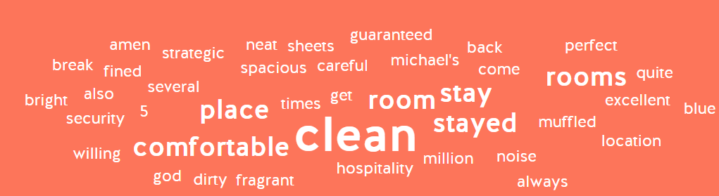

Figure

(Figure 22) 2021 (word clouds translated from Indonesian to English for understanding)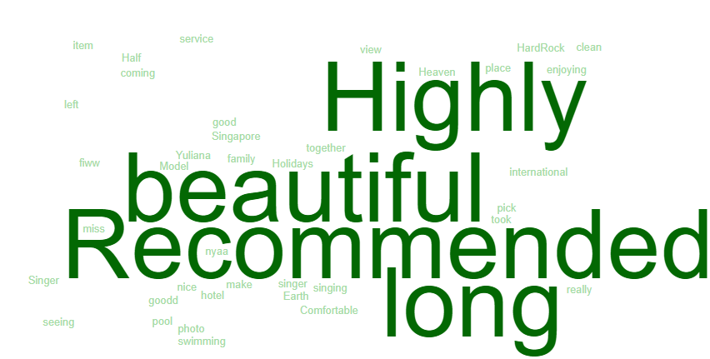

Figure

(Figure 23) 2020: Covid19 restrictions started in April[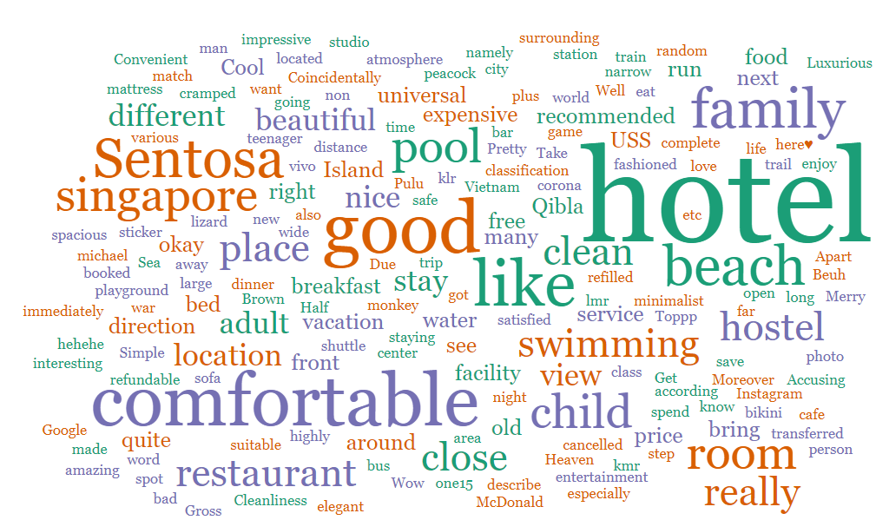](https://wordsift.org/)

Figure

(Figure 24) 2019: Pre-Covid / should be normal tourism data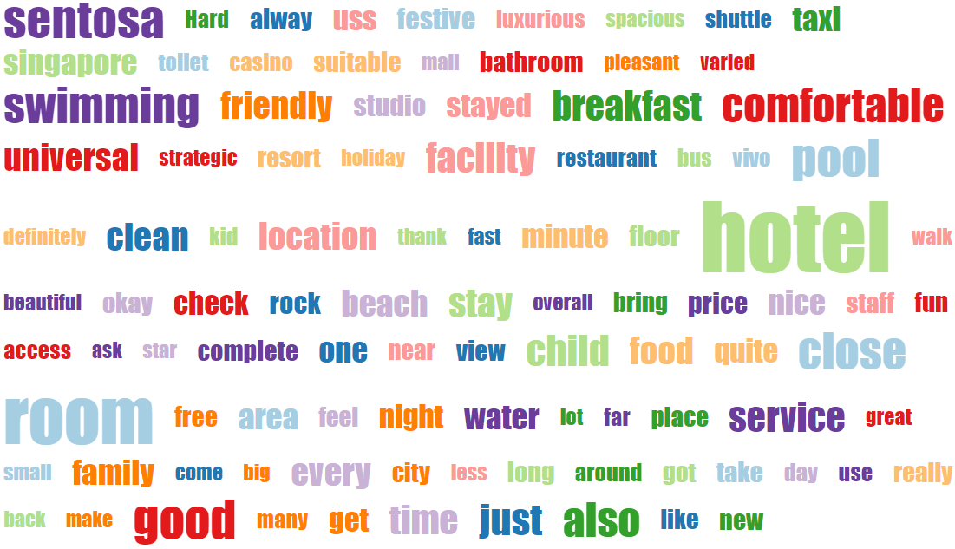

Figure

(Figure 25) 2018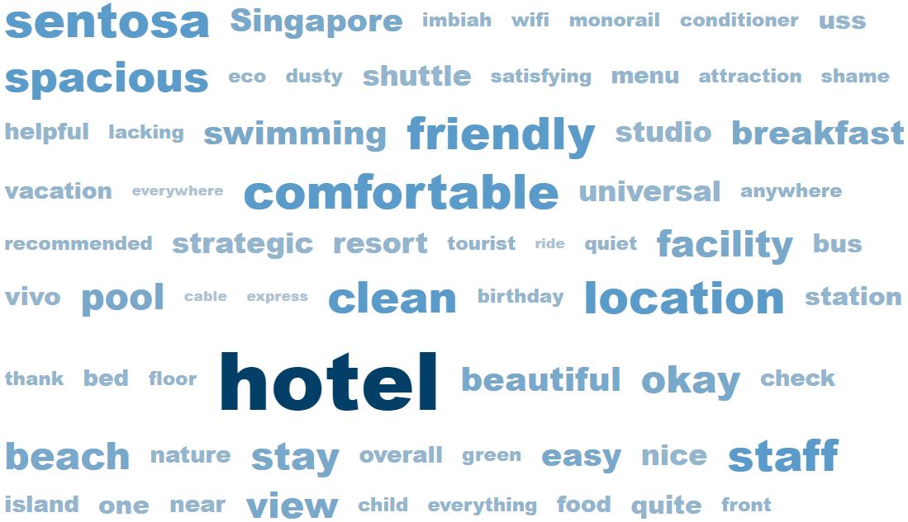

Figure

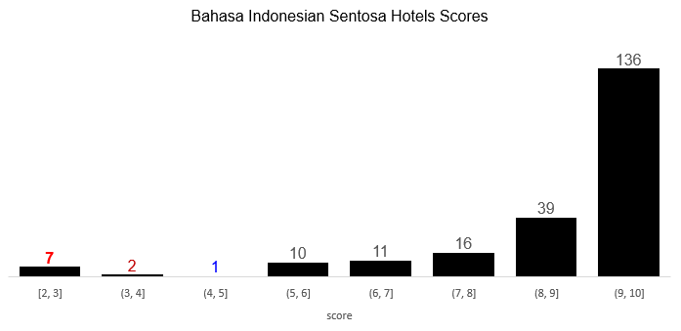

Traveloka 2020 Village Hotel

Google  
2022 Hard Rock Hotel  
2021 Village Hotel  
2020:  
Festive Hotel RWS  
W@Sentosa Cove (**3**)  
2019 Sofitel Sentosa Spa Resort

Google  
2020 Hotel Michael RWS  
2018 Sofitel Sentosa Spa Resort

Festive Hotel RWS (**24**) / Siloso Beach Resort (18) / Hotel Michael RWS (18) / Hard Rock Hotel (15) / Sofitel Sentosa Spa Resort (13) / Oasia Resort Sentosa (10) / Equarius Hotel RWS (8) One15 Sentosa Cove (7)   
Crockfords Tower RWS (5)  
Shangrila Rasa Sentosa (5)  
Capella (3)  
Village Hotel (3)  
Amara Sanctuary (2)  
Outpost Hotel (2)  
Beach Villas RWS (1)

Figure

TripAdvisor

Tiket

Traveloka

Google

Figure

## **3.4. Dining Trends and Insights**

SDC listed 117 F&Bs[47] but only 102 are found online and only **39** has Indonesians reviews:

1. Malaysia Food Street (Google 20 / TripAdvisor[48] 3)
2. Good Old Days Food Court – Halal (Google 8 / TripAdvisor 1)
3. Hard Rock Café (Google 7 / TripAdvisor 1)

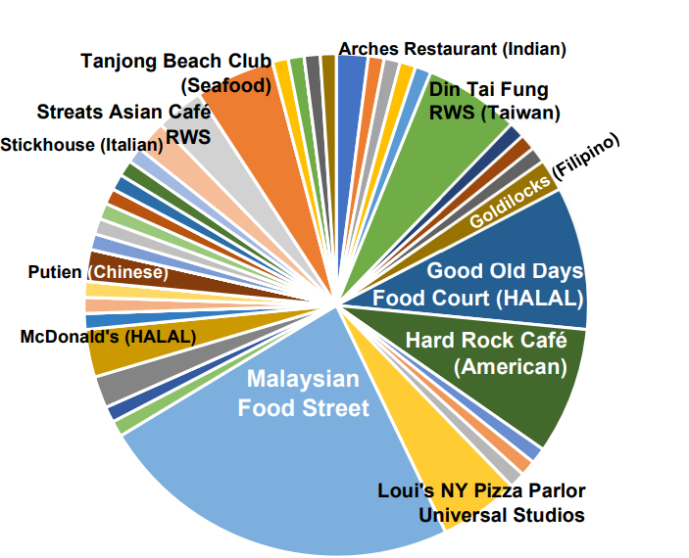

Figure

Google Dining Indo

1) Malaysian Food Street **20**

2) Good Old Days Food Court (HALAL) **8**

3) Hard Rock Café (American) **7**

6) Din Tai Fung RWS (Taiwan) 5

6) Loui's NY Pizza Parlor Universal Studios 5

6) Tanjong Beach Club (Seafood) 5

7) Streats Asian Café RWS 3

12) Arches Restaurant (Indian) 2

12) Goldilocks Fried Chicken (Filipino) 2

12) Putien (Chinese) 2

12) McCafe (HALAL) 2

12) McDonald's (HALAL) 2

35) Blue Lotus Singapore Chinese Eating House 1

35) Bones 'n Barrels Sentosa (Live Music Bar) 1

35) Coastes @ Siloso Beach Walk (Bar) 1

35) Coffee Bean and Tea Leaf (HALAL) 1

35) eM By The Marina (Japanese) 1

35) Feng Shui Inn (Cantonese) 1

35) Fratelli Trattoria (Italian) 1

35) Krispy Kreme Sentosa (HALAL) 1

35) Marrybrown (Malaysian fast-food) 1

35) Mambo Beach Club (Bar) 1

35) Mel’s Drive-in RWS (American) 1

35) Oasis Spice Café RWS (Indian) 1

35) Ola Beach Club Siloso (Hawaiian) 1

35) Royal Albatross Luxury Tall Ship RWS 000(Sunset Dinner Cruise) 1

35) Rumours Beach Club (Bar) 1

35) Silver Shell Café (Beach Buffet) 1

35) Shutters Amara Sentosa (Fusion) 1

35) SolePomodoro Trattoria Pizzeria (Italian) 1

35) Starbucks Café 1

35) Texas Chicken RWS 1

35) ToastBox (Snack) 1

35) Trapizza (Italian) 1

TripAdvisor Dining Indo

1) Malaysian Food Street 3

10) Din Tai Fung RWS (Taiwan) 1

10) Good Old Days Food Court (HALAL) 1

10) Hard Rock Café (American) 1

10) Kitchen Table (European) 1

10) Kwee Zeen (French) 1

10) Starbot Café (Chinese) 1

10) Stickhouse (Italian) 1

10) The Knolls (European) 1

10) McDonald's (HALAL) 1

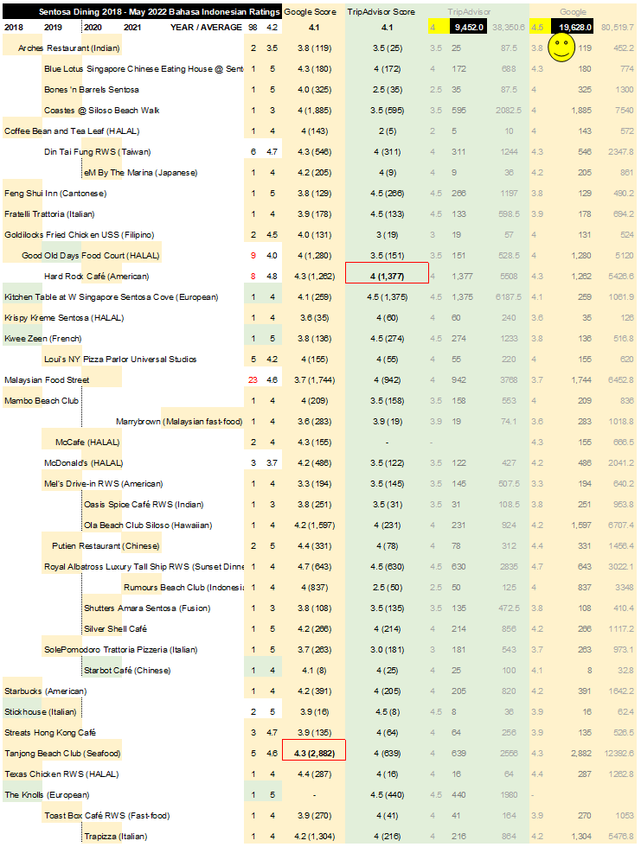

Figure

|  |  |  |  |  |  |  |
| --- | --- | --- | --- | --- | --- | --- |
| **Translation** | TOP WORDS | frequency |  | **Translation** | bigram | frequency |
| food | makanan | 50 |  | Ms. Naomi | mbak naomi | 19 |
| no | tidak | 37 |  | universal studio | universal studio | 15 |
| eat | makan | 36 |  | food court | food court | 11 |
| the place | tempat | 33 |  | dinner | makan malam | 9 |
| nice | enak | 24 |  | food choices | pilihan makanan | 8 |
| many | banyak | 22 |  | universal login | masuk universal | 6 |
| we | kami | 21 |  | there isn't any | tidak ada | 6 |
| service | pelayanan | 21 |  | fat rice | nasi lemak | 5 |
| miss | mbak | 20 |  | naomi wu | naomi wu | 5 |
| price | harga | 19 |  | a bit expensive | agak mahal | 4 |
| naomi | naomi | 19 |  | peanut porridge | bubur kacang | 4 |
| pass | berlalu | 18 |  | green beans | kacang ijo | 4 |
| choice | pilihan | 17 |  | high ice | es teler | 4 |
| the restaurant | restorannya | 17 |  | fast service | pelayanan cepat | 4 |
| rice | nasi | 16 |  | lots of choices | banyak pilihan | 4 |
| but | tapi | 16 |  | sentosa island | pulau sentosa | 4 |
| studio | studio | 15 |  | Indonesian people | orang indonesia | 4 |
| universal | universal | 15 |  | the ice cream | es krimnya | 3 |
| come | datang | 14 |  | prata bread | roti prata | 3 |
| because | karena | 14 |  | not friendly | tidak ramah | 3 |
| like | seperti | 14 |  |  |  |  |
| reasonable | lumayan | 13 |  | **Translation** | trigram | frequency |
| good | baik | 12 |  | enter universal studio | masuk universal studio | 6 |
| from | dari | 12 |  | this food court | food court ini | 5 |
| ok | deh | 12 |  | Ms. Naomi Wu | mbak naomi wu | 5 |
| more | lebih | 12 |  | green bean porridge | bubur kacang ijo | 4 |
| night | malam | 12 |  | Indonesian tongue | lidah orang indonesia | 4 |
| peace | sentosa | 12 |  | dinner at | makan malam di | 3 |
| good | bagus | 11 |  | lots of food choices | banyak pilihan makanan | 3 |
| court | court | 11 |  | good but it seems | bagus tapi sepertinya | 3 |
| only | cuma | 11 |  | looks like it needs more | sepertinya butuh lebih | 3 |
| expensive | mahal | 11 |  | many tables and | banyak meja dan | 3 |
| friendly | ramah | 11 |  | sit down so people | duduk supaya orang | 3 |
| breakfast | sarapan | 11 |  | not fighting for a place | tidak berebut tempat | 3 |
| before | dulu | 10 |  | with fine cuisine | dengan masakan ala | 3 |
| halal | halal | 10 |  | Malaysian style food | masakan ala malaysia | 3 |
| if | kalau | 10 |  | great choice of food | banget pilihan makanan | 3 |
| time | kali | 10 |  | this is too crowded | ini plg ramai | 3 |
| person | orang | 10 |  | for lunch | untuk makan siang | 3 |
| finally | akhirnya | 9 |  | AC room | ruangan ber ac | 3 |
| even | bahkan | 9 |  | good for cooling | lumayan buat mendinginkan | 3 |
| star | bintang | 9 |  | the staff don't understand | stafnya tidak mengerti | 3 |
| delicious | enak2 | 9 |  |  |  |  |
| cool | mendinginkan | 9 |  |  |  |  |
| menu | menu | 9 |  |  |  |  |
| same | sama | 9 |  |  |  |  |
| singapore | singapura | 9 |  |  |  |  |
| the staff | stafnya | 9 |  |  |  |  |
| chicken | ayam | 8 |  |  |  |  |
| cleanliness | kebersihannyaa | 8 |  |  |  |  |

Over 60% Sentosa Dining Indonesian Reviews 2018-May 2022 lands in the ‘Family’ zones[49] with ‘Entertainment / Fun’[50]

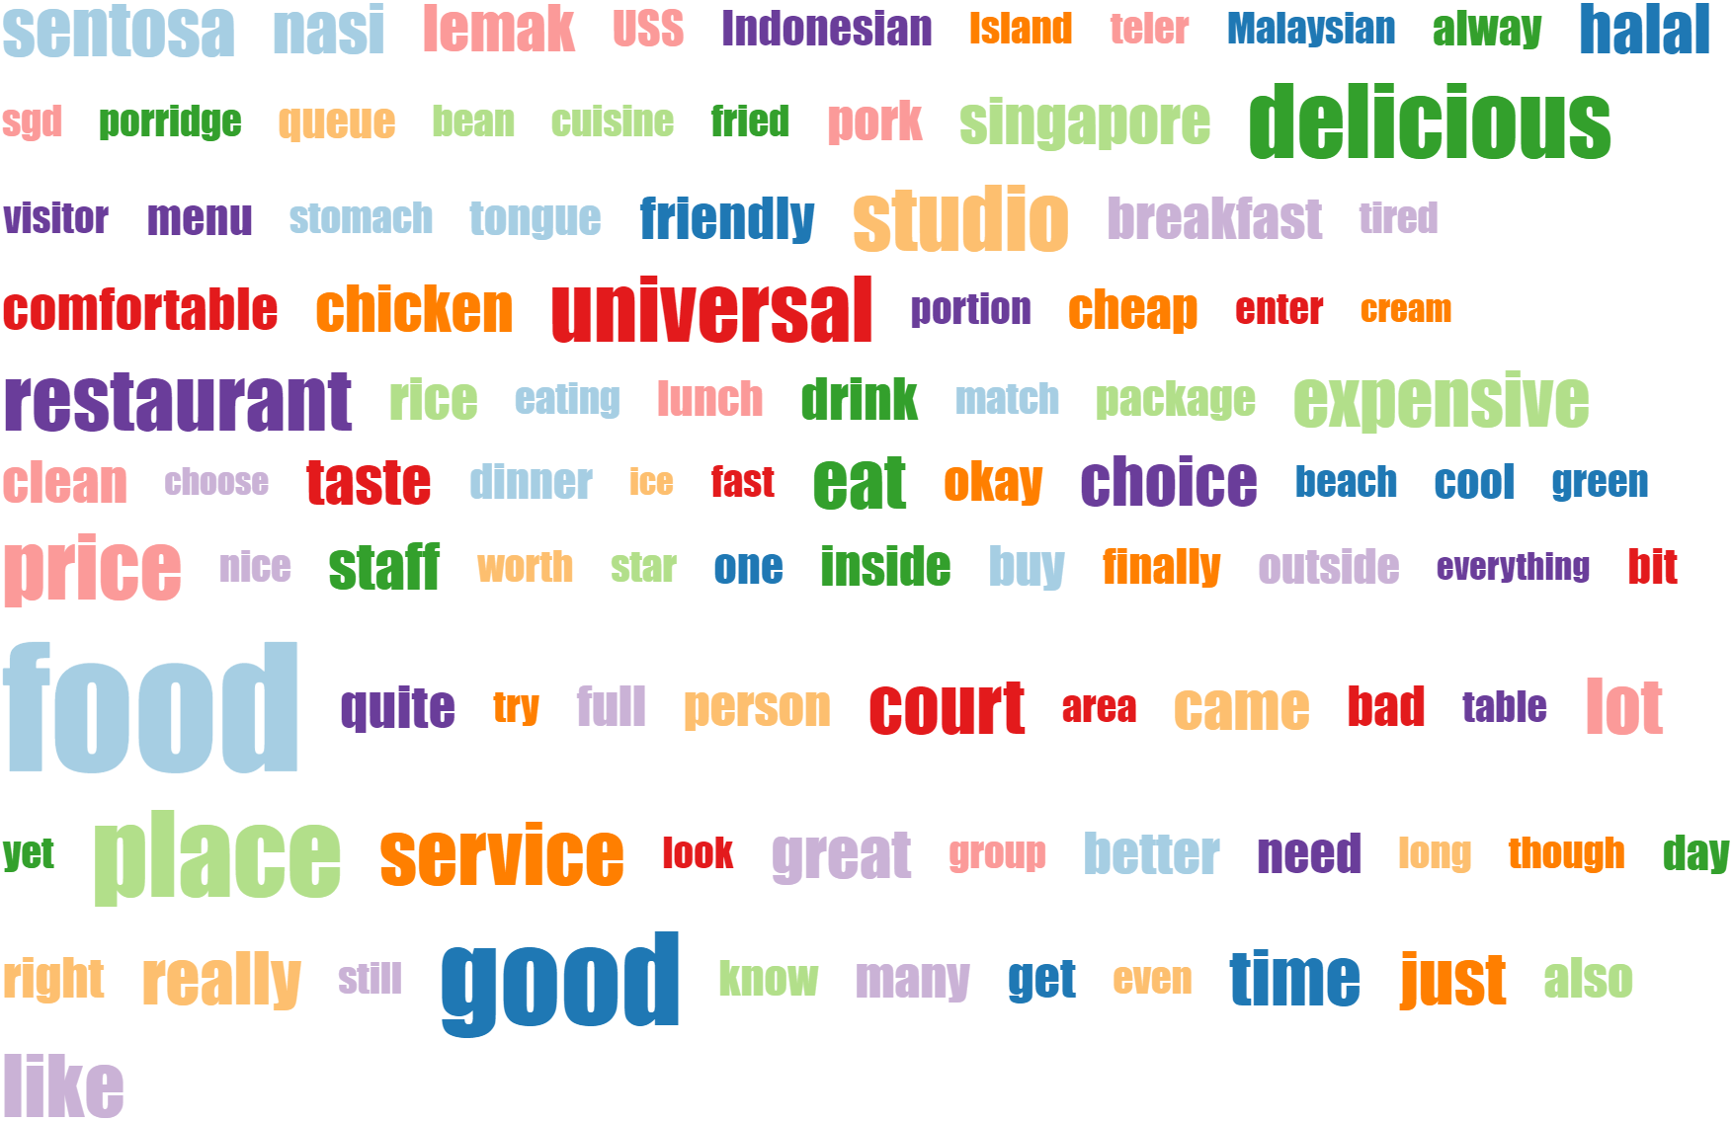

Figure

Translated top-words sorted from rare to common reveals ‘halal’[51], ‘pork’, ‘friendly’, ‘chicken’[52], ‘staff’, ‘service’ (Figure 36)

Grouping the Sentosa F&Bs with Indonesian reviews further expose trends such as ‘halal’, ‘asian’, ‘chinese’, ‘indian’ (Figure 37) which coincides with the country’s basic information available online <https://en.wikipedia.org/wiki/Indonesian_cuisine>

|  |  |  |  |  |  |
| --- | --- | --- | --- | --- | --- |
|  | **country** | **muslimPopulation** | **pop2022** | **muslim%** | **worldMuslim%** |
| 1 | Indonesia[53] | 229,000,000 | 279,135 | **87.2** | 12.7 |
| 2 | Pakistan | 200,400,000 | 229,489 | 96.5 | 11.1 |
| 3 | India | 195,000,000 | 1,406,632 | 14.2 | 10.9 |
| 4 | Bangladesh | 153,700,000 | 167,886 | 90.4 | 9.2 |
| 5 | Nigeria | 99,000,000 | 216,747 | 49.6 | 5.3 |
| 24 | Malaysia | 16,318,355 | 33,181 | 61.3 | 1.1 |
| 88 | Singapore | 781,558 | 5,944 | 14.7 | 0 |
| 178 | Timor-Leste | 1,000 | 1369.429 | 0.1 | 0 |

Figure

|  |  |  |  |
| --- | --- | --- | --- |
| **Asian (27%)**  - Malaysian Food Street (23)  - Streats Hong Kong Café RWS (3) | **HALAL (17%)[54]**  - Good Old Days Food Court (9)  - McDonald's (3)  - McCafe (2)  - Coffee Bean and Tea Leaf (1)  - Krispy Kreme Sentosa (1)  - Texas Chicken RWS (1) | **AMERICAN (10%)**  - Hard Rock Café (8)  - Starbucks (1)  - Mel’s Drive-in RWS (1) | **ITALIAN (10%)**  - Loui’s NY Pizza Parlor Universal Studios (5)  - Fratelli Trattoria (1)  - SolePomodoro Trattoria Pizzeria (1)  - Trapizza (1)  - Stickhouse (2) |
| **TAIWAN (6%)**  Din Tai Fung RWS (6) | **SEAFOOD (5%)**  Tanjong Beach Club (5) | **CHINESE (4%)**  - Putien Restaurant (2)  - Starbot Café (1)  - Blue Lotus Singapore Chinese Eating House @ Sentosa Cove (1) | **INDIAN (3%)**  - Arches Restaurant (2)  - Oasis Spice Café RWS (1) |
| **BAR (3%)**  - Bones 'n Barrels Sentosa (1)  - Mambo Beach Club (1)  - Coastes @ Siloso Beach Walk (1) | **EUROPEAN (2%)**  - Kitchen Table at W Singapore Sentosa Cove (1)  - The Knolls (1) | **FAST-FOOD (2%)**  - MarryBrown (1)  - Toast Box Café RWS (1) | **Filipino (2%)**  Goldilocks Fried Chicken USS (2) |
| **FRENCH (1%)** Kwee Zeen (1) | **FUSION (1%)**  Shutters Amara Sentosa (1) | **Hawaiian (1%)** Ola Beach Club Siloso (1) | **INDONESIAN (1%)** Rumours Beach Club (1) |
| **JAPANESE (1%)** eM By The Marina (1) | **Cantonese (1%)** Feng Shui Inn (1) | **BEACH BUFFET (1%)** Silver Shell Café (1) | **SUNSET DINNER CRUISE (1%)** Royal Albatross Luxury Tall Ship RWS (1) |

Figure

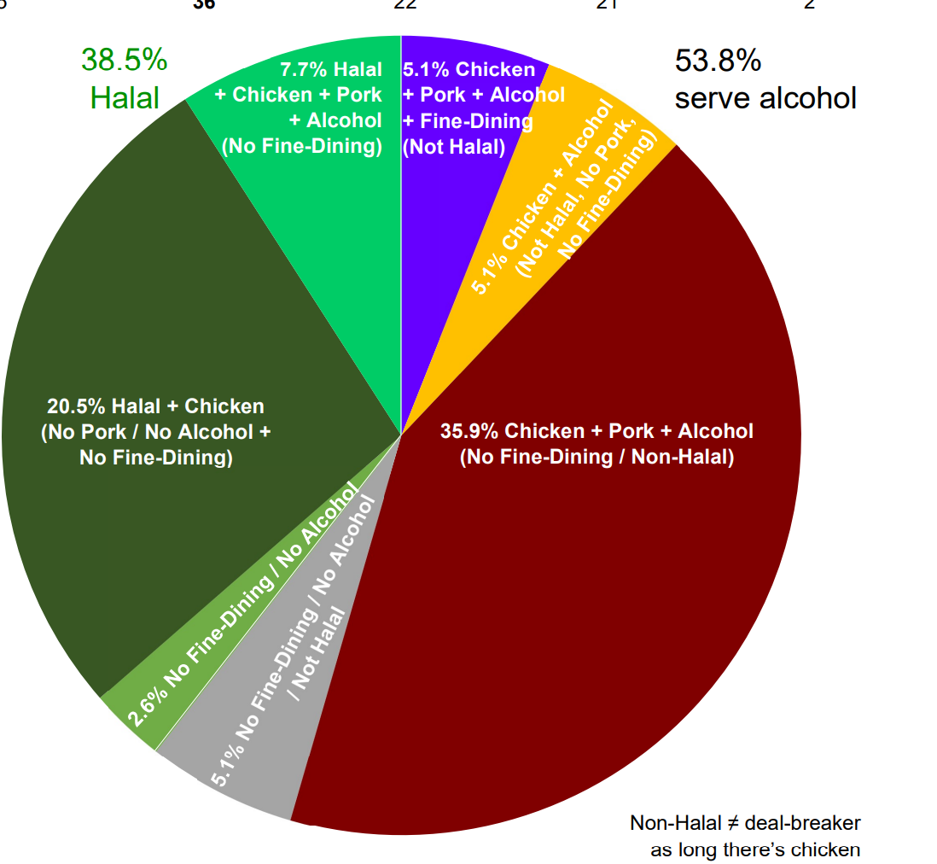

Figure

Operating hours doesn’t seem to be a significant factor for Indonesians

No chicken option  
McCafe  
Krispy Crème  
Stickhouse Italian Gelato

15 **36** 22 21 2

Figure

|  |  |  |  |  |  |  |  |
| --- | --- | --- | --- | --- | --- | --- | --- |
| **Sentosa Dining 2018 - May 2022 Bahasa Indonesian Ratings** | | [**HALAL**](https://www.sentosa.com.sg/en/things-to-do/dining/?page=2) | **CHICKEN** | **PORK** | **ALCOHOL** | [**FINE-DINING**](https://www.sentosa.com.sg/en/things-to-do/dining/?page=5) | **no 24-HR options at Sentosa** |
| 4.6 | Malaysian Food Street (**23**) | **✓** | **✓** | **✓** | **✓** | X | Thu-Tue 11am-7pm |
| 4.7 | Streats Hong Kong Café RWS (3) | **✓** | **✓** | X | X | X | 11am-3pm / 5-10pm |
| 4.0 | Good Old Days Food Court (**9**) | **✓** | **✓** | **✓** | X | X | 11am-8pm |
| 3.7 | McDonald's (3) | **✓** | **✓** | X | X | X | 8am-9pm |
| 4.0 | McCafe (2) | **✓** | X | X | X | X |
| 4.0 | Coffee Bean and Tea Leaf (1) | **✓** | **✓** | X | X | X | 8am-10pm |
| 4.0 | Krispy Kreme Sentosa (1) | **✓** | X | X | X | X | Sat/Sun 11am-7pm |
| 4.0 | Texas Chicken RWS (1) | **✓** | **✓** | X | X | X | 11am-9pm |
| 4.8 | Hard Rock Café (**8**) | X | **✓** | **✓** | **✓** | X | 11am-9.30pm |
| 4.0 | Starbucks (1) | X | **✓** | X | X | X | 7.30am-8pm |
| 4.0 | Mel’s Drive-in RWS (1) | **✓** | **✓** | X | X | X | Thu-Sun 12-7pm |
| 4.2 | Loui’s NY Pizza Parlor Universal Studios (**5**) | **✓** | **✓** | X | X | X |
| 4.0 | Fratelli Trattoria RWS (1) | X | **✓** | **✓** | **✓** | **✓** | Wed-Sun 5-10pm |
| 5.0 | SolePomodoro Trattoria Pizzeria (1) | X | **✓** | **✓** | **✓** | X | 12-3pm / 6-**10.30pm** |
| 4.0 | Trapizza (1) | X | **✓** | **✓** | **✓** | X | 12-9pm |
| 5.0 | Stickhouse (2) | X | X | X | X | X | 10am-9.30pm |
| 4.7 | Din Tai Fung RWS (**6**) | X | **✓** | **✓** | X | X | Fri-Sun 11.30am-3pm / 5.50-8pm |
| 4.6 | Tanjong Beach Club (**5**) | X | **✓** | **✓** | **✓** | X | 10am-8pm |
| 5.0 | Putien Restaurant (2) | X | **✓** | **✓** | **✓** | X | 11.30am-3pm / 5.30-10pm |
| 4.0 | Starbot Café RWS (1) | X | **✓** | X | X | X | 10.30am-7pm |
| 5.0 | Blue Lotus Singapore Chinese Eating House @ Sentosa Cove (1) | X | **✓** | **✓** | **✓** | X | 5.30-10pm |
| 3.5 | Arches Restaurant (2) | X | **✓** | X | X | X | 12-3pm / 5.30-9.30pm |
| 3.0 | Oasis Spice Café RWS (1) | **✓** | **✓** | X | X | X | 10am-7pm |
| 5.0 | Bones 'n Barrels Sentosa (1) | X | **✓** | X | **✓** | X | 12-**10.30pm** |
| 4.0 | Mambo Beach Club (1) | X | **✓** | **✓** | **✓** | X | 11am-9pm |
| 3.0 | Coastes @ Siloso Beach Walk (1) | X | **✓** | **✓** | **✓** | X | 9am-9.30pm |
| 4.0 | Kitchen Table at W Singapore Sentosa Cove (1) | X | **✓** | **✓** | **✓** | X | **6.30am**-10pm |
| 5.0 | The Knolls @ Capella Hotel (1) | **✓** | **✓** | **✓** | **✓** | X | 12-10pm |
| 4.0 | MarryBrown (1) | **✓** | **✓** | X | X | X | 11.30am-8.30pm |
| 4.0 | Toast Box Café RWS (1) | X | **✓** | **✓** | X | X | 8am-8pm |
| 4.5 | Goldilocks Fried Chicken USS (2) | **✓** | **✓** | X | X | X | 12-8pm |
| 5.0 | Kwee Zeen (1) | X | **✓** | **✓** | **✓** | X | 7am-9.30pm |
| 3.0 | Shutters Amara Sentosa (1) | X | **✓** | **✓** | **✓** | X | 7am-10pm |
| 4.0 | Ola Beach Club Siloso (1) | X | **✓** | **✓** | **✓** | X | 10am-9pm |
| 4.0 | Rumours Beach Club (1) | X | **✓** | **✓** | **✓** | X | 11am-9pm |
| 4.0 | eM By The Marina (1) | X | **✓** | **✓** | **✓** | X | 11am-**10.30pm** |
| 5.0 | Feng Shui Inn RWS (1) | X | **✓** | **✓** | **✓** | **✓** | 11am-3pm / 6-9pm |
| 5.0 | Silver Shell Café (1) | **✓** | **✓** | **✓** | **✓** | X | **6.30am**-10pm |
| 4.0 | Royal Albatross Luxury Tall Ship RWS (1) | X | **✓** | X | **✓** | X | Fri-Sun 5am-10pm |

The only Sentosa F&B that got a one-star rating in this Indonesian reviews dataset is ‘Good Old Days Food Court’ online TripAdvisor dated 2019 March.

**10%** of the Indonesia reviews for Sentosa Dining rated below 80%:

|  |  |  |
| --- | --- | --- |
| 2019 March | McDonald | TripAdvisor |
| 2020 | Malaysian Food Street | TripAdvisor |
| 2020 | McCafe | Google |
| 2020 | Oasis Spice Café RWS (Indian) | Google |
| 2020 | Shutters Amara Sentosa (Fusion) | Google |
| 2020 | McDonald's Sentosa Gateway | Google |
| 2019 | Loui's NY Pizza Parlor Universal Studios | Google |
| 2019 | Malaysian Food Street | Google |
| 2018 | Arches Indian Restaurant | Google |

On a typical scale of 1 – 5 for usual online ratings, 1=BAD 5=Perfect so is 3=Neutral? But computer only process numbers so 3/5 = 60% NOT just pass 50%

(Figure 45) A supposedly neutral three-star review mentioning a specific staff in an Indonesian review disclosed a positive sentiment after being salvaged from a negative experience (Figure 46)

(Figure 41) Over **91%** Indonesia visitors rated above 80% for #1 Sentosa F&B in this dataset

|  |  |  |  |  |  |
| --- | --- | --- | --- | --- | --- |
| **Malaysian Food Street** | **5.0/5** | **4.0/5** | **3.0/5** | **2022-2018 Total** |  |
| 2020 | 3 |  | 1 | 4 |  |
| 2019 | 8 | 4 | 1 | 13 | 65.22% |
| 2019-06-01 |  | 1 |  | 1 |  |
| 2019-05-01 | 1 |  |  | 1 |  |
| 2018-02-01 | 1 |  |  | 1 |  |
| 2018 | 2 | 1 |  | 3 |  |
| **Rating Total** | **15** | **6** | **2** | **23** |  |
|  | 65.22% | 26.09% | *Neutral?* |  |  |

Figure

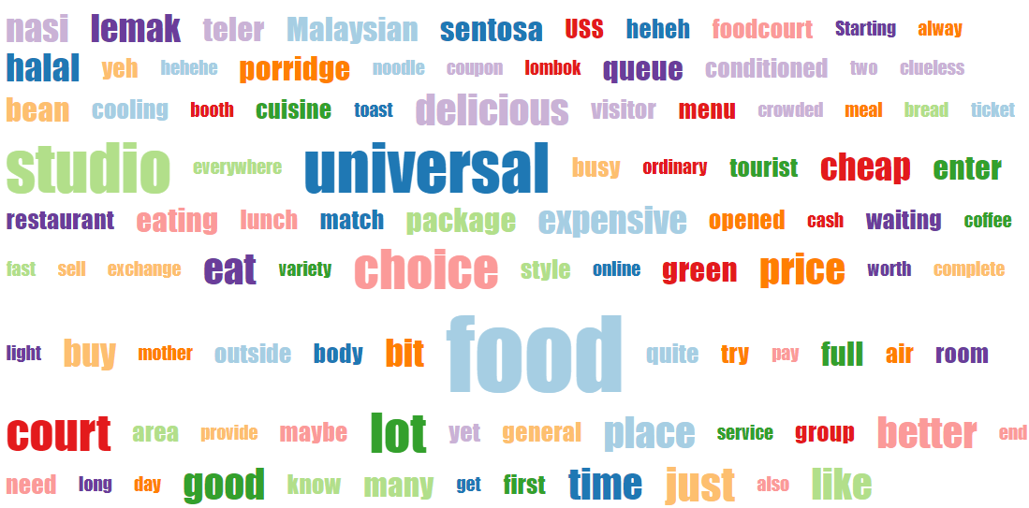

Figure

(Figure 43) **6** of 8 (75%) Hard Rock Café (#3) reviews were given 5/5 while the remaining 2 had four-stars ratings out of five (5)

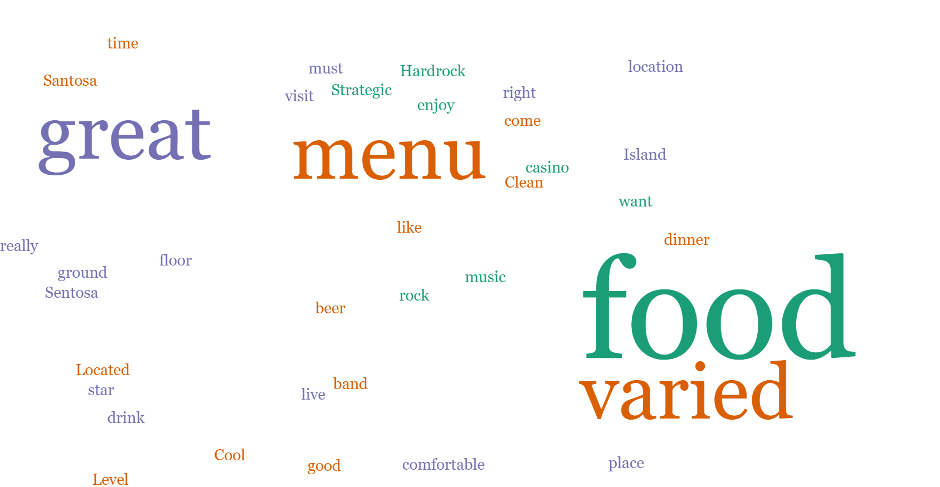

Figure

‘PRICE’ and ‘EXPENSIVE’ in the top words but absent for low ratings (Figure 44)

Word cloud translated for 10 reviews rated 3/5 & below

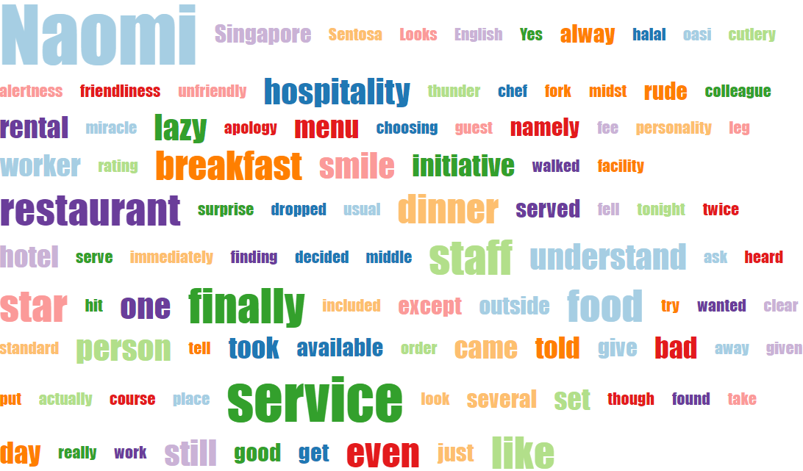

Figure

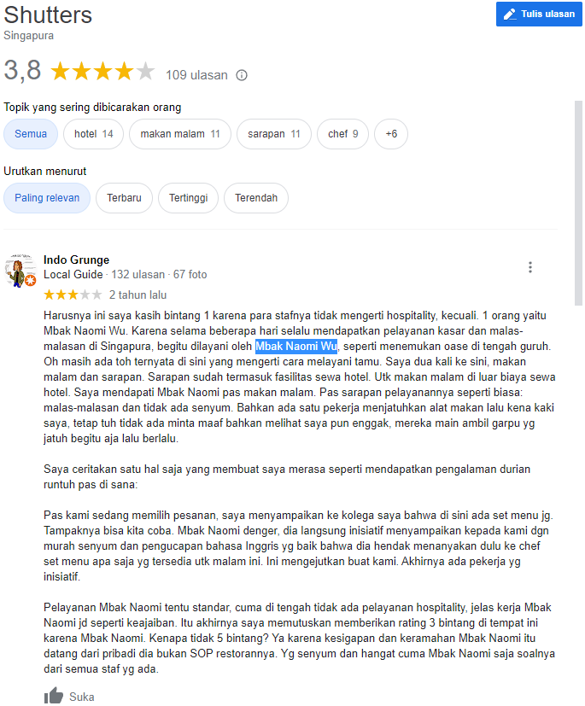

Number of characters (including spaces): 1728

Number of characters (without spaces): 1412

**Number of words: 276**

Number of sentences: 20

Number of syllables: 603

**Level 7** (out of 10)  
<https://support.google.com/local-guides/answer/6225851?hl=en>

Figure <https://goo.gl/maps/uGcjxbKtYbMATKdH7>

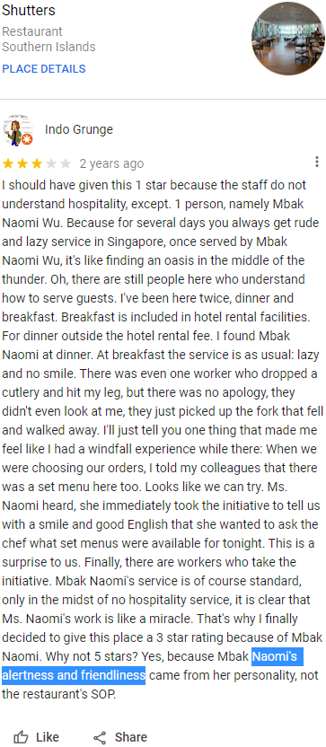

Face-masking wearing mandatory mid-Apr 2020

2020 (Data collected 2022 May) Covid19 restriction started April 2020

Figure

## **Hindsight**

Top word ‘Naomi’ in the low rating word cloud emerged from a single review that mentioned the specific staff by name nineteen (19) times. This case study of a supposedly neutral three stars rating revealed a resulting positive sentiment salvaged from an initial negative experience. Such linguistics nuances might prove challenging for current NLP model to be fully capable of analyzing with a simplistic scale of just positive, neutral, or negative.

This small dataset for Sentosa hotels and dining from Indonesian visitors dated 2018 till May 2022 might not be ideal for NLP machine learning in Artificial Intelligence which typically involves Big Data. But this provided the valuable opportunity to branch-off with simple functionalities in Excel spreadsheet and readily available free tools online to extract surprisingly useful insight using traditional textual data analysis quickly. Users are only required to have basic understanding of data and statistics to execute, without extensive ability to write programming codes. Even with coding completed, this framework of insight extraction forms the backbone of this textual data processing and shed light on much of the project direction. This manual methodology also could serve as a verification checks against the NLP models built to test accuracy.

# 4. Part of Speech Extraction and Analysis – By Odelia Tan

Ever wondered how certain words lets people know which one, what kind or how many of something that you are talking about? Or to what extent are you describing a subject or why certain words represents a name, place, thing or idea?

In English, as in many languages, each word belongs to a part of speech. These words when grouped together, show a common feature about them. They could be words that are used to describe a place or a thing or they could be words that let others know to what degree you are describing an object.

In this chapter, we use part of speech to extract words that describe about what is in Sentosa from our text corpus of reviews which serves to give us meaningful keywords without having to read every single line of reviews.

## **4.1 Background**

Part of speech indicates how the word functions in meaning as well as grammatically within the sentence. In English, as in many other languages, a single word can function as more than one part of speech when used in different circumstances. Understanding part of speech is essential for determining the correct definition of a word when using the dictionary. There are eight Parts of speech in the English language: noun, pronoun, verb, adjective, adverb, preposition, conjunction, and interjection.

1. Noun

A noun is the name of a person, place, thing or idea. Nouns are often used with an article (the, a, an) but not always. Proper nouns always start with a capital letter; common nouns do not. Nouns can function in different roles within a sentence. For example, a noun can be a subject, direct object, indirect object, subject complement, or object of a preposition.

*The young* ***girl*** *asked her* ***mother*** *to bring her to the* ***beach*** *at* ***Sentosa*** *for a* ***picnic*** *and then she quickly hid under the blanket. Wow!*

1. Pronoun

A pronoun is a word that is used in place of a noun. A pronoun is usually substituted for a specific noun, which is called its antecedent. In the italics sentence below, the antecedent for the pronoun her is the girl. Pronouns are further defined by type: personal pronouns refer to specific persons or things; possessive pronouns indicate ownership; reflexive pronouns are used to emphasize another noun or pronoun; relative pronouns introduce a subordinate clause; and demonstrative pronouns identify, point to, or refer to nouns.

*The young girl asked* ***her*** *mother to bring* ***her*** *to the beach at Sentosa for a picnic and then* ***she*** *quickly hid under the blanket. Wow!*

1. Verb

The verb in a sentence expresses action or being. There is a main verb and sometimes one or more helping verbs. (“*She can dance.*” *Dance* is the main verb; *can* is the helping verb.) A verb must agree with its subject number (both are singular or both are plural). Verbs also take different forms to express tense.

*The young girl* ***asked*** *her mother to* ***bring*** *her to the beach at Sentosa for a picnic and then she quickly* ***hid*** *under the blanket. Wow!*

1. Adjective

An adjective is a word used to modify or describe a noun or a pronoun. It usually answers the question of which one, what kind, or how many. (Articles [a, an, the] are usually classified as adjectives.)

*The* ***young*** *girl asked her mother to bring her to the beach at Sentosa for a picnic and then she quickly hid under the blanket. Wow!*

1. Adverb

An adverb describes or modifies a verb, an adjective, or another adverb. It usually answers the questions of when, where, how, why, under what conditions, or to what degree. Adverbs often end in -ly.

*The young girl asked her mother to bring her to the beach at Sentosa for a picnic and then she* ***quickly*** *hid under the blanket. Wow!*

1. Preposition

A preposition is a word placed before a noun or pronoun to form a phrase modifying another word in the sentence.

*The young girl asked her mother to bring her to the beach at Sentosa for a picnic and then she quickly hid* ***under*** *the blanket. Wow!*

1. Conjunction

A conjunction joins words, phrases, or clauses and indicates the relationship between the elements joined. Coordinating conjunctions connect grammatically equal elements: and, but, or, nor, for, so, yet. Subordinating conjunctions connect clauses that are not equal: because, although, while, since, etc.

*The young girl asked her mother to bring her to the beach at Sentosa for a picnic* ***and*** *then she quickly hid under the blanket. Wow!*

1. Interjection

An interjection is a word used to express emotion.

*The young girl asked her mother to bring her to the beach at Sentosa for a picnic* ***and*** *then she quickly hid under the blanket.* ***Wow****!*

## **4.2 Methodology and Design**

Native speakers possess an intuitive knowledge of parts of speech (often without an awareness of the underlying technicalities) but computers have to first understand these constituent parts of speech before they can effectively analyse language.

Part-of-speech tagging for Indonesian language has been limited and industrial-strength libraries such as Natural Language Toolkit and spaCy also do not have support for it.

For this project, Stanza, a Python natural language analysis package created by StanfordNLP, has been chosen to do Part-of-speech tagging. The toolkit is designed to be parallel among more than 70 languages, using the Universal Dependencies formalism. For each word in a sentence, Stanza assigns it a POS, and analyses its universal morphological features (UFeats, e.g., singular/plural, 1st/2nd/3rd person, etc.). To predict POS and UFeats, it adopts a bidirectional long short-term memory network (Bi-LSTM) as the basic architecture. For consistency among universal POS (UPOS), treebank-specific POS (XPOS), and UFeats, it adopts the biaffine scoring mechanism from Dozat and Manning (2017) to condition XPOS and UFeats prediction on that of UPOS.

The 17 Universal Part of Speech tags are shown in the table below.

|  |  |
| --- | --- |
| Universal Part of Speech Tags | |
| ADJ: adjective  ADP: adposition  ADV: adverb  AUX: auxiliary  CCONJ: coordinating conjunction  DET: determiner  INTJ: interjection  NOUN: noun  NUM: numeral | PART: particle  PRON: pronoun  PROPN: proper noun  PUNCT: punctuation  SCONJ: subordinating conjunction  SYM: symbol  VERB: verb  X: other |

Table 1: Universal Part of Speech Tags

Using Stanza, adjectives were first chosen to be extracted as they are descriptive words that can show us what people are describing about Sentosa. Adverbs were then added as they could help to show to what extent of the descriptive words that were used. Lastly, nouns were added to help identify what was being described.

Using the concept of ngrams, a bigram would consist of an adverb and an adjective while a trigram would consist of a noun, an adverb and an adjective or an adverb, an adjective and a noun in the sequences as mentioned.

The tables below show a comparison of unigrams versus bigrams vs trigrams.

|  |  |  |
| --- | --- | --- |
| Unigrams | | |
| Part of Speech | Indonesian | English |
| Adjectives | puas  lama  nak  murah  panas  ampun  keren  lengkap  luas  nyaman | satisfied  long  nice  inexpensive  hot  sorry  cool  complete  large  comfortable |

Table 2: Unigrams

|  |  |  |
| --- | --- | --- |
| Bigrams | | |
| Part of Speech | Indonesian | English |
| Adverb + Adjective | sangat lengkap  sangat nyaman  cukup mahal  lebih baik  terlalu besar  kadang jengkel  juga bersih  sangat bagus  juga enak  lebih seru | very complete  very comfortable  quite expensive  better  too big  sometimes annoyed  also clean  very good  also delicious  more fun |

Table 3: Bigrams

|  |  |  |
| --- | --- | --- |
| Trigrams | | |
| Part of Speech | Indonesian | English |
| Adverb + Adjective + Noun  Noun + Adverb + Adjective | paling seru transformer  sangat spektakuler tempat  sangat wow tempat  kurang pas anak  sangat bersih disini  paling keren 3d  lumayan mahal tempat  sagat bagus tempat  sangat rekomended pengalaman  lumayan moderen pertunjukan | the most exciting transformer  very spectacular place  very wow place  not fitting for children  very clean here  the coolest 3d  pretty expensive place  really good place  very recommended experience  pretty modern show |

Table 4: Trigrams

It can be seen that after adding adverbs and nouns to the initial unigram which was only an adjective by itself, the phrases add more meaning and context to the adjectives. Thus, for the purpose of this project, bigrams and trigrams which consisted of adverbs, adjectives and nouns were chosen to be extracted from the text corpus of reviews. For simplicity, the term ‘ngrams’ will be used to represent bigrams and trigrams throughout this chapter.

The ngrams would be run on Google Cloud Natural Language API for Sentiment Analysis which would classify them into positive, negative or neutral. This would help to group the ngrams which belong to the same sentiment together for a cleaner analysis.

Using the review ids which were uniquely tagged to all the reviews, the ngrams can be linked back to the reviews to get a bigger picture of what the Indonesians are saying about Sentosa.

All ngrams and reviews in Indonesian Language would be translated into English Language using Google Translate.

## **4.3 Findings**

Using Tableau Desktop, horizontal bar charts of the frequency of positive and negative ngrams were plotted for years 2017 to 2022 for the attractions: Adventure Cove, Beach Waterfront, Cable Car, S.E.A Aquarium, Skyline Luge, Universal Studios Singapore and Wings of Time.

The image below shows the positive ngrams sorted by highest frequency for Skyline Luge in 2019.

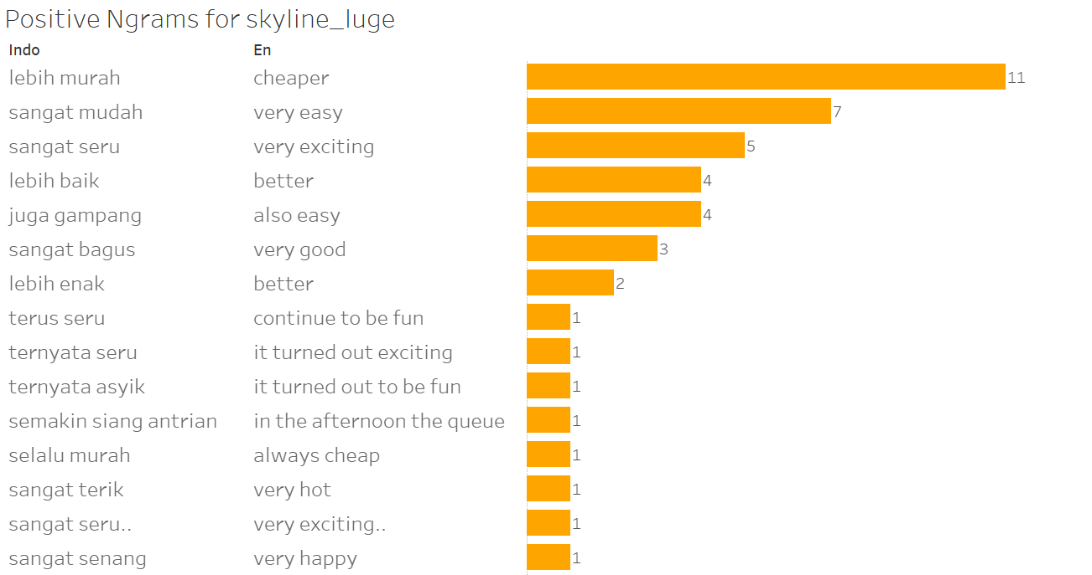

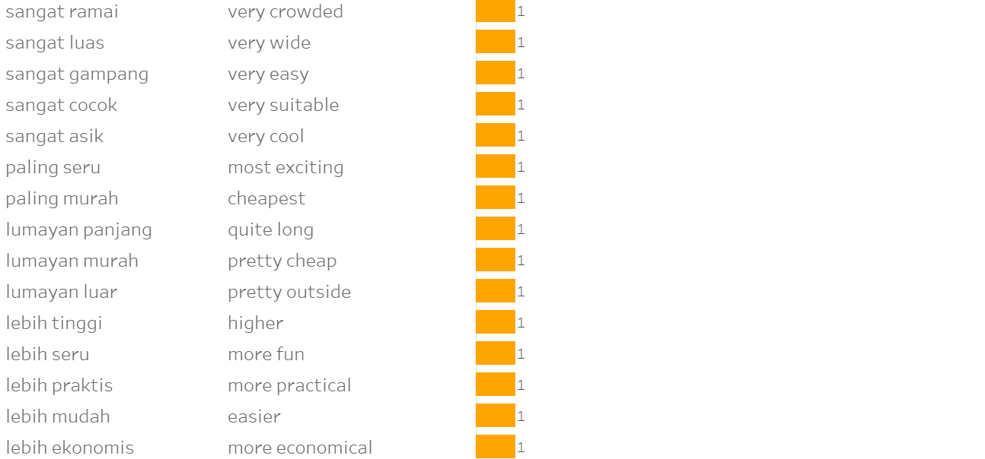

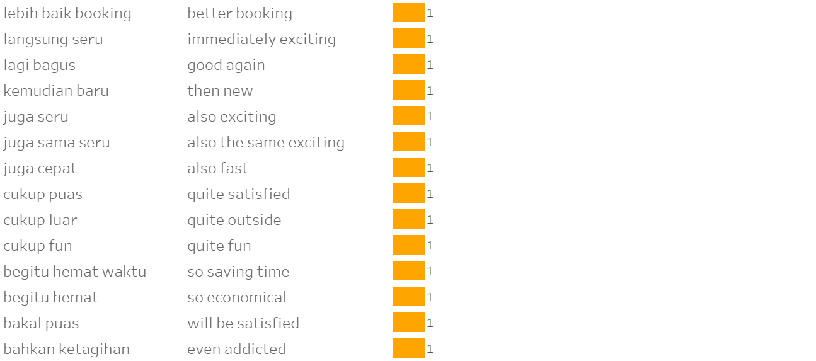

Figure 1: Positive Ngrams for Skyline Luge in 2019

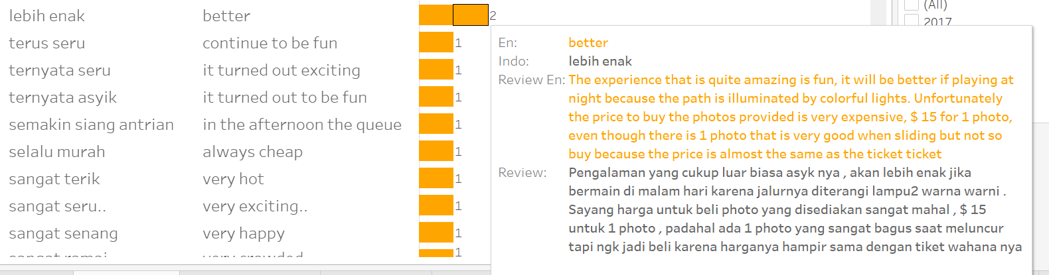

Figure 2: Sample Review for Ngram ‘better’ for Skyline Luge in 2019

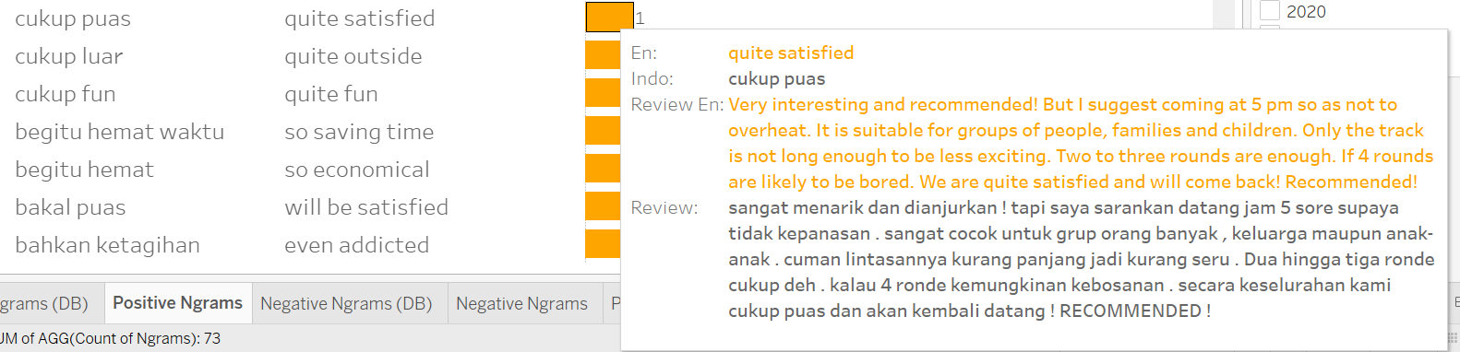

Figure 3: Sample Review for Ngram ‘quite satisfied’ for Skyline Luge in 2019

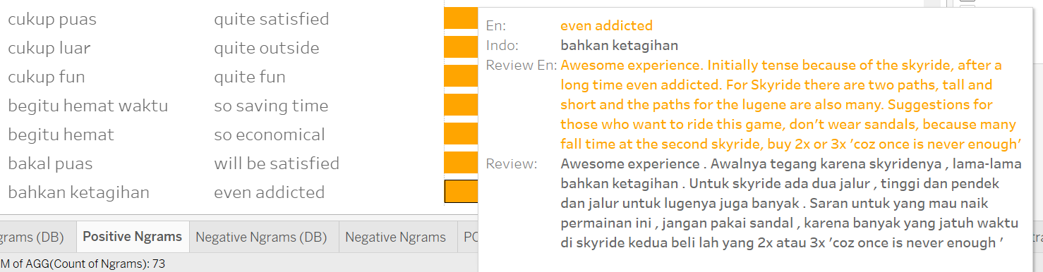

Figure 4: Sample Review for Ngram ‘even addicted’ for Skyline Luge in 2019

The image below shows the negative ngrams sorted by highest frequency for Skyline Luge in 2019.

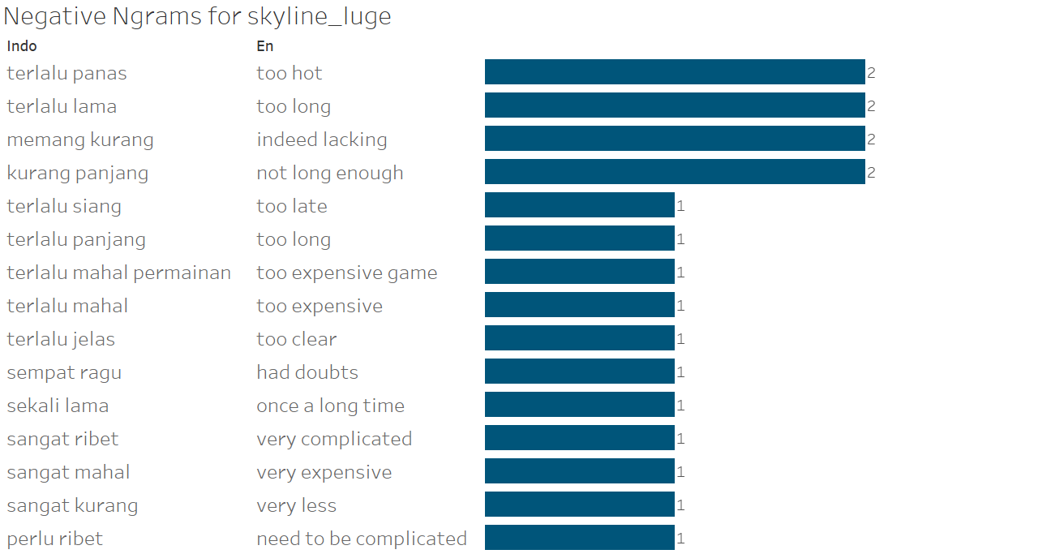

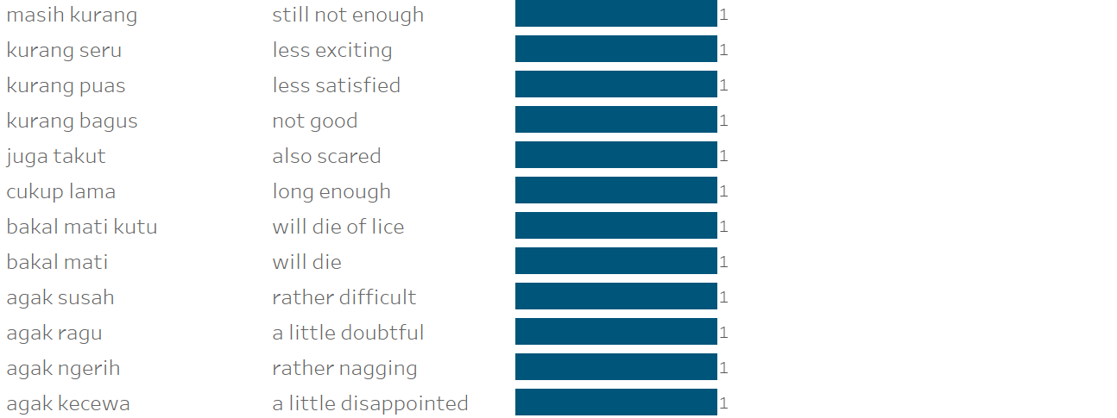

Figure 5: Negative Ngrams for Skyline Luge in 2019

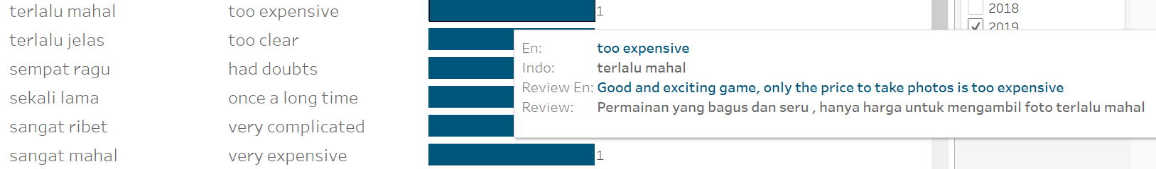

Figure 6: Sample Review for Ngram ‘too expensive’ for Skyline Luge in 2019

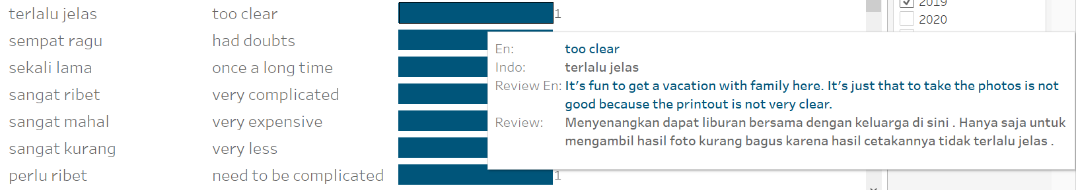

Figure 7: Sample Review for Ngram ‘too clear’ for Skyline Luge in 2019

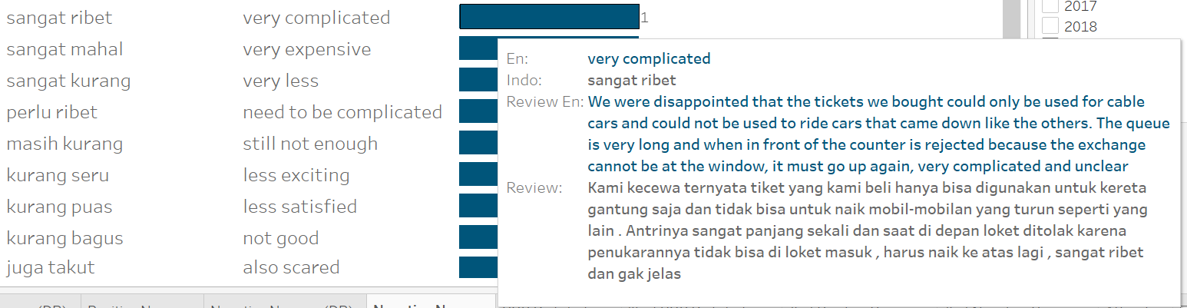

Figure 8: Sample Review for Ngram ‘very complicated’ for Skyline Luge in 2019

## **4.4 Evaluation and Analysis**

This model serves to narrow down the reviews to the bare minimum of the adjectives, adverbs and nouns which describes what the Indonesians are talking about for the various attractions in Sentosa.

Even though the frequency of the ngrams may be small for some ngrams, these ngrams actually serve as keywords which we can scan through to get a quick overview of what keywords Indonesians are using to describe the attractions in Sentosa. Also, these ngrams could also lead us to reviews which are of better quality and of use to Sentosa Development Corporation. Using Tableau Desktop, the dashboard allows users to interact with it by choosing whing year or attraction. One of the highlights of the dashboard is that by hovering the horizontal bar charts, users can also see the reviews which contains the ngram in both Indonesian and English Language (translated).

The image below shows the final dashboard created using Tableau Desktop.

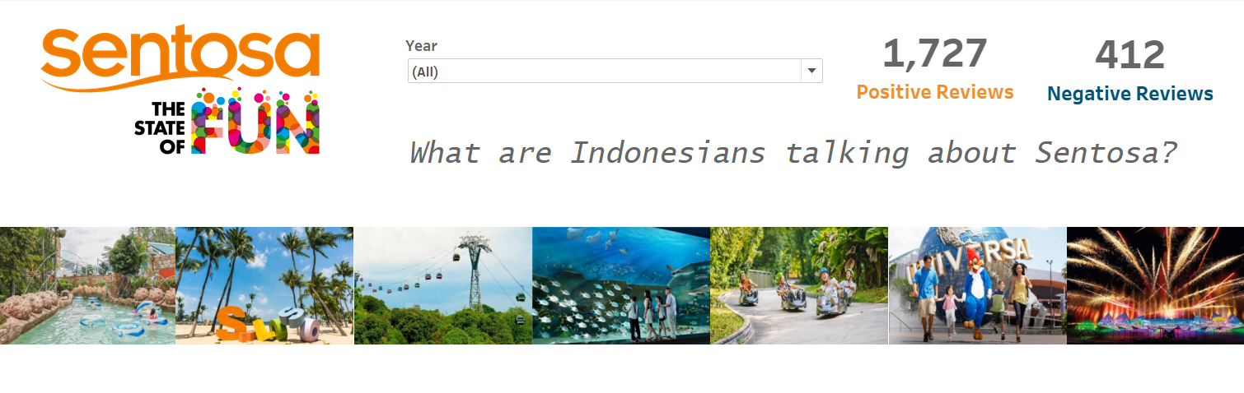

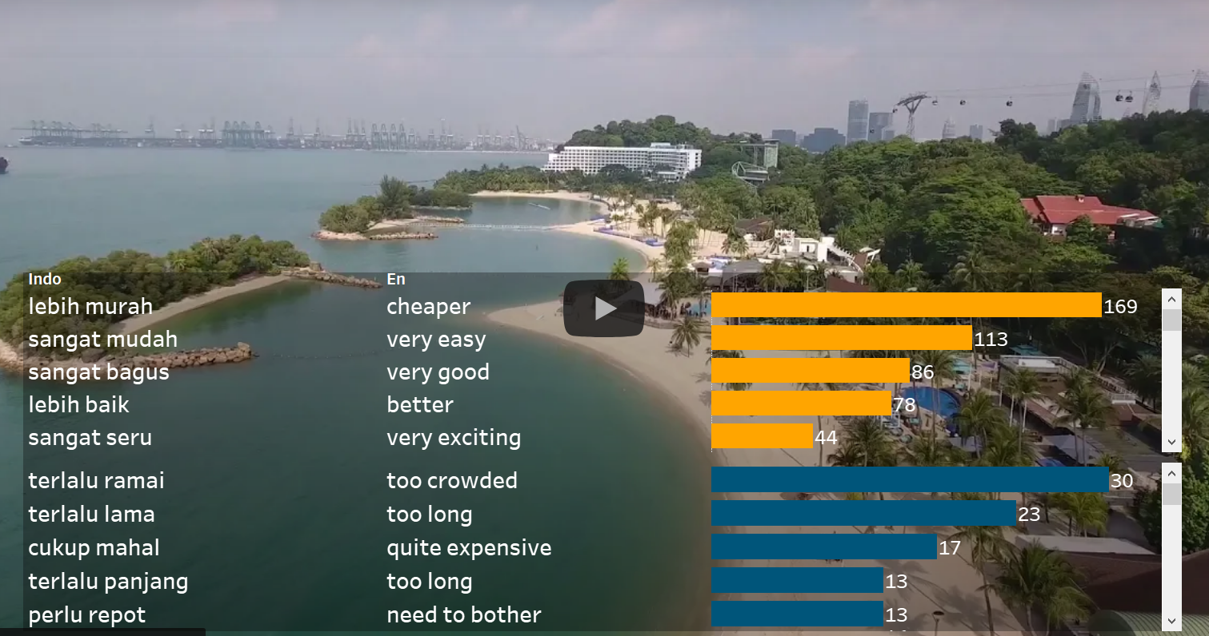

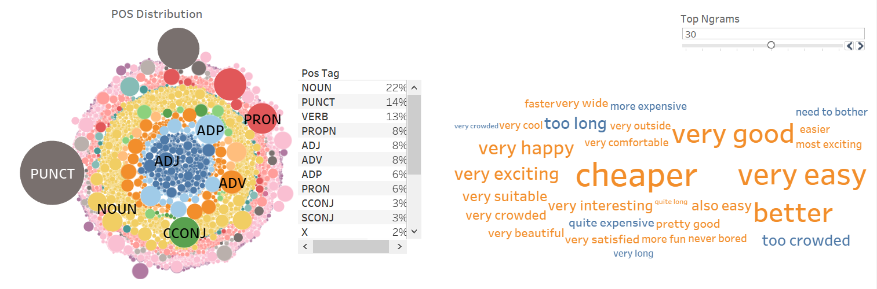

Figure 9: Dashboard done in Tableau Desktop

Overall, this model which uses part of speech to tag the reviews and extract the adjectives, adverbs and nouns out as bigrams and trigrams shows how different part of speech can be made used of to extract specific information that we want from a text corpus. This saves time and filters out unnecessary texts which users could spend long hours reading.

## **4.5 Conclusion**

In this chapter, we utilised part-of-speech tagging to extract adjectives, adverbs and nouns as bigrams and trigrams to acquire meaningful keywords. These meaningful keywords, grouped by sentiments using Google Cloud Natural Language API give us insights into what Indonesians are talking about the various attractions in Sentosa in a more concise manner compared to reading the reviews individually.

## **4.6 Recommendations**

Incorporate Topic Labelling (to be discussed in Chapter 5) into the dataframe to classify reviews according to topics which would act as an additional filter such that the ngrams would be classified as shown below. This would aim to provide an even more streamlined analysis.

Figure 10: Classification of Ngrams

# 5. Topic Modelling and Labelling – By Alfred Tan

This scope aims to extract out topics and keywords from a large set of documents, in the form of attractions and travel reviews sourced from Klook, Traveloka, Google reviews and TripAdvisor in Bahasa Indonesia language.

Apart from extracting topics, these topics will be labelled that best describes the topics. The goal is to give every travel review in the text data a topic label. Creating high level summaries of the travel review is now made possible.

The dataset consists of about 5000 reviews extracted from the 4 travel review websites described previously on Universal Studios, S.E.A Aquarium, Skyline Luge, Beaches, Wings of Time, Cable car and Adventure Cove. For this scope, Top2Vec is used to carry out topic modelling on the dataset. This algorithm detects topics present in the text data master-list and generates jointly embedded topic, document and word vectors. Once the Top2Vec model is trained, we can obtain number of detected topics, hierarchichal topics, search topics by keywords, search documents by topic, search documents by keywords.

Thereafter, Pandas can be used to extract insights derived from the Top2vec algorithm. Data-frames will be constructed to contain all useful information and extracted insights. The final format would be to convert from a Pandas Dataframe format to an exportable MS Excel file.

## **5.1 Background**

In doing text analysis and considering topic modelling as a solution to the problem, Top2Vec is used. Top2Vec allows complex topic modelling to be carried out with only a few lines of code. If the traditional Latent Dirichlet Allocation is used to perform topic modelling, a lot of text pre-processing and manual coding to get the topic model working correctly.

Topic modelling is a way we used unsupervised learning, in machine learning terms to throw a whole bunch of documents at the model so that it can find patterns of similarity and cluster them into topics. These topics will be analysed and be given labels.

Top2Vec essentially is a seamless pipeline that brings together a bunch of python libraries in one easy to use library. Top2Vec wraps around Python, Tensorflow, UMAP and HDBSCAN. The first thing this algorithm does is to convert all the documents into numbers. In this scope, the embedding model is adopted from sentence transformers library from S-Bert or Hugging Face.

What this means is that the documents will be converted into a single vector. This vector is a number that corresponds to a meaning; in another words what the document is all about. However, these vectors are very high dimension which means they have a lot of numbers that relate to the meaning of all the words in your document. To understand what these documents mean for humans to understand, the documents need to be flattened out and reduce the dimensionality of these vectors.

In this Top2Vec algorithm, it leverages the new UMAP algorithm for dimensionality reduction. When this process is completed, the documents are flattened out and then can be graphed in two-dimensional or three-dimensional space. Once the data has been reduced in dimensionality, the algorithm uses HDBSCAN which is able to go over all these plots on a graph in two-dimensional space and find the areas of concentration. These areas of concentration or clusters indicate semantic similarity.

Documents that have an underlying similarity have an underlying topic. This is the latent or hidden quality of topic modelling finding these hidden topics that might exist because of overlapping semantic similarity.

This means that documents that have similar words used in similar ways tend to mean or belong to similar topics. These clusters are then vectorized with the central most document in that cluster being the topic vector. All other document vectors are moving outward in the outer circumference around that topic vector in decreasing similarity to that vector’s core or central topic. The top 50 similar words will be extracted that capture the meaning of that topic. Anyone can make use of these core words that make that topic particular and unique amongst all the data set.

## **5.2 Methodology and Design**

The assumption the algorithm makes is that many semantically similar documents are indicative of an underlying topic. The following are the steps to the methodology.

**Step 1: Create a joint embedding of document and word vectors with sentence transformers.**

Once documents and words are embedded in a vector space the goal of the algorithm is to find dense clusters of documents, then identify which words attracted those documents together. Each dense area is a topic and the words that attracted the documents to the dense area are the topic words. Semantically similar documents should be placed close together in the embedding space, and dissimilar documents are placed further from each other. Words should be close to documents which they best describe.

**Step 2: Create lower dimensional embedding of document vectors using**[**UMAP**](https://github.com/lmcinnes/umap)**.**

Document vectors are in high dimensional space and are sparse from each other. Dimension reduction helps for finding dense areas. UMAP is a stochastic algorithm and is used in the backend of Top2Vec. It makes use of randomness both to speed up approximation steps, and to aid in solving hard optimization problems. This means that different runs of UMAP can produce different results.

**Step 3: Find dense areas of documents using HDBSCAN.**

At this stage, document vectors will have varying density throughout the semantic space. There are sparse areas where documents are not similar. The goal of density-based clustering is to find areas of highly similar documents in the semantic space, which indicate an underlying topic. Not similar documents, often seen as noise as there is no prominent underlying topic. To overcome this, a clustering algorithm used is Hierarchical Density-Based Spatial Clustering of Applications with Noise (HDBSCAN) to find dense areas of document vectors. HDBSCAN assigns a label to each dense cluster of document vectors and assigns a noise label to documents not in any dense clusters.

**Step 4: Establish topic vectors by calculating centroid of document vectors for each dense area.**

After UMAP and HDBSCAN processes are completed, and the document vectors in every dense cluster fully labelled, topic vectors can be calculated. Top2Vec uses simple method of calculating the centroid which is the mean distance of the dense area of documents to the topic vector. The centroid is calculated for each set of document vectors that belong do a dense cluster, generating a topic vector for each set. The number of dense areas found is the number of prominent topics identified in the corpus.

#### **Step 5: Find closest word vectors to the resulting topic vector.**

The distance of each word vector to the topic vector will indicate how semantically similar the word is to the topic. The words closest to the topic vector are the words most similar to all documents into the dense area, as the topic vector is the centroid of that area. These words can be used to summarize the common topic of the documents.

Common words appearing in most documents are often in a region of the semantic space that is equally distant from all documents. Therefore, words closest to a topic vector will rarely be stop-words. Thus, there is no need for stop-word removal when using Top2Vec for topic modelling.

## **5.3 Findings**

After understanding the model from a theoretical perspective, let’s get our hands dirty by going deep into the actual code workflow.

**Finding #1 – Default Unigram output not adequate to derive topic label**

During the initial stage, the Top2Vec model is run using many default parameters, including the default tokenizer Gen sim simple pre-process function. The results generated by the model are single words in the form of unigrams. A collection of 50 unigrams makes it difficult to put forward a convincing label to best describe the topic.

**Solution:**

A solution to this problem is to create 2 words and 3 words combination, specifically N-Grams range (1,2) or (1,3). In the case of N-Gram range (1,3), this means a minimum of unigram and a maximum of trigram. Once I feed this callable to the parameter in the model, it will result in an output of a mix of bigrams and trigrams in each cluster of 50 words.

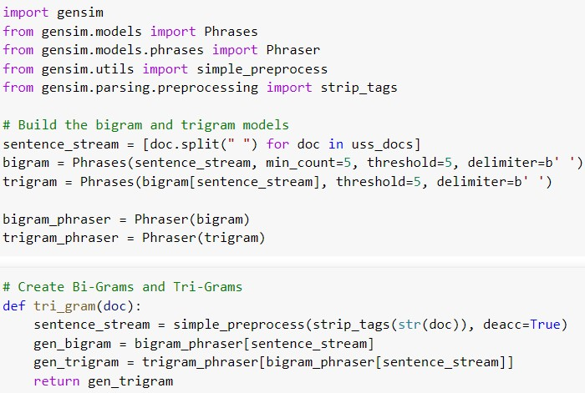

Gen sim library has functions such as Phrases and Phraser to create phrases in the form of bigram and trigra. In the above example, a function named tri_gram groups together the steps required to create trigrams using Gen sim library. The function will be called into the tokenizer parameter of the Top2Vec algorithm.

**Finding #2 – Embedding model with multilingual capabilities**

In this project, SDC are looking at different segments of the Asian tourism market, specifically India, China and Indonesia. Therefore, a multi-lingual model is required to work well with any given language.

For Top2Vec, the valid string options to feed into the embedding model parameter are doc2vec, universal-sentence-encoder-multilingual, distiluse-base-multilingual-cased and paraphrase-multilingual-MiniLM-L12-v2. The SBERT pre-trained sentence transformer options: distiluse-base-multilingual-cased and paraphrase-multilingual-MiniLM-L12-v2 are suggested for multilingual datasets and languages.

The distiluse-base-multilingual-cased sentence transformer maps sentences & paragraphs to a 512 dimension dense vector space whereas paraphrase-multilingual-MiniLM-L12-v2 sentence transformer maps sentences & paragraphs to a 384 dimensional dense vector space. For this project, distiluse-base-multilingual-cased sentence transformer is adopted.

**Finding #3 – Generated results not consistent between runs**

The stochastic nature of the model leads to different results with repeated modelling. In the most apparent form, I experienced difference in the number of topics generated and the arrangement of the top 50 closest words may differ between runs. Top2Vec differs from LDA model because Top2Vec provides continuous rather than discrete topic modelling.

This is due to the stochastic nature of UMAP algorithm that is performing in the backend of the Top2Vec algorithm. UMAP is a stochastic algorithm, it makes use of randomness both to speed up approximation steps, and to aid in solving hard optimization problems. Stochastic gradient descent is used during the optimization process.

**Final Model During Training**

This will be the actual Top2Vec training of the model run.

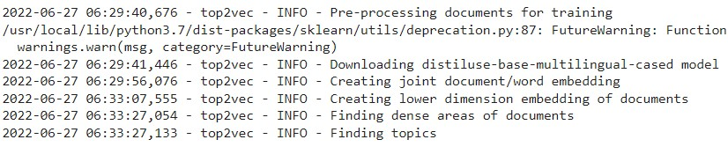

After the model is run, the unsupervised machine learning ends here. Information extraction can begin.

## **5.4 Evaluation and Analysis**

Now that the model run is completed, we can start to extract the results to evaluate and analyse. Python programming and Pandas are used to carry out these tasks.

**Evaluation #1 – Get Number of Topics**

In this example, Universal Studios has about 3800 rows of data. Due to the wide variety of chatter present in the reviews data, Top2Vec can derive between 24 to 29 different topics during repeated runs. We can reduce the number of topics to a more manageable number, without sacrificing the original structure of the topics generated.

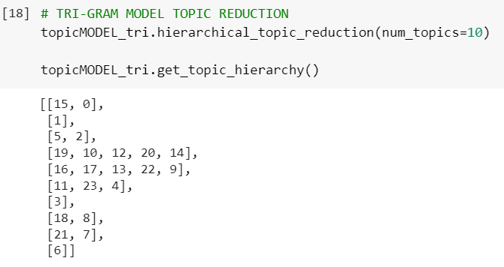

As shown above, a total of 24 topics are generated, from 0 to 23. The number of topics to be generated is set to a maximum number of 10 topics. The most representative topics will be found by iteratively merging each smaller topic to the most similar topic until the desired number of topics is reached. After topic reduction is employed. The hierarchy of topics are topic 0 is now a combination of topic 15 and 0. Topic 2 is a combination of topic 2 and 5 together.

**Evaluation #2 – Analyzing Topics and Topics words**

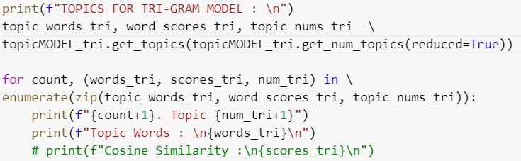

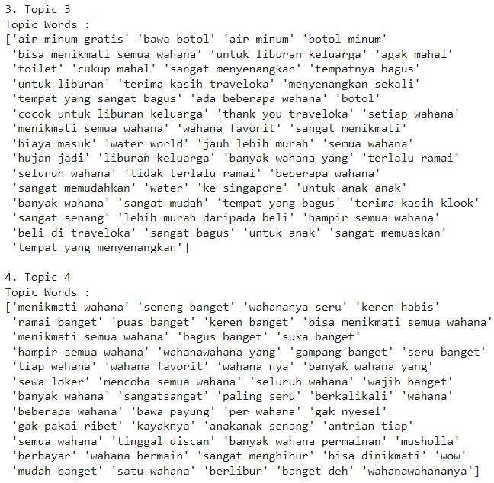

The topics words are kept in native Bahasa Indonesia throughout the entire codes. No translation API is included in the code because it is easier and faster to copy the results to Google Translate to extract and study the topics words.

**Evaluation #3 – Connect to Actual Documents with Search By Topic Number**

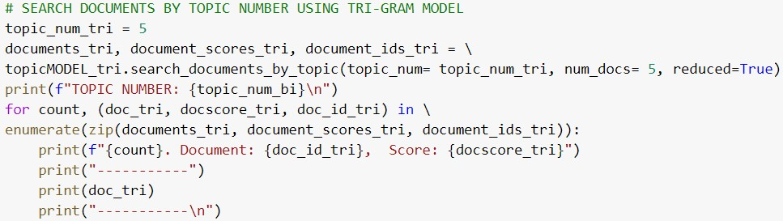

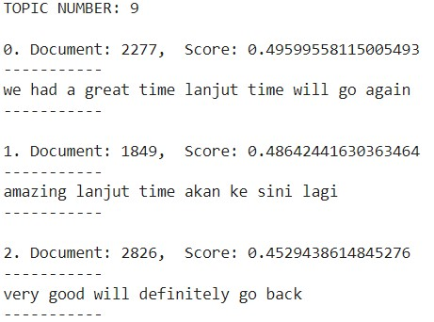

The results shown are able to link the topics to the documents that are within the dense cluster of the topic vector. In the above example, topic 9 is linked to document 2277, 1849 and 2826.

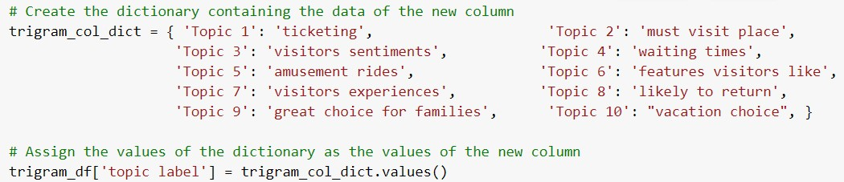**Evaluation #4 – Label the Topics with Manually Defined Names**

## **5.5 Results**

**Topic Labels**

**Universal Studios Singapore**

|  |  |
| --- | --- |
| ***Topic Labels*** | ***Selected Topic Words*** |
| Ticketing | express tickets, buy tickets, buy express tickets, buy tickets at Traveloka, ticket price, buy ticket online, buy express pass, Traveloka is very helpful, bought on Traveloka. |
| Must Visit Place | universal studios Singapore, must visit, want to visit, Indonesian people, tourist spots, for a family vacation,  from Indonesia for vacation, fun place. |
| Visitors Experiences | can enjoy all the rides, for a family vacation, abit expensive,  toilet, quite expensive, too crowded. |
| Waiting Times | too long, long enough, long queue, long queue, good but long queue, always crowded, takes time but worth it, queue every time. |
| Amusement Rides | transformer rides, Battlestar Galactica, roller coaster ride, the rides are fun, enjoyed all the rides, many rides, multiple rides , very entertaining, enjoyable, Wow. |
| Features Visitors Like | many photo spots, photo spots, Instagramable.  Many rides, many games, games are fun, amusement park,  can enjoy all the rides |
| Visitors Sentiments | A bit expensive, quite expensive, nice place, thank you Traveloka, too crowded, no regrets. |
| Likely To Return | will come back again, back again, here again, want to come back, very enjoyable, very satisfying very entertaining, |
| Vacation Choice | very nice place, beautiful place, amazing place, interesting place, favourite place, must visit place, a place of entertainment, a place to visit, vacation place. |
| Great Choice for Families | the children are happy, for the children, bring the little ones, suitable for family vacation, with family, holiday with family, family vacation. |

The above table shows the manually defined topic labels and a selection of the topic words that best describe these topic labels. Universal Studios has a wide variety of topics, at least 10 topics as compared to the other attractions in Sentosa that has a maximum of 4 prominent topics.

|  |  |
| --- | --- |
| **Attraction** | **Topic Labels** |
| Wings of Time | Visitors Sentiments  Features Visitors Like  Ticketing  Vacation choice |
| Cable Car | Visitors Experiences  Ticketing |
| Skyline Luge | Features Visitors Like  Visitors Experiences |
| Sea Aquarium | Features Visitors Like  Visitors Experiences  Visitors Sentiments |
| Sentosa Beaches and  Boardwalk Waterfront | Visitors Experiences  Features Visitors Like |
| Adventure Cove | Features Visitors Like  Visitors Experiences |

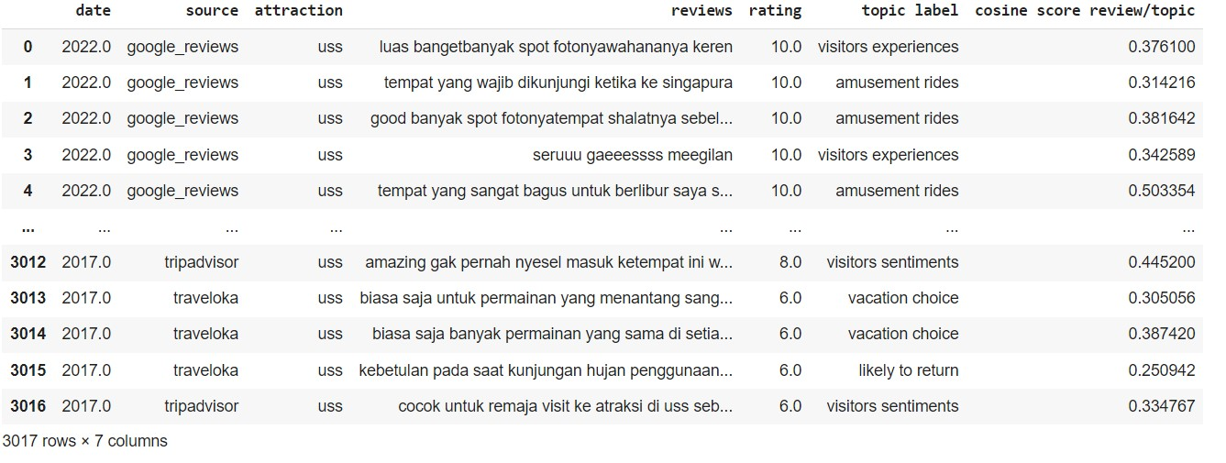Master List of Travel Reviews - Universal Studios Singapore

After the original master-list has been labelled with the 10 topics, I created additional column to display the cosine similarity score of the document vector compared against topic vector. There are a couple of ways to increase these similarity scores. The approaches are:   
  
a) Do Not Apply Topic Reduction  
  
- to allow Top2Vec to naturally extract out the maximum number of topics without topic reduction.   
- With larger number of topics, the topics words will be correctly categorized within its cluster of semantic space, where these words would best describe the topic.   
- The document vectors will have higher cosine similarity values since these documents are located in its correct topic cluster.  
  
b) Experiment with another sentence transformer  
- Use another sentence transformer and put the callable to the embedding model parameter.  
  
c) Collect curated data or Use better quality data  
- the reviews have to be collected personally from the Sentosa visitors themselves.  
- cannot rely entirely on travel review websites as there is no control on the quality and type of review the visitors are providing.

## **5.6 Conclusion**

The objectives relating to the task of topics extraction has been achieved. Top2Vec is an easy to use topic modelling algorithm. It has very good explicit and implicit capabilities to determine the clusters, extract out these topics clusters and define the topics and the closest words that describes these topics.

This algorithm leverages joint document and word semantic embedding to find topic vectords and does not require substantial text pre-processing such as lemmatization and stop words removal. Topic modelling is an effective way to gain insights about the latent topics in a collection of documents, which in our case is domain specific, concerning documents from platforms addressing visitors’ perception and sentiments to Sentosa resort island and the attractions located within Sentosa Island.   
  
The limitations of topic modelling include the requirement of a lot of relevant data and consistent structure too be able to form clusters and the need for domain expertise to interpret the relevance of the results.

## **5.7 Recommendations**

1. For future studies, parameter tuning can be carried out extensively to gauge the change in the results.
2. Instead of using Top2Vec as a topic modelling tool, Bertopic can be used to compare the results.

# GIE Conclusion

One of the key aspects of this project is data collection. Collection of data is vital and often the data is not easily extracted despite being easily accessible. Data scrapping also falls under the gray area of the law as it could easily be argued that some data collection can allow a person to piece together more details than a person is likely to be consented to giving. This also leads to the data collected being lacking or poor in "quality".

Between social media and travel review websites, social media draw its strength from being nearly instant in terms of guest feedback but shallower in terms of insights that can be derived from it.

Travel review websites have better guest feedback attributed to being incentivized to giving a more detailed review for some monetary value in exchange (discounts, membership points). Being more detailed and having more parameters like ratings. This gives us more ways to filter, process and analyse the data we can extract leading to better “quality” data.

Another issue was encountered when searching for pre-train NLP models to process and analyse the data. There are significantly lower amount of pre-trained NLP models that natively process each language. Bahasa Indonesia has less than 10 models available on hugging face versus other European language which easily has more than 30.

This significantly hampers the kind of insights you can derive with the language natively as translation introduces inaccuracies to the data. Creating your own NLP models can get around this issue.

Lastly, a marketing campaign that takes into consideration travel reviews website and social media addresses much of the problems of getting inaccurate or irrelevant data.

Despite the issues encountered, we can conclude that it is possible to derive insights from Guests speaking Asian languages from what is publicly available on the internet, and it could be further enhanced with marketing campaigns that take into consideration for social media and travel review websites.

# Appendices

(Figure 47) SDC presentation slide #10 from “GIE Insights_18 Mar 2022.pdf”:

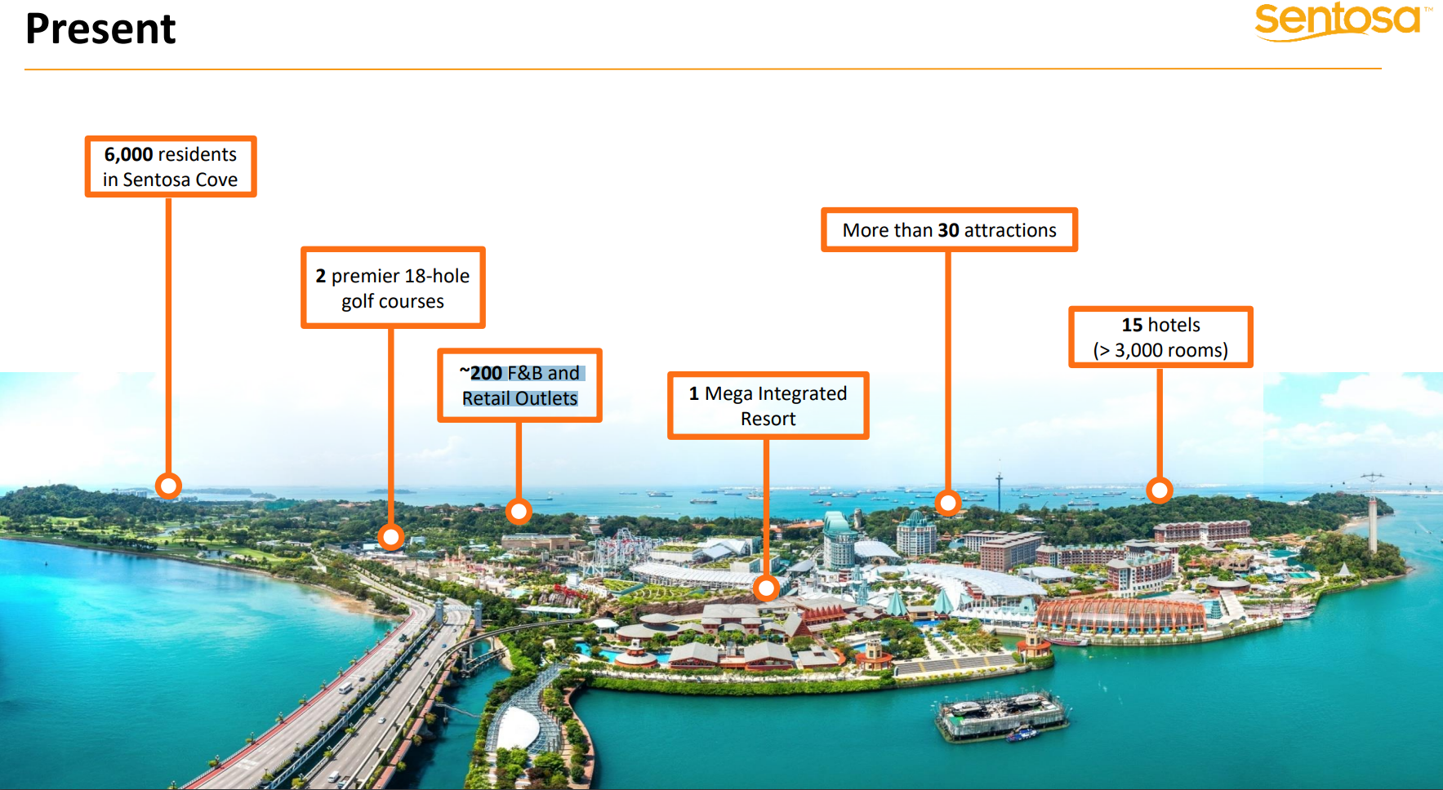

8 in RWS

Figure

(Figure 48) 115 F&B listed in Sentosa brochure 2022 March provided[55]: 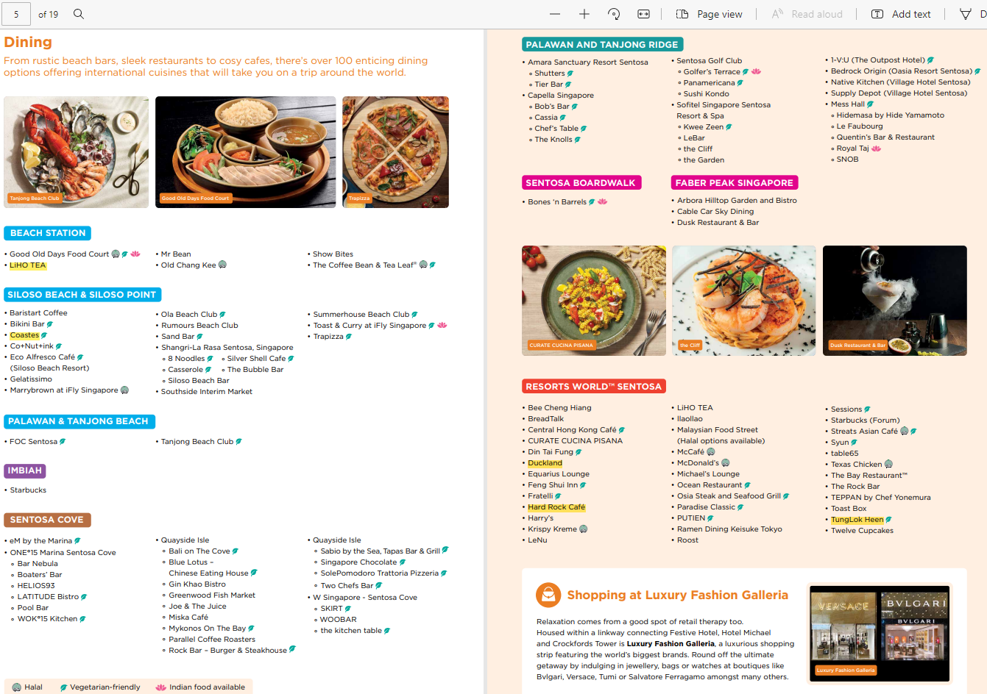

Figure

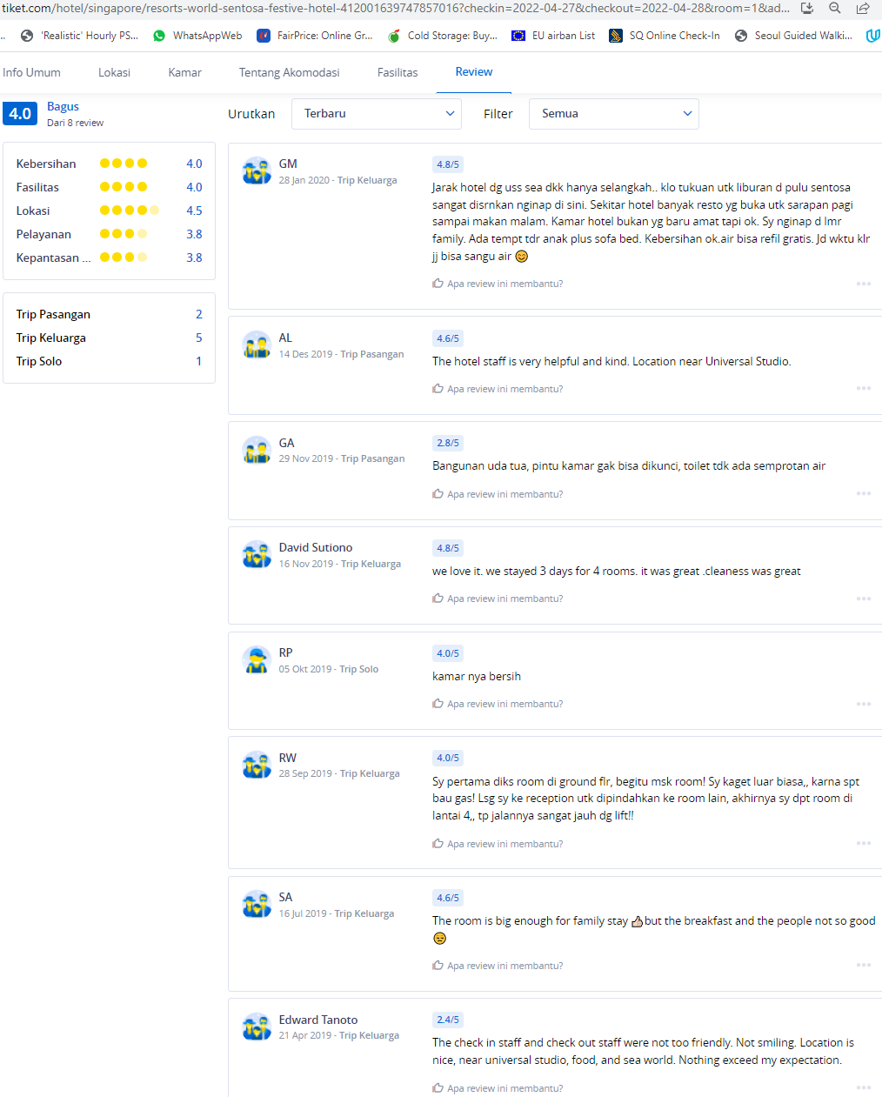

Figure

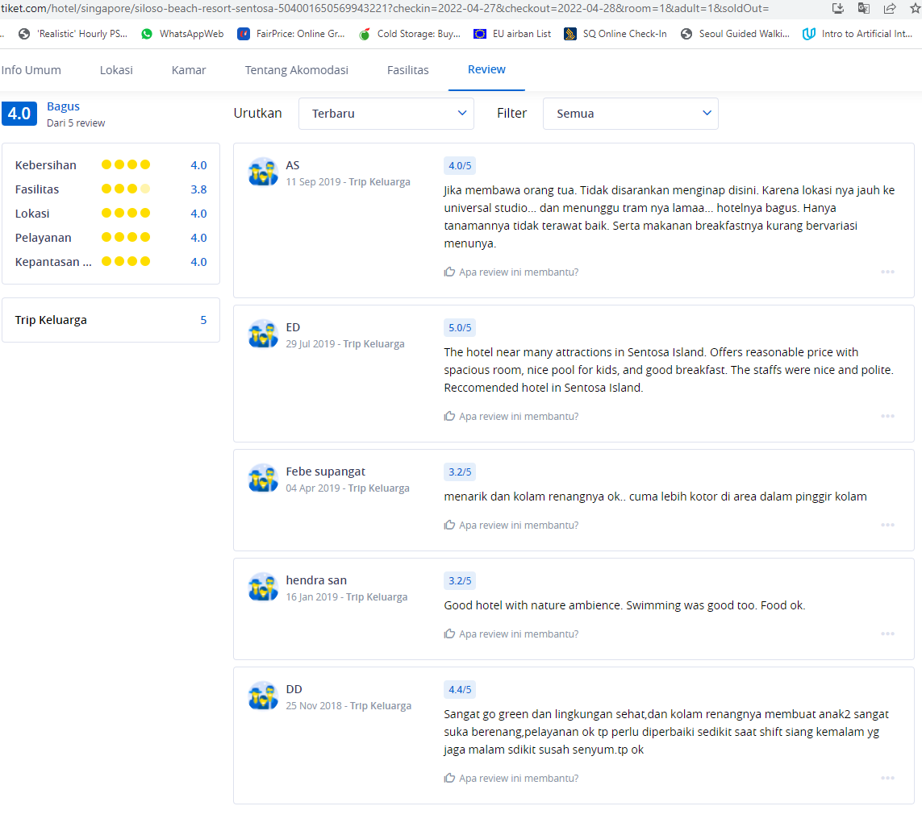

Figure

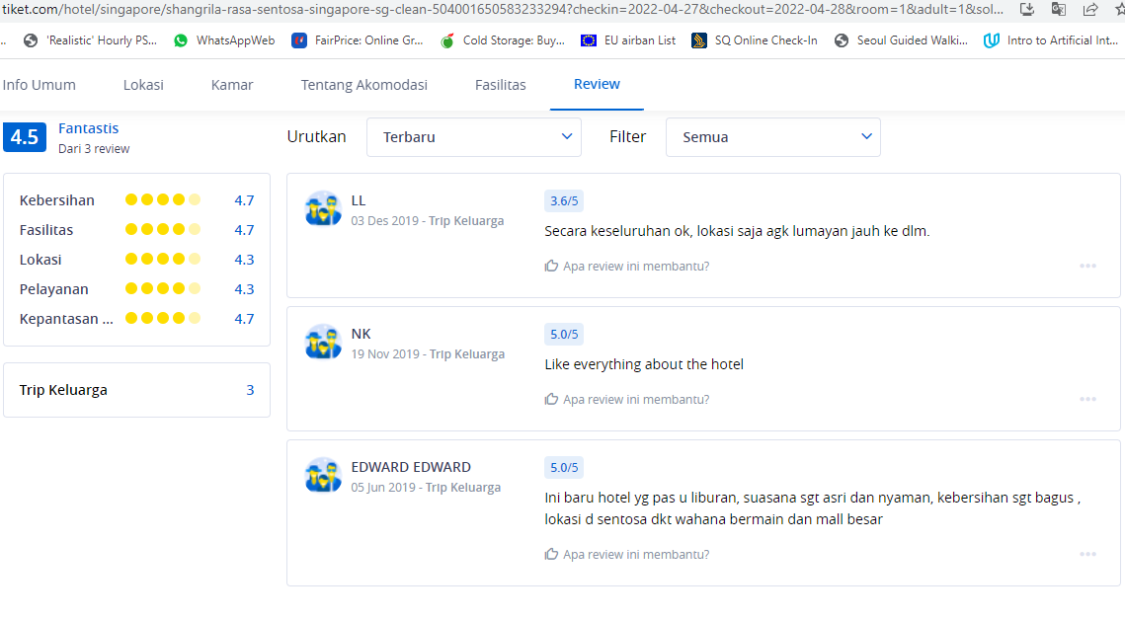

Figure

(Figure 52) Only 6 Sentosa hotels listed and the Indonesian review is outside specific date range (Figure 53)

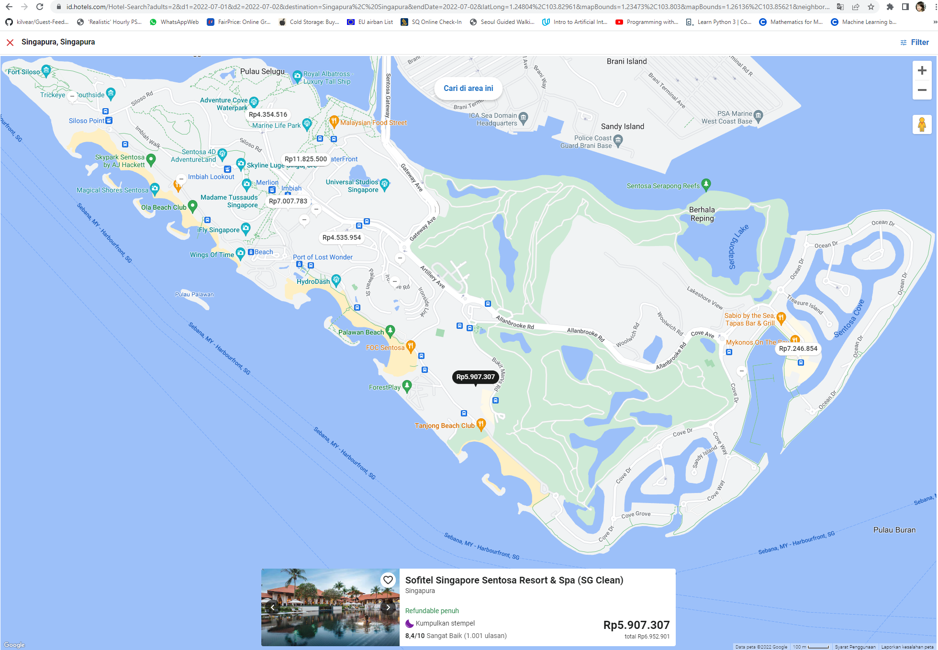

Figure

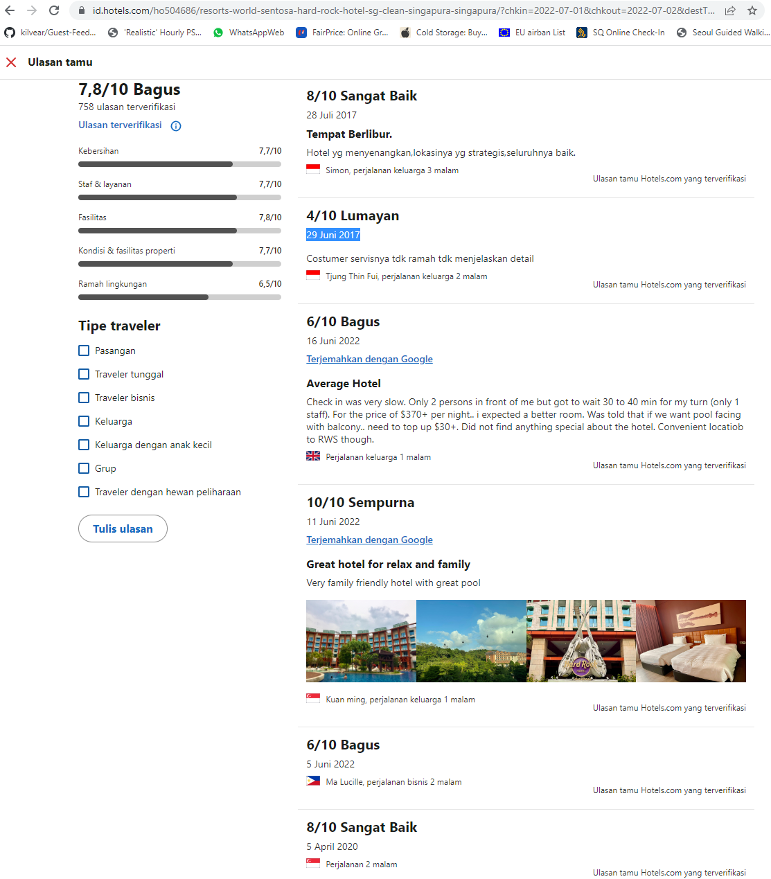

Figure

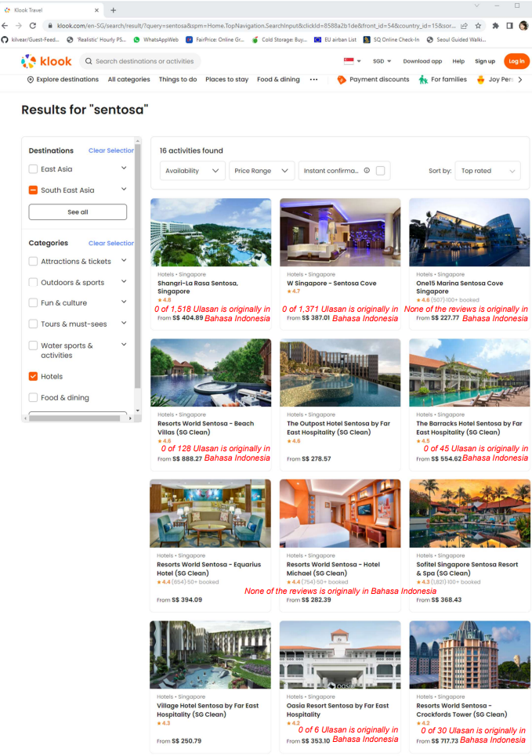

Figure

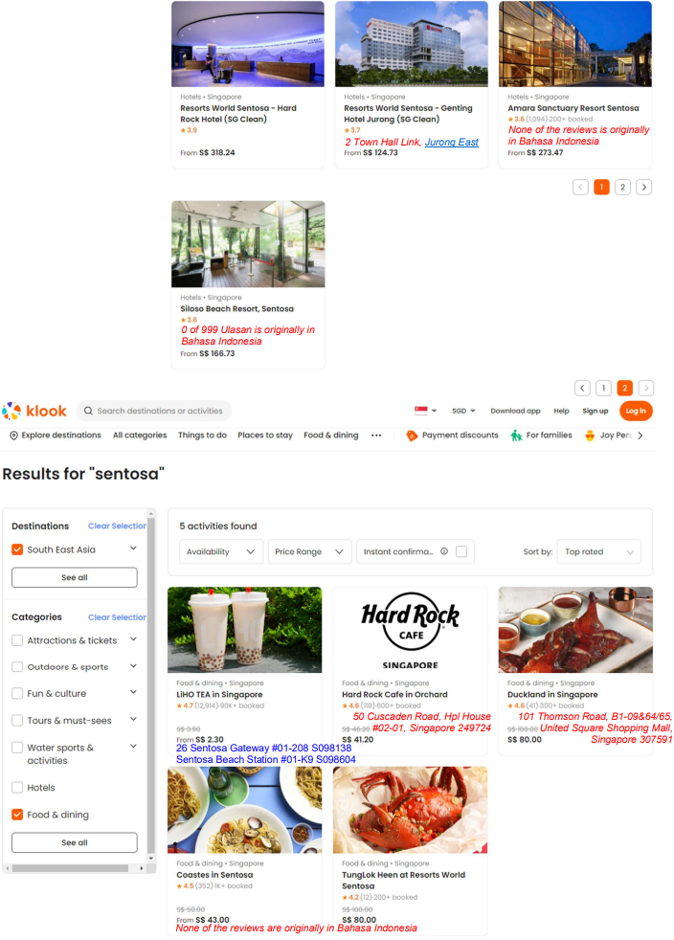

Figure

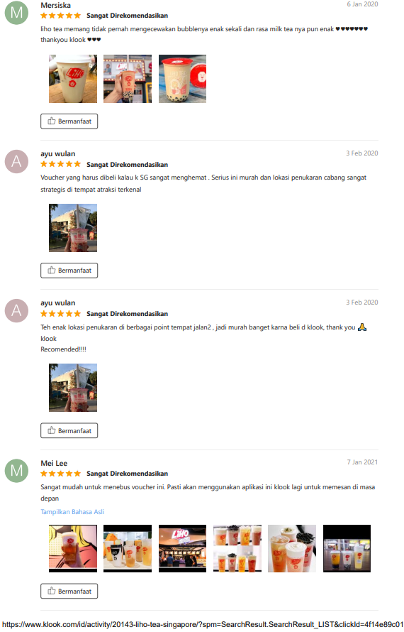

Figure 56

* ‘Show Native Language’

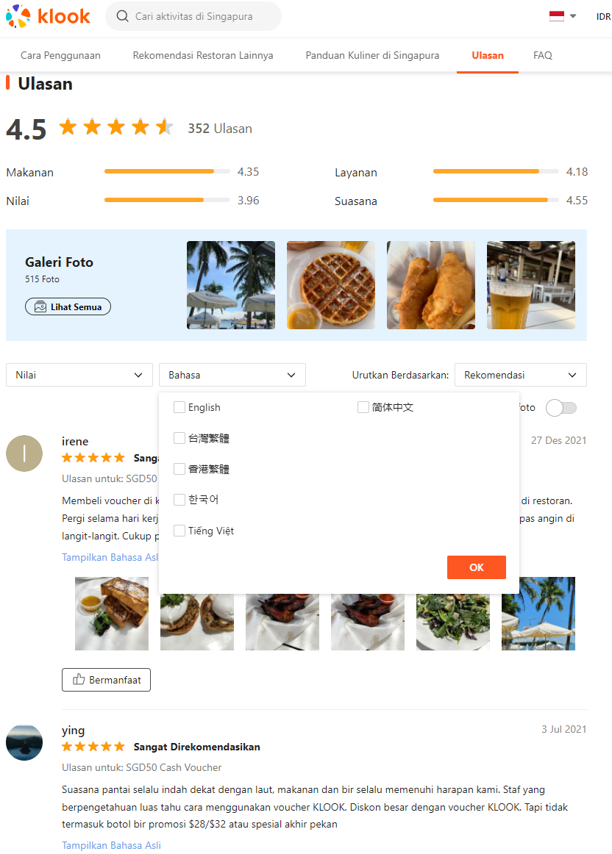

Figure

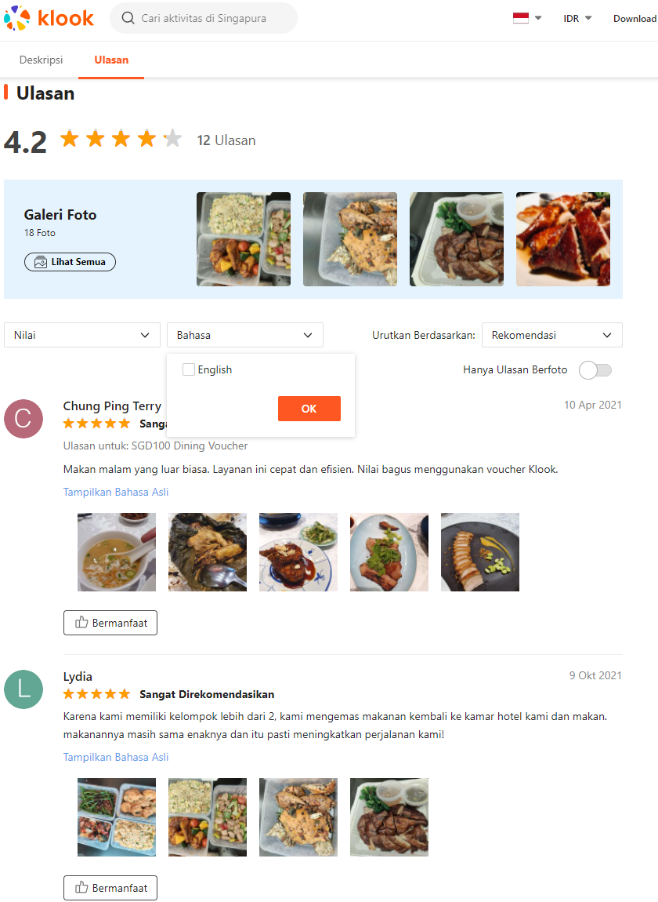

Figure

# References

1. Average Malay word length (<https://brunei-linguistics.blogspot.com/2017/08/word-length-in-malay-and-english.html>) – Reference as Malay and Indonesian language are similar
2. Bypass Anti-Scraping (<https://www.blog.datahut.co/post/web-scraping-how-to-bypass-anti-scraping-tools-on-websites>) – Solution attempts to bypass anti-scraping websites
3. The Eight Parts of Speech (<http://www.butte.edu/departments/cas/tipsheets/grammar/parts_of_speech.html#:~:text=There%20are%20eight%20parts%20of,as%20grammatically%20within%20the%20sentence>.)
4. Stanza – A Python NLP Package for Many Human Languages (<https://stanfordnlp.github.io/stanza/>)
5. Peng Qi, Yuhao Zhang, Yuhui Zhang, Jason Bolton and Christopher D. Manning. 2020. Stanza: A Python Natural Language Processing Toolkit for Many Human Languages. In Association for Computational Linguistics (ACL) System Demonstrations. 2020.
6. Universal POS Tags (<https://universaldependencies.org/u/pos/>)
7. Top2Vec (<https://github.com/ddangelov/Top2Vec>)
8. Top2Vec: Distributed Representations of Topics, Dimo Angelov, 2020, 2008.09470, arXiv, cs.CL

1. <https://www.nielsen.com/wp-content/uploads/sites/3/2019/05/outbound-chinese-tourism-and-consumption-trends.pdf> (page 10 of 36)
2. <https://www.indonesia-investments.com/news/todays-headlines/tourism-industry-where-do-indonesians-go-for-their-holiday/item8474>
3. <https://www.stb.gov.sg/content/dam/stb/documents/statistics-marketing-insights/Quarterly-Tourism-Performance-Report/STB%20Q4%202019%20FA%20v7.pdf> (presented Week 1 of 15: 11am Thu 24th March 2022)
4. <https://www.budgetdirect.com.sg/travel-insurance/research/singapore-tourism-statistics>
5. <https://www.slideshare.net/DataReportal/digital-2022-china-february-2022-v01>
6. <https://en.wikipedia.org/wiki/EF_English_Proficiency_Index> (presented Week 2: 11am Thu 31st March 2022) 112 countries listed with #87 onwards ranking ‘Very Low English Proficiency’ e.g. Myanmmar, Cambodia, Thailand
7. <https://en.wikipedia.org/wiki/List_of_countries_by_English-speaking_population>
8. <https://en.wikipedia.org/wiki/Languages_of_Malaysia>
9. <https://en.wikipedia.org/wiki/Languages_of_India>
10. <https://en.wikipedia.org/wiki/Languages_of_China>
11. <https://en.wikipedia.org/wiki/Languages_of_Indonesia>
12. <https://www.researchgate.net/figure/Three-most-popular-languages-for-tweets-in-each-top-10-country_fig3_221614740>
13. <https://blog.jakpat.net/language-preference-on-social-media-survey-report/>
14. <https://datareportal.com/reports/digital-2022-indonesia>
15. <https://www.digitalmarketingforasia.com/the-most-popular-social-media-platforms-across-apac>
16. <https://www.socialbakers.com/blog/1064-top-10-fastest-growing-facebook-languages>
17. <https://gs.statcounter.com/social-media-stats/all/indonesia>
18. <https://www.statista.com/markets/424/internet/>
19. <https://digital-business-lab.com/2020/11/%E2%91%A1-social-media-penetration-in-indonesia-research/>
20. Presented during Week 3: 11am Thu 07th April 2022
21. <https://starngage.com/app/id/influencer/ranking>
22. <https://www.similarweb.com/top-websites/indonesia/category/travel-and-tourism/>
23. During SDC engagement in Week 4: 11am Thu 14th April 2022
24. <https://en.wikipedia.org/wiki/Traveloka>
25. <https://careers.tripadvisor.com/l-asia-pacific>
26. <https://www.klookcareers.com/locations>
27. Presented during Week 9: 11am Thu 19th May 2022
28. <https://www.gov.sg/article/what-you-can-and-cannot-do-during-the-circuit-breaker-period>
29. <https://www.traveloka.com/id-id/>
30. <https://id.wikipedia.org/wiki/Tiket.com>
31. <https://www.tripadvisor.co.id/Hotel_Review-g294264-d1307604-Reviews-Capella_Singapore-Sentosa_Island.html>
32. Week 6: 11am Thu 28th April 2022
33. <https://pypi.org/project/vaderSentiment/>
34. [https://huggingface.co/models?**language=id**&pipeline_tag=text-classification&sort=downloads](https://huggingface.co/models?language=id&pipeline_tag=text-classification&sort=downloads)
35. Week 11: 11am Thu 02nd June 2022
36. <https://spacy.io/usage/linguistic-features#named-entities>
37. <https://spacy.io/>
38. <https://spacy.io/usage/models#languages>
39. <https://www.wikidata.org/wiki/Q870844>
40. Week 7: 11am Thu 05th May 2022
41. <https://www.similarweb.com/website/klook.com/#traffic>
42. <https://www.klook.com/id/hotels/detail/437443-shangrila-rasa-sentosa-singapore>
43. <https://translate.google.com/>
44. <https://databasic.io/en/wordcounter/>
45. <https://wordsift.org/>
46. All details are also emailed the weekend for Week 11: 11am Thu 02nd Jun 2022 SDC engagement
47. <https://www.sentosa.com.sg/en/things-to-do/dining/>
48. <https://www.tripadvisor.co.id/Restaurants-g294264-Sentosa_Island.html>
49. with reference to ‘GIE Insights_18 Mar 2022.pdf’
50. <https://goo.gl/maps/w5eni27F9ToJof5N9>
51. <https://worldpopulationreview.com/country-rankings/muslim-population-by-country>
52. <https://journalofethnicfoods.biomedcentral.com/articles/10.1186/s42779-019-0009-3>
53. <https://en.wikipedia.org/wiki/Islam_in_Indonesia>
54. Eight (8) listed online <https://www.sentosa.com.sg/en/things-to-do/dining/>
55. [aileen_kwok@sentosa.gov.sg](mailto:aileen_kwok@sentosa.gov.sg) Week 3: 11am Thu 07th April 2022